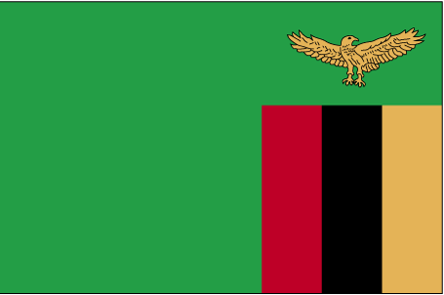 tkfEc;k

- ns’k Js.kh eqnzk o”kZ fooj.k -

ZAMBIA 10 KWACHA 1992
ZAMBIA 1 NGWEE 1992
ZAMBIA 1 NGWEE 1983 KM 9A
ZAMBIA 2 NGWEE 1983
ZAMBIA 5 NGWEE 1968
ZAMBIA 5 NGWEE 1972
ZAMBIA 5 NGWEE 1982
ZAMBIA 10 NGWEE 1968
ZAMBIA 10 NGWEE 1972
ZAMBIA 20 NGWEE 1968
ZAMBIA 50 NGWEE 1992

