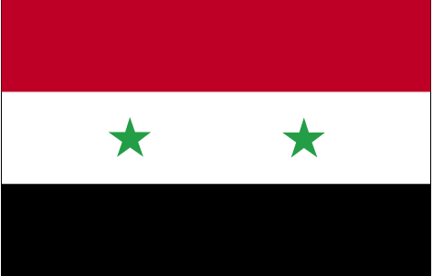 fLkfj;k

- ns’k Js.kh eqnzk o”kZ fooj.k -

SYRIA 0.5 PIASTRE 1935 KM 75
SYRIA 0.5 PIASTRE 1936 KM 75
SYRIA 1 PIASTRE 1936 KM 71
SYRIA 2.5 PIASTRE 1382 1962 KM 93
SYRIA 5 PIASTRE 1933 KM 70
SYRIA 5 PIASTRE 1380 1960 KM 91
SYRIA 5 PIASTRE 1392 1971
SYRIA 5 PIASTRE 1400 1979
SYRIA 10 PIASTRE 1368 1948 Km 83
SYRIA 10 PIASTRE 1382 1962 Km 95
SYRIA 10 PIASTRE 1385 1965 Km 95
SYRIA 10 PIASTRE 1394 1974 Km 106
SYRIA 10 PIASTRE 1399 1979 Km 117
SYRIA 25 PIASTRE 1388 1968 Km 96
SYRIA 25 PIASTRE 1399 1979 Km 118
SYRIA 50 PIASTRE 1396 1975
SYRIA 50 PIASTRE 1388 1968
SYRIA 50 PIASTRE 1394 1974 km 108
SYRIA 50 PIASTRE 1399 1979
SYRIA 1 Pound 1389 1968 Km 99 FAO
SYRIA 1 Pound 1392 1972 Km 103 25th ann.
Baath party
SYRIA 1 Pound 1399 1979 Km 120.1
SYRIA 1 Pound 1398 1978 Km 115 reelection of
the president
SYRIA 1 Pound 1412 1991 Km 120.2
SYRIA 1 Pound 1415 1994 Km 121
SYRIA 2 Pound 1417 1996 Km 125
SYRIA 5 Pound 1417 1996 Km 123 palace
SYRIA 5 Pound 1424 2003 Km 129
SYRIA 10 Pound 1416 1996 Km 124
SYRIA 10 Pound 1418 1997 Km 128
SYRIA 10 Pound 1424 2003 Km 130
SYRIA 25 QURSH 1396 1975
SYRIA 50 QURSH 1399 1978

