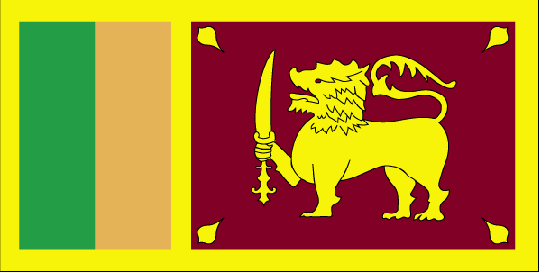 Jhyadk

- ns’k Js.kh eqnzk o”kZ fooj.k -

SRI LANKA (CEYLON) ½ CENT 1926
SRI LANKA (CEYLON) 1 CENT 1912
SRI LANKA (CEYLON) 1 CENT 1870
SRI LANKA 1 CENT 1942
SRI LANKA 1 CENT 1943
SRI LANKA 1 CENT 1965
SRI LANKA 1 CENT 1969
SRI LANKA 1 CENT 1975
SRI LANKA 2 CENT 1970
SRI LANKA 2 CENT 1978
SRI LANKA(CEYLON) 5 CENT 1910
SRI LANKA(CEYLON) 5 CENT 1912
SRI LANKA(CEYLON) 5 CENT 1943
SRI LANKA 5 CENT 1965
SRI LANKA 5 CENT 1968
SRI LANKA 5 CENT 1971
SRI LANKA 5 CENT 1978
SRI LANKA(CEYLON) 10 CENT 1944
SRI LANKA(CEYLON) 10 CENT 1951
SRI LANKA 10 CENT 1971
SRI LANKA 10 CENT 1978
SRI LANKA 10 CENT 1988 KM 140A
SRI LANKA(CEYLON) 25 CENT 1943
SRI LANKA 25 CENT 1963
SRI LANKA 25 CENT 1965
SRI LANKA 25 CENT 1971
SRI LANKA 25 CENT 1975
SRI LANKA 25 CENT 1978
SRI LANKA 25 CENT 1982
SRI LANKA 25 CENT 1991
SRI LANKA 25 CENT 1994 KM 141.2
SRI LANKA(CEYLON) 50 CENT 1943
SRI LANKA 50 CENT 1963
SRI LANKA 50 CENT 1965
SRI LANKA 50 CENT 1971
SRI LANKA 50 CENT 1972
SRI LANKA 50 CENT 1975
SRI LANKA 50 CENT 1978
SRI LANKA 50 CENT 1982
SRI LANKA 50 CENT 2002
SRI LANKA 1 RUPEE 1963
SRI LANKA 1 RUPEE 1965
SRI LANKA 1 RUPEE 1972
SRI LANKA 1 RUPEE 1975
SRI LANKA 1 RUPEE 1978
SRI LANKA 1 RUPEE 1982
SRI LANKA 1 RUPEE 1992
SRI LANKA 1 RUPEE 1994
SRI LANKA 1 RUPEE 1996
SRI LANKA 1 RUPEE 2002
SRI LANKA 2 RUPEE 1981 MAHAVELI
SRI LANKA 2 RUPEE 1984
SRI LANKA 2 RUPEE 1993
SRI LANKA 2 RUPEE 1995 50TH ANNIVERSARY FAO
SRI LANKA 2 RUPEE 1996
SRI LANKA 2 RUPEE 2001
SRI LANKA 2 RUPEE 2002
SRI LANKA 2 RUPEE 2004
SRI LANKA 5 RUPEE 1981 UNIVERSAL ADULT FRANCHISE
SRI LANKA 5 RUPEE 1986
SRI LANKA 5 RUPEE 1994
SRI LANKA 5 RUPEE 1995
SRI LANKA 5 RUPEE 1996 CRICKET WORLD CUP
SRI LANKA 5 RUPEE 2002
SRI LANKA 5 RUPEE 2003 km 169 Upasampada
SRI LANKA 10 RUPEE 1998 50 YEARS OF INDEPENDENCE

