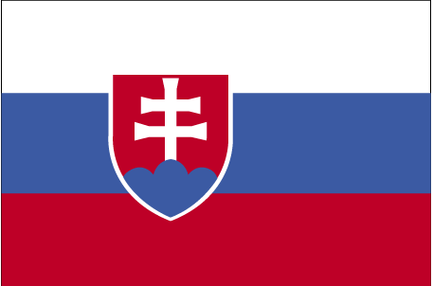 Lyksokfd;k

- ns’k Js.kh eqnzk o”kZ fooj.k -

SLOVAKIA 10 HALERU 1993 Km 17
SLOVAKIA 10 HALERU 1994 Km 17
SLOVAKIA 10 HALERU 1996 Km 17
SLOVAKIA 10 HALERU 1999 Km 17
SLOVAKIA 10 HALERU 2000 Km 17
SLOVAKIA 10 HALERU 2002 Km 17
SLOVAKIA 20 HALERU 1993 Km 18
SLOVAKIA 20 HALERU 1994 Km 18
SLOVAKIA 20 HALERU 1996 Km 18
SLOVAKIA 20 HALERU 1998 Km 18
SLOVAKIA 20 HALERU 2000 Km 18
SLOVAKIA 20 HALERU 2001 Km 18
SLOVAKIA 20 HALERU 2002 Km 18
SLOVAKIA 50 HALERU 1993 Km 15
SLOVAKIA 50 HALERU 1996 Km 35
SLOVAKIA 50 HALERU 2000 Km 35
SLOVAKIA 50 HALERU 2001 Km 35
SLOVAKIA 50 HALERU 2002 Km 35
SLOVAKIA 50 HALERU 2006 Km 35
SLOVAKIA 1 KORUNA 1993 Km 12
SLOVAKIA 1 KORUNA 1994 Km 12
SLOVAKIA 1 KORUNA 1995 Km 12
SLOVAKIA 2 KORUNA 1993 Km 13
SLOVAKIA 2 KORUNA 1994 Km 13
SLOVAKIA 2 KORUNA 1995 Km 13
SLOVAKIA 2 KORUNA 2001 Km 13
SLOVAKIA 2 KORUNA 2002 Km 13
SLOVAKIA 2 KORUNA 2003 Km 13
SLOVAKIA 5 KORUNA 1993 KM 14
SLOVAKIA 5 KORUNA 1994 KM 14
SLOVAKIA 5 KORUNA 1995 KM 14
SLOVAKIA 10 KORUNA 1993 Km 11.1
SLOVAKIA 10 KORUNA 1994 Km 11.1
SLOVAKIA 10 KORUNA 1995 Km 11.1

