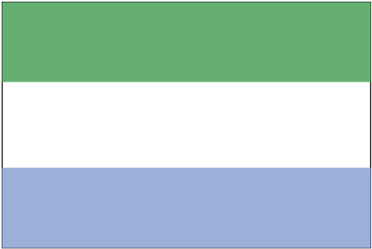 lh;jk fy;ksus

- ns’k Js.kh eqnzk o”kZ fooj.k -

SIERRA LEONE 1/2 CENT 1964 Km 16
SIERRA LEONE 1 CENT 1964 Km 17
SIERRA LEONE 10 CENT 1964 Km 19

