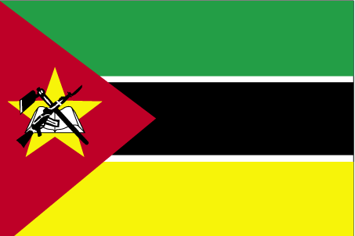 ekstkEchd

- ns’k Js.kh eqnzk o”kZ fooj.k -

MOZAMBIQUE 1 CENTAVO 2006
MOZAMBIQUE 5 CENTAVO 2006
MOZAMBIQUE 10 CENTAVO 1960 Km 83
MOZAMBIQUE 10 CENTAVO 1961 Km 83
MOZAMBIQUE 10 CENTAVO 2006
MOZAMBIQUE 20 CENTAVO 1974 Km 88
MOZAMBIQUE 20 CENTAVO 2006
MOZAMBIQUE 50 CENTAVO 2006
MOZAMBIQUE 2.5 ESCUDO 1953 Km 78
MOZAMBIQUE 1 ESCUDO 1968 KM 82
MOZAMBIQUE 1 METICAI 1994 Km 115
MOZAMBIQUE 5 METICAI 1982 Km 101
MOZAMBIQUE 5 METICAI 1994 Km 116
MOZAMBIQUE 10 METICAI 1994 Km 117
MOZAMBIQUE 100 METICAI 1994 Km 120
MOZAMBIQUE 500 METICAI 1994 Km 121
MOZAMBIQUE 1000 METICAI 1994 Km 122
MOZAMBIQUE 10000 METICAI 2003

