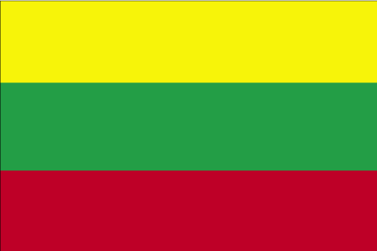 fyFkqvkfu;k

- ns’k Js.kh eqnzk o”kZ fooj.k -

LITHUANIA 1 CENTAS 1991 KM 85
LITHUANIA 2 CENTAS 1991 KM 86
LITHUANIA 5 CENTAS 1991 KM 87
LITHUANIA 10 CENTAS 1991 Km 88 Thin “CENTU”
LITHUANIA 10 CENTAS 1991 Km 88 Thick “CENTU”
LITHUANIA 10 CENTAS 1997 KM 106
LITHUANIA 10 CENTAS 1998 KM 106
LITHUANIA 10 CENTAS 1999 Km 106
LITHUANIA 20 CENTAS 1991 KM 89
LITHUANIA 20 CENTAS 1997 KM 107
LITHUANIA 20 CENTAS 1998 KM 107
LITHUANIA 20 CENTAS 1999 KM 107
LITHUANIA 50 CENTAS 1991 KM 90
LITHUANIA 50 CENTAS 1997 KM 108
LITHUANIA 50 CENTAS 1998 KM 108
LITHUANIA 50 CENTAS 1999 KM 108
LITHUANIA 50 CENTAS 2000 KM 108
LITHUANIA 1 LITAS 1999 KM 111
LITHUANIA 1 LITAS 1999 Km 117 Baltic Highway
LITHUANIA 1 LITAS 2000 KM 111
LITHUANIA 1 LITAS 2001 KM 111
LITHUANIA 1 LITAS 2002 KM 111
LITHUANIA 1 LITAS 2004 KM 137 Vilniaus University
LITHUANIA 1 LITAS 2005 LIETUVOS DIDZIOSIOS
KUNIGAIKSTYSTES VALDOVU ROMAI
LITHUANIA 2 LITAI 1998 KM 112
LITHUANIA 2 LITAI 1999 KM 112
LITHUANIA 2 LITAI 2001 KM 112
LITHUANIA 2 LITAI 2002 KM 112
LITHUANIA 5 LITAI 1998 KM 113
LITHUANIA 5 LITAI 1999 KM 113

