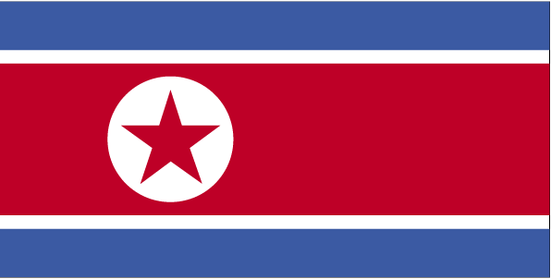 mRrjh
dksfj;k

- ns’k Js.kh eqnzk o”kZ fooj.k -

NORTH KOREA 0.5 CHON 2002 KM 184
NORTH KOREA 1 CHON 1970 KM 1
NORTH KOREA 1 CHON 2002 KM 195
NORTH KOREA 5 CHON 1959 KM 2
NORTH KOREA 5 CHON 1974 KM 2
NORTH KOREA 10 CHON 1959 KM 3
NORTH KOREA 50 CHON 1978 KM 4
NORTH KOREA 1 WON 1987 KM 18
NORTH KOREA 10 WON 2005 KM 425
NORTH KOREA 100 WON 2005 KM 427

