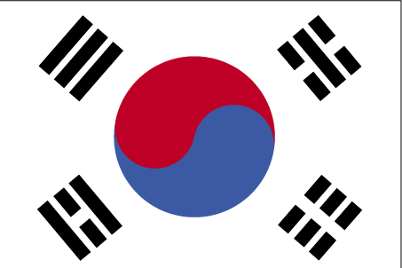 nf{k.k dksfj;k

- ns’k Js.kh eqnzk o”kZ fooj.k -

KOREA ANCIENT COIN 1
KOREA ANCIENT COIN 2
S.KOREA 10 WON 1971 km 6a
S.KOREA 10 WON 1979 km 6a
S.KOREA 10 WON 1983 KM 33.1
S.KOREA 10 WON 1986 KM 33.1
S.KOREA 10 WON 1987 KM 33.1
S.KOREA 10 WON 1989 KM 33.1
S.KOREA 10 WON 1990 KM 33.1
S.KOREA 10 WON 1991 KM 33.1
S.KOREA 10 WON 1993 KM 33.1
S.KOREA 10 WON 1994 KM 33.2
S.KOREA 10 WON 1995 KM 33.2
S.KOREA 10 WON 1999 KM 33.1
S.KOREA 10 WON 2000 KM 33.2
S.KOREA 10 WON 2001 KM 33.1
S.KOREA 50 WON 1982 KM 20
S.KOREA 50 WON 1988 KM 34
S.KOREA 50 WON 1989 KM 34
S.KOREA 50 WON 1990 KM 34
S.KOREA 50 WON 1997 KM 34
S.KOREA 50 WON 2000 KM 34
S.KOREA 50 WON 2003 KM 34
S.KOREA 100 WON 1978 KM 9
S.KOREA 100 WON 1980 KM 9
S.KOREA 100 WON 1986 KM 35.2
S.KOREA 100 WON 1987 KM 35.2
S.KOREA 100 WON 1988 KM 35.2
S.KOREA 100 WON 1989 KM 35.2
S.KOREA 100 WON 1990 KM 35.2
S.KOREA 100 WON 1991 KM 35.2
S.KOREA 100 WON 1992 KM 35.2
S.KOREA 100 WON 1993 KM 35.2
S.KOREA 100 WON 1994 KM 35.2
S.KOREA 100 WON 1995 KM 35.2
S.KOREA 100 WON 1996 KM 35.2
S.KOREA 100 WON 1997 KM 35.2
S.KOREA 100 WON 1999 KM 35.2
S.KOREA 100 WON 2000 KM 35.2
S.KOREA 100 WON 2001 KM 35.2
S.KOREA 100 WON 2002 KM 35.2
S.KOREA 100 WON 2003 KM 35.2
S.KOREA 500 WON 1984 km 27
S.KOREA 500 WON 1988 km 27
S.KOREA 500 WON 1991 km 27
S.KOREA 500 WON 1992 km 27
S.KOREA 500 WON 1994 km 27
S.KOREA 500 WON 1995 km 27
S.KOREA 500 WON 1999 km 27
S.KOREA 500 WON 2000 km 27
S.KOREA 500 WON 2002 km 27

