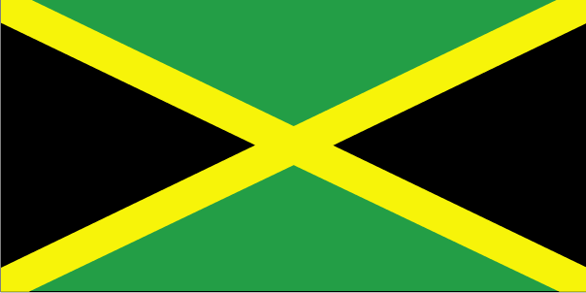 tkek;dk

- ns’k Js.kh eqnzk o”kZ fooj.k -

JAMAICA 1 CENT 1969
JAMAICA 1 CENT 1970 km 45
JAMAICA 1 CENT 1971 LET US PRODUCE MORE FOOD
JAMAICA 1 CENT 1986 Km 64
JAMAICA 1 CENT 1987 Km 64
JAMAICA 1 CENT 1991
JAMAICA 5 CENT 1969
JAMAICA 5 CENT 1972
JAMAICA 5 CENT 1980 KM 46
JAMAICA 5 CENT 1986 KM 46
JAMAICA 5 CENT 1989 KM 46
JAMAICA 5 CENT 1990 KM 46
JAMAICA 5 CENT 1992
JAMAICA 5 CENT 1993 km 46a
JAMAICA 10 CENT 1969
JAMAICA 10 CENT 1972
JAMAICA 10 CENT 1975
JAMAICA 10 CENT 1977
JAMAICA 10 CENT 1981
JAMAICA 10 CENT 1983
JAMAICA 10 CENT 1986
JAMAICA 10 CENT 1987
JAMAICA 10 CENT 1988
JAMAICA 10 CENT 1989
JAMAICA 10 CENT 1990
JAMAICA 10 CENT 1995
JAMAICA 10 CENT 1996 km 146.2
JAMAICA 10 CENT 2003 km 146.2
JAMAICA 20 CENT 1969
JAMAICA 25 CENT 1984 km 49
JAMAICA 25 CENT 1986
JAMAICA 25 CENT 2003 km 167
JAMAICA 50 CENT 1975
JAMAICA 50 CENT 1985 km 65
JAMAICA 1 DOLLAR 1990 SIR ALEXANDER BUSTAMANTE
JAMAICA KM 164 1 DOLLAR 1994 SIR ALEXANDER BUSTAMANTE
JAMAICA 1 DOLLAR 1996
JAMAICA 1 DOLLAR 1999 km 164
JAMAICA 1 DOLLAR 2003
JAMAICA 5 DOLLAR 1993 km 157
JAMAICA 5 DOLLAR 1996 km 163
JAMAICA 10 DOLLAR 1999 km 181
JAMAICA 20 DOLLAR 2000 KM 182
JAMAICA 1/2 PENNY 1964 KM38
JAMAICA 1/2 PENNY 1958 km 36
JAMAICA 1/2 PENNY 1966
JAMAICA 1 PENNY 1960 km 37
JAMAICA 1 PENNY 1961 km 37
JAMAICA 1 PENNY 1962
JAMAICA 1 PENNY 1964 km 39

