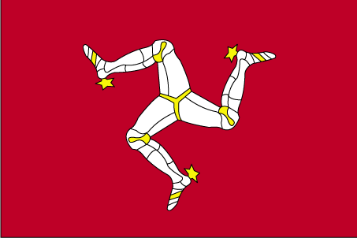 vkby vkQ eSu

- ns’k Js.kh eqnzk o”kZ fooj.k -

ISLE OF MAN 1/2 PENNY 1971
ISLE OF MAN 1/2 PENNY 1981
ISLE OF MAN 1 PENNY 1983
ISLE OF MAN 1 PENNY 1984
ISLE OF MAN 1 PENNY 1994 KM 207
ISLE OF MAN 1 PENNY 1996
ISLE OF MAN 1 PENNY 1997
ISLE OF MAN 1 PENNY 2000 Ancient Keeills Of MAnn
ISLE OF MAN 2 PENNY 1981
ISLE OF MAN 2 PENNY 1988 Ellann Vannin
ISLE OF MAN 2 PENNY 2002 Clasht Rooin o Hiarn
ISLE OF MAN 2 PENNY 2005 Albert Tower
ISLE OF MAN 5 PENNY 1999
ISLE OF MAN 10 PENNY 1992 Quocunque Jeceris Stabit

