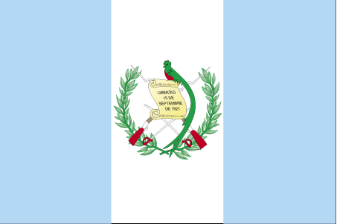 xqvkrsekyk

- ns’k Js.kh eqnzk o”kZ fooj.k -

GUATEMALA 1 CENTAVO 1973
GUATEMALA 1 CENTAVO 1976
GUATEMALA 1 CENTAVO 1982
GUATEMALA 1 CENTAVO 1984
GUATEMALA 1 CENTAVO 1986
GUATEMALA 1 CENTAVO 1989
GUATEMALA 1 CENTAVO 1990 KM 275.2
GUATEMALA 1 CENTAVO 1991 Bartolome de las Casas
GUATEMALA 1 CENTAVO 1992 Bartolome de las Casas KM
275.5
GUATEMALA 1 CENTAVO 1999 Bartolome de las Casas
GUATEMALA 5 CENTAVO 1971
GUATEMALA 5 CENTAVO 1989
GUATEMALA 5 CENTAVO 1990 km 276.4
GUATEMALA 5 CENTAVO 1992
GUATEMALA 5 CENTAVO 1993
GUATEMALA 5 CENTAVO 1994 km 276.4
GUATEMALA 5 CENTAVO 1996
GUATEMALA 5 CENTAVO 2000
GUATEMALA 10 CENTAVO 1971 SMALL WREATH
GUATEMALA 10 CENTAVO 1990
GUATEMALA 10 CENTAVO 1991 km 277.5
GUATEMALA 10 CENTAVO 1992 km 277.5
GUATEMALA 10 CENTAVO 1994
GUATEMALA 10 CENTAVO 1995
GUATEMALA 10 CENTAVO 1996
GUATEMALA 10 CENTAVO 1997
GUATEMALA 10 CENTAVO 2000 km 277.6
GUATEMALA 25 CENTAVO 1977
GUATEMALA 25 CENTAVO 1978
GUATEMALA 25 CENTAVO 1991
GUATEMALA 25 CENTAVO 1993
GUATEMALA 25 CENTAVO 1994 km 278.5
GUATEMALA 25 CENTAVO 1995 km 278.5
GUATEMALA 25 CENTAVO 1997 km 278.6
GUATEMALA 25 CENTAVO 1998 km 278.6
GUATEMALA 50 CENTAVO 2001 km 283
GUATEMALA 1 QUETZAL 1999
GUATEMALA 1 QUETZAL 2000
GUATEMALA 1 QUETZAL 2001
GUATEMALA 1/4 REAL 1889
GUATEMALA 1/4 REAL 1895
GUATEMALA 1/4 REAL 1901

