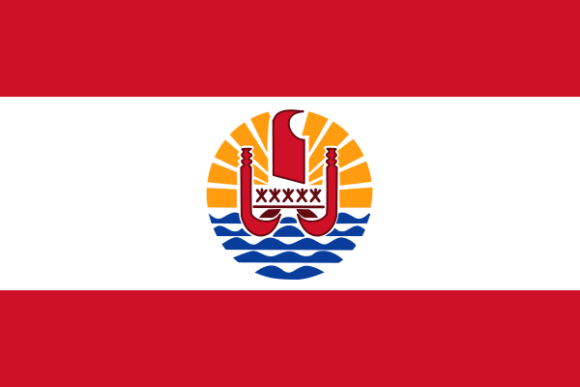ÝSap vks’kfu;k

- ns’k Js.kh eqnzk o”kZ fooj.k - z

FRENCH OCEANIA 1 FRANC 1949

FRENCH OCEANIA 5 FRANC 1952 Km4

