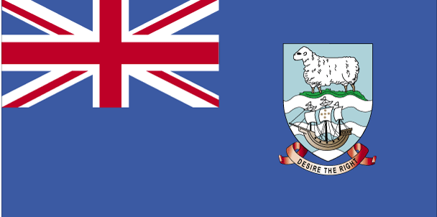QkdySaM }hi

- ns’k Js.kh eqnzk o”kZ fooj.k -

FALKLAND ISLANDS 1 PENNY 1980
FALKLAND ISLANDS 1 PENNY 1983
FALKLAND ISLANDS 1 PENNY 1985
FALKLAND ISLANDS 1 PENNY 1987
FALKLAND ISLANDS 1 PENNY 1992
FALKLAND ISLANDS 1 PENNY 1998
FALKLAND ISLANDS 2 PENNY 1980 PROOF
FALKLAND ISLANDS 2 PENNY 1983
FALKLAND ISLANDS 2 PENNY 1992
FALKLAND ISLANDS 50 PENNY 1980 PROOF

