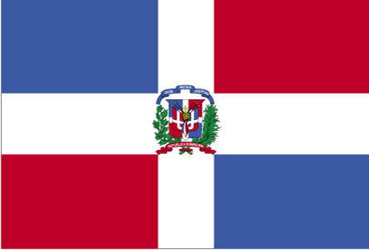 Mksfefudu x.kjkT;

- ns’k Js.kh eqnzk o”kZ fooj.k -

DOMINICAN REPUBLIC 5 CENTAVO 1984 km 59
DOMINICAN REPUBLIC 5 CENTAVO 1987 km 59
DOMINICAN REPUBLIC 5 CENTAVO 1989
DOMINICAN REPUBLIC 10 CENTAVO 1975
DOMINICAN REPUBLIC 10 CENTAVO 1987 km 60
DOMINICAN REPUBLIC 10 CENTAVO 1989
DOMINICAN REPUBLIC 25 CENTAVO 1979
DOMINICAN REPUBLIC 25 CENTAVO 1983 HERMANAS MIRABAL
DOMINICAN REPUBLIC 25 CENTAVO 1986 Km61
DOMINICAN REPUBLIC 25 CENTAVO 1987 km61
DOMINICAN REPUBLIC 25 CENTAVO 1989 Km71.1
DOMINICAN REPUBLIC 25 CENTAVO 1990 KM 71.2
DOMINICAN REPUBLIC 25 CENTAVO 1991
DOMINICAN REPUBLIC 1/2 PESO 1987
DOMINICAN REPUBLIC 1 PESO 1991
DOMINICAN REPUBLIC 1 PESO 1992
DOMINICAN REPUBLIC 1 PESO 1993
DOMINICAN REPUBLIC 1 PESO 2000 Km 80.2
DOMINICAN REPUBLIC 1 PESO 2002 Km 80.2
DOMINICAN REPUBLIC 5 PESO 1997
DOMINICAN REPUBLIC 5 PESO 2002 Km 89

