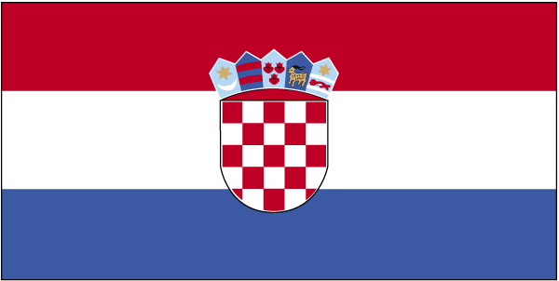 Øks,f’k;k

- ns’k Js.kh eqnzk o”kZ fooj.k -

CROATIA 1 KUNA 1993
CROATIA 1 KUNA 1994
CROATIA 1 KUNA 1995
CROATIA 1 KUNA 1996
CROATIA 1 KUNA 1996 Atlanta Olympics
CROATIA 1 KUNA 1997
CROATIA 1 KUNA 1998
CROATIA 1 KUNA 1999
CROATIA 1 KUNA 1995
CROATIA 1 KUNA 1999 KM 9.2, 5TH ANN. ISSUE OF KUNA
CROATIA 1 KUNA 2000
CROATIA 1 KUNA 2001 KM 9.1
CROATIA 1 KUNA 2002
CROATIA 1 KUNA 2003
CROATIA 1 KUNA 2004 Luscinia Megarhynichos
CROATIA 1 KUNA 2005
CROATIA 1 KUNA 2006 KM 20
CROATIA 1 KUNA 2007 KM 9.1
CROATIA 2 KUNA 1941 KM 2
CROATIA 2 KUNA 1993
CROATIA 2 KUNA 1994
CROATIA 2 KUNA 1995
CROATIA 2 KUNA 1995 FAO, KM 22
CROATIA 2 KUNA 1996
CROATIA 2 KUNA 1998
CROATIA 2 KUNA 1999 KM 10
CROATIA 2 KUNA 2000
CROATIA 2 KUNA 2001 KM 10
CROATIA 2 KUNA 2002 KM 21
CROATIA 2 KUNA 2003
CROATIA 2 KUNA 2004 KM 21
CROATIA 2 KUNA 2005
CROATIA 2 KUNA 2006 KM 21
CROATIA 2 KUNA 2007 KM 10
CROATIA 5 KUNA 1993
CROATIA 5 KUNA 1994
CROATIA 5 KUNA 1994 500 years
CROATIA 5 KUNA 1995
CROATIA 5 KUNA 1999 KM 11
CROATIA 5 KUNA 2000
CROATIA 5 KUNA 2001
CROATIA 25 KUNA 1999
CROATIA 1 LIPA 1993
CROATIA 1 LIPA 1994
CROATIA 1 LIPA 1995
CROATIA 1 LIPA 1997
CROATIA 1 LIPA 1998
CROATIA 1 LIPA 1999
CROATIA 1 LIPA 2000
CROATIA 1 LIPA 2001
CROATIA 1 LIPA 2002
CROATIA 1 LIPA 2003
CROATIA 1 LIPA 2004
CROATIA 1 LIPA 2005
CROATIA 1 LIPA 2006
CROATIA 2 LIPA 1993
CROATIA 2 LIPA 1994
CROATIA 2 LIPA 1995
CROATIA 2 LIPA 1997
CROATIA 2 LIPA 1998
CROATIA 2 LIPA 1999
CROATIA 2 LIPA 2001
CROATIA 2 LIPA 2002
CROATIA 2 LIPA 2004
CROATIA 2 LIPA 2005
CROATIA 5 LIPA 1993
CROATIA 5 LIPA 1995
CROATIA 5 LIPA 1996
CROATIA 5 LIPA 1997
CROATIA 5 LIPA 1999
CROATIA 5 LIPA 2000
CROATIA 5 LIPA 2001
CROATIA 5 LIPA 2002
CROATIA 5 LIPA 2003
CROATIA 5 LIPA 2005
CROATIA 10 LIPA 1993
CROATIA 10 LIPA 1995
CROATIA 10 LIPA 1995 KM 38 UNO
CROATIA 10 LIPA 1996
CROATIA 10 LIPA 1997
CROATIA 10 LIPA 1999
CROATIA 10 LIPA 2000
CROATIA 10 LIPA 2001
CROATIA 10 LIPA 2002
CROATIA 10 LIPA 2003
CROATIA 10 LIPA 2004
CROATIA 10 LIPA 2005
CROATIA 10 LIPA 2007 KM 6
CROATIA 20 LIPA 1993
CROATIA 20 LIPA 1994
CROATIA 20 LIPA 1995
CROATIA 20 LIPA 1995 FAO
CROATIA 20 LIPA 1996
CROATIA 20 LIPA 1997
CROATIA 20 LIPA 1998
CROATIA 20 LIPA 1999
CROATIA 20 LIPA 2000
CROATIA 20 LIPA 2001
CROATIA 20 LIPA 2001 Error “2” filled in
CROATIA 20 LIPA 2002
CROATIA 20 LIPA 2003
CROATIA 20 LIPA 2004
CROATIA 20 LIPA 2005
CROATIA 20 LIPA 2006 KM 17
CROATIA 50 LIPA 1993
CROATIA 50 LIPA 1993 ERROR REVERSE ROTATED BY
30 DEGREES
CROATIA 50 LIPA 1994
CROATIA 50 LIPA 1995
CROATIA 50 LIPA 1996
CROATIA 50 LIPA 1996 ENGLESKA
CROATIA 50 LIPA 1998
CROATIA 50 LIPA 2000
CROATIA 50 LIPA 2001
CROATIA 50 LIPA 2002
CROATIA 50 LIPA 2003
CROATIA 50 LIPA 2004
CROATIA 50 LIPA 2005
CROATIA 50 LIPA 2005 EXTRA METAL ON “0” AND “5”
CROATIA 50 LIPA 2006 KM 19

