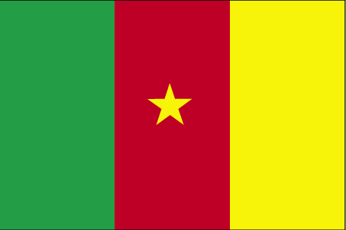 dSe:u

- ns’k Js.kh eqnzk o”kZ fooj.k -

CAMEROUN  Km 8 | 1 | FRANC | 1948
CAMEROUN  Km 2A | 10 | FRANC | 1965

