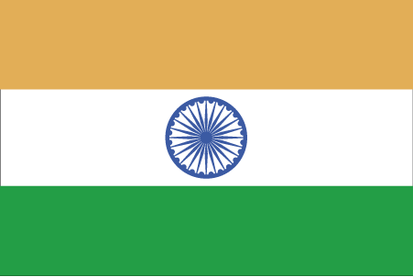 Hkkjr
¼mn;iqj½

- ns’k Js.kh eqnzk o”kZ fooj.k -

BHARAT ¼ ANNA 1999 (S) Dosti landan, square

BHARAT ½ ANNA 1999 (S) Dosti landan, round

BHARAT 1 ANNA 2000 (S) Dosti landan, octagonal

BHARAT 1 RUPEE (S)

BHARAT 1 RUPEE 1985 (S)

BHARAT 1/2 RUPEE 1985 (S)

BHARAT 1/4 RUPEE 1985 (S)

BHARAT 2 ANNA 1985 (S)

BHARAT 1 ANNA 1985 (S)

