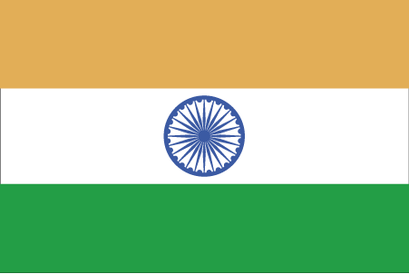 Hkkjr
¼jryke½

- ns’k Js.kh eqnzk o”kZ fooj.k -

BHARAT 1 PAISA 1945 RATLAM THICK

BHARAT 1 PAISA 1945 RATLAM THICK 2

BHARAT 1 PAISA 1945 RATLAM THICK 3

BHARAT 1 PAISA 1945 RATLAM THIN

BHARAT 1 PAISA 1945 RATLAM THIN 2

BHARAT 1 PAISA 1945 RATLAM THIN 3

BHARAT RAEJ SERIES 1

BHARAT RAEJ SERIES 2

