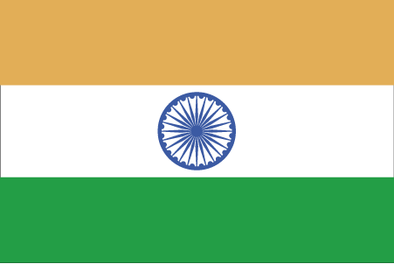 Hkkjr
¼eSlwj½

- ns’k Js.kh eqnzk o”kZ fooj.k -
BHARAT 1 KASU 1783-1799 TIPU SULTAN KM 153 ZAFARABAD MINT
COIN 1

BHARAT 1 KASU 1783-1799 TIPU SULTAN KM 153 ZAFARABAD MINT
COIN 2

BHARAT 1 KASU 1783-1799 TIPU SULTAN ZAFARABAD MINT COIN 3

BHARAT 1 KASU 1783-1799 TIPU SULTAN KM 152 ZAFARABAD MINT
COIN 1

BHARAT 1 KASU 1783-1799 TIPU SULTAN KM 152 ZAFARABAD MINT
COIN 2

BHARAT 1 KASU 1783-1799 TIPU SULTAN KM 152 ZAFARABAD MINT
COIN 3

