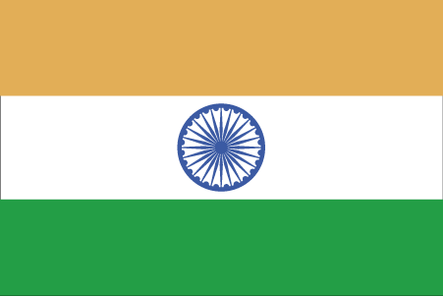 Hkkjr
¼dkaxMk½
- ns’k Js.kh eqnzk o”kZ fooj.k -

BHARAT ??? KANGRA - 1
BHARAT ??? KANGRA - 2
BHARAT ??? KANGRA - 3
BHARAT ??? KANGRA - 4
BHARAT ??? KANGRA - 5
BHARAT ??? KANGRA - 6
BHARAT ??? KANGRA - 7
BHARAT ??? KANGRA - 8

