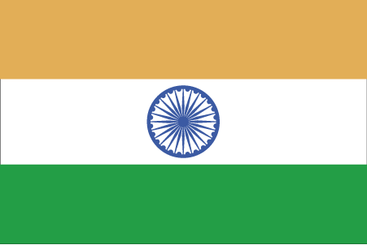 Hkkjr
¼t;iqj½
- ns’k Js.kh eqnzk o”kZ fooj.k -

BHARAT 1 ANNA 1944 (S) SAWAI MANSINGH

BHARAT 1 ANNA 1943 (S) NO PICTURE

BHARAT 1 ANNA 1944 (S) NO PICTURE

BHARAT 1 ANNA 1944 (S) NO PICTURE FINE LETTERING

BHARAT 2 ANNA 1941-2 NAZRANA BRASS

