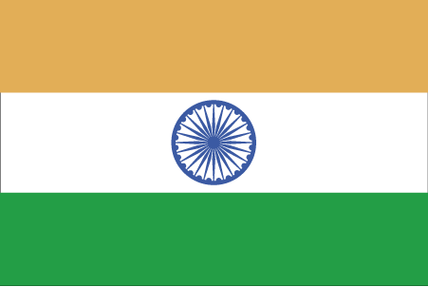 Hkkjr
¼Nrjiqj½

- ns’k Js.kh eqnzk o”kZ fooj.k -

BHARAT 1 RUPEE 1192 AH SHAH ALAM 2 RY 21, KM 19
BHARAT 1 RUPEE SHAH ALAM 2 RY 11, KM 15.1

