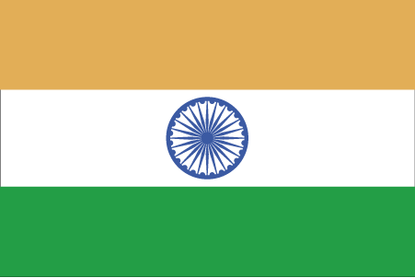 Hkkjr
¼CkjksMk½

- ns’k Js.kh eqnzk o”kZ fooj.k -

BHARAT 1 PAISA 1946 (S)- BARODA
BHARAT 1 PAISA 1947 (S)- BARODA
BHARAT 1 PAISA 1948 (S) BARODA
BHARAT 1 PAISA 1949 (S)- BARODA
BHARAT 1 PAISA 1950 (S) – BARODA
BHARAT 2 PAISA 1942 (S) – BARODA
BHARAT 2 PAISA 1948 (S) – BARODA
BHARAT 1 PIE 1950 (S)- BARODA THIN LARGE LEGENDS
BHARAT 1 PIE 1950 (S)- BARODA SMALL LEGENDS

