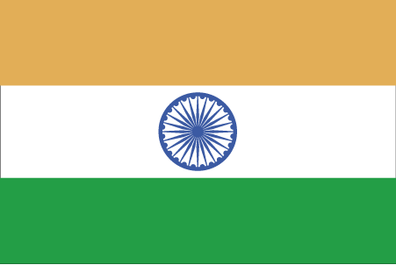 Hkkjr
¼ckgeuh½
- ns’k Js.kh eqnzk o”kZ fooj.k -

BHARAT ??? 1359 BAHMANI – MUHAMMAD SHAH 1

BHARAT ??? 1359 BAHMANI – MUHAMMAD SHAH 2

BHARAT ??? 1359 BAHMANI – MUHAMMAD SHAH 3

BHARAT ??? 1359 BAHMANI – MUHAMMAD SHAH 4

BHARAT ??? 1359 BAHMANI – MUHAMMAD SHAH 5

BHARAT ??? 1359 BAHMANI – MUHAMMAD SHAH 6

BHARAT ??? 1359 BAHMANI – MUHAMMAD SHAH 7

BHARAT ??? 1359 BAHMANI – MUHAMMAD SHAH 8

BHARAT ??? 1359 BAHMANI – MUHAMMAD SHAH 9

BHARAT ??? 1359 BAHMANI – MUHAMMAD SHAH 10

BHARAT ??? 1377-1397 MUHAMMAD SHAH 2

BHARAT AFGHANI 1434-57 BAHMANI – SHAMSUDDIN AHMED SHAH II 1

BHARAT ??? AFGHANI 1434-57 BAHMANI – SHAMSUDDIN AHMED SHAH II 2

BHARAT ??? AFGHANI 1434-57 BAHMANI – SHAMSUDDIN AHMED SHAH II 3

BHARAT ??? AFGHANI 1434-57 BAHMANI – SHAMSUDDIN AHMED SHAH II 4

BHARAT ??? AFGHANI 1434-57 BAHMANI – SHAMSUDDIN AHMED SHAH II 5

BHARAT ??? AFGHANI 1434-57 BAHMANI – SHAMSUDDIN AHMED SHAH II 6

BHARAT ??? AFGHANI 1434-57 BAHMANI – SHAMSUDDIN AHMED SHAH II 7

BHARAT ??? AFGHANI 1434-57 BAHMANI – SHAMSUDDIN AHMED SHAH II 8

BHARAT ??? AFGHANI 1434-57 BAHMANI – SHAMSUDDIN AHMED SHAH II 9

BHARAT ??? AFGHANI 1434-57 BAHMANI – SHAMSUDDIN AHMED SHAH II 10

BHARAT ??? AFGHANI 1434-57 BAHMANI – SHAMSUDDIN AHMED SHAH II 11

BHARAT 1 paisa 1347 Alauddin Bahman Shah BAHMANI KINGDOM

