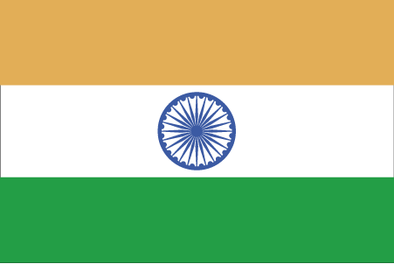 Hkkjr
¼vo/k½

- ns’k Js.kh eqnzk o”kZ fooj.k -

BHARAT 1 rupee 1805 Shah Alam II, Ry 46, Najibabad mint

BHARAT 1 rupee 1215 AH Shah Alam II, Ry 26, LUCKNOW mint, KM 103.2
BHARAT 1 rupee 1224 AH Shah Alam II, Ry 26, LUCKNOW mint, KM 103.2
BHARAT 1 rupee 1228 AH Shah Alam II, Ry 26, LUCKNOW mint, KM 103.2
BHARAT 1 rupee 1233 AH Shah Alam II, Ry 26, LUCKNOW mint, KM 103.2

