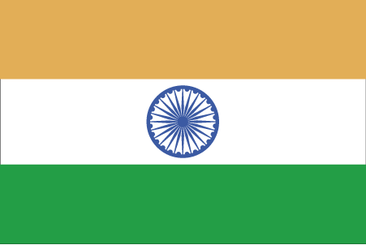 Hkkjr
¼vyoj½
- ns’k Js.kh eqnzk o”kZ fooj.k -

BHARAT -ALWAR state 1 RUPEE 1877 Maharao raja Sawai Mangal Singh
Bahadur KM 45
BHARAT -ALWAR state 1 RUPEE 1882 Maharao raja Sawai Mangal Singh

BHARAT 1 PAISA 18XX Saudan singh - VICTORIA

