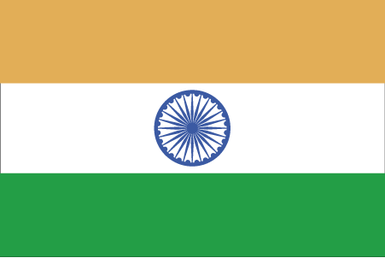 Hkkjr
¼vtesj½

- ns’k Js.kh eqnzk o”kZ fooj.k -

BHARAT ??? PRITHVIRAJ CHAUHAN
BHARAT 1170 AD Prithviraj Chauhan 1
BHARAT 1170 AD Prithviraj Chauhan 2
BHARAT 1 JITAL 1170 AD Prithviraj Chauhan
BHARAT 1 JITAL 1170 AD Prithviraj Chauhan
COIN 2
BHARAT 1 JITAL 1170 AD Prithviraj Chauhan
COIN 3
BHARAT CHAUHAN
BHARAT 1200 AD Somala Devi – Sanyogita

