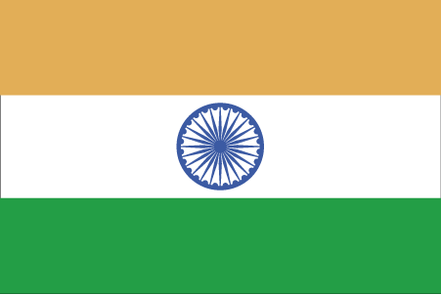 Hkkjr

- ns’k Js.kh eqnzk o”kZ fooj.k -

BHARAT- PORTUGUESE 0.6 escudo 1958 GOA
BHARAT- PORTUGUESE 1 escudo 1958 GOA
BHARAT- PORTUGUESE 1 escudo 1959 GOA
BHARAT- PORTUGUESE 3 escudo 1958 GOA
BHARAT- PORTUGUESE 3 escudo 1959 GOA
BHARAT- PORTUGUESE 6 escudo 1959 GOA
BHARAT- PORTUGUESE 10 centavo 1959 GOA
BHARAT- PORTUGUESE 30 centavo 1958 GOA
BHARAT- PORTUGUESE 1 rupee 1952 GOA big
BHARAT- PORTUGUESE ½ rupee 1952 GOA
BHARAT- PORTUGUESE ¼ rupia 1952 GOA
BHARAT- PORTUGUESE 1/8 TANGA 1884 GOA
BHARAT- PORTUGUESE ¼ TANGA 1901 GOA
BHARAT- PORTUGUESE ½ TANGA 1901 GOA
BHARAT- PORTUGUESE 1 TANGA 1947 GOA
BHARAT- PORTUGUESE 1 TANGA 1952 GOA

