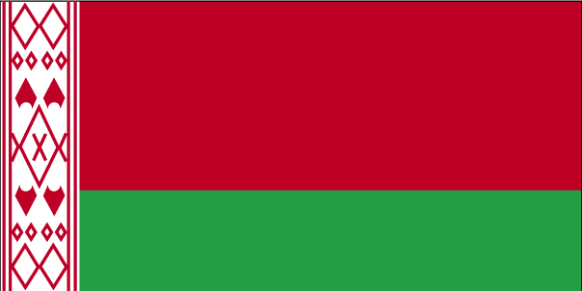 csykjql

- ns’k Js.kh eqnzk o”kZ fooj.k -

BELARUS 25 NOTE
BELARUS 50 NOTE
BELARUS 100 NOTE
BELARUS 1 ROUBLE 2003 FREE STYLE WRESTLING
BELARUS 1 ROUBLE 2005 TENNIS
BELARUS 1 ROUBLE 2007 AV ALADAVA
BELARUS 10 ROUBLE 2007 AV ALADAVA
BELARUS 20 ROUBLE 2005 WORLD CUP FIFA 2006
BELARUS 20 ROUBLE 2005 WORLD CUP HOCKEY 2006

