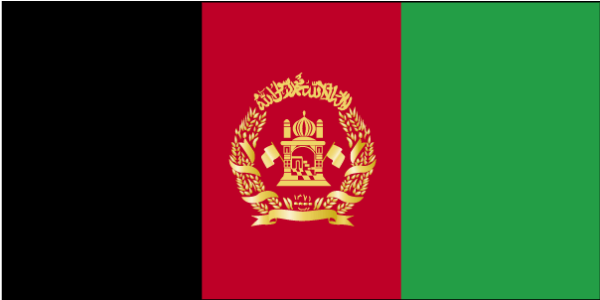 vQxkfuLrku

- ns’k Js.kh eqnzk o”kZ fooj.k -

AFGHANISTAN 1/2 AFGHANI 1952 1331 SH 50 PUL KM 947
AFGHANISTAN 1 AFGHANI 1961 1340 SH KM 953 100 PUL
AFGHANISTAN 2 AFGHANI 1961 1340 SH KM 954.1
AFGHANISTAN 20 PAISA 1895 1313 AH 1 abbasi km 810
AFGHANISTAN 5 PUL 1937 1316 SH KM 938
AFGHANISTAN 25 PUL 1937 1316 SH KM 940
AFGHANISTAN 50 PUL 1973 1352 SH KM 976

