Lody Lawson Books

Lody Lawson 3
Booty Prints 31
Cousin Callie 57
Lody Has a Boyfriend 89
Lody Lawson Goes Too Far 130

Lody Lawson

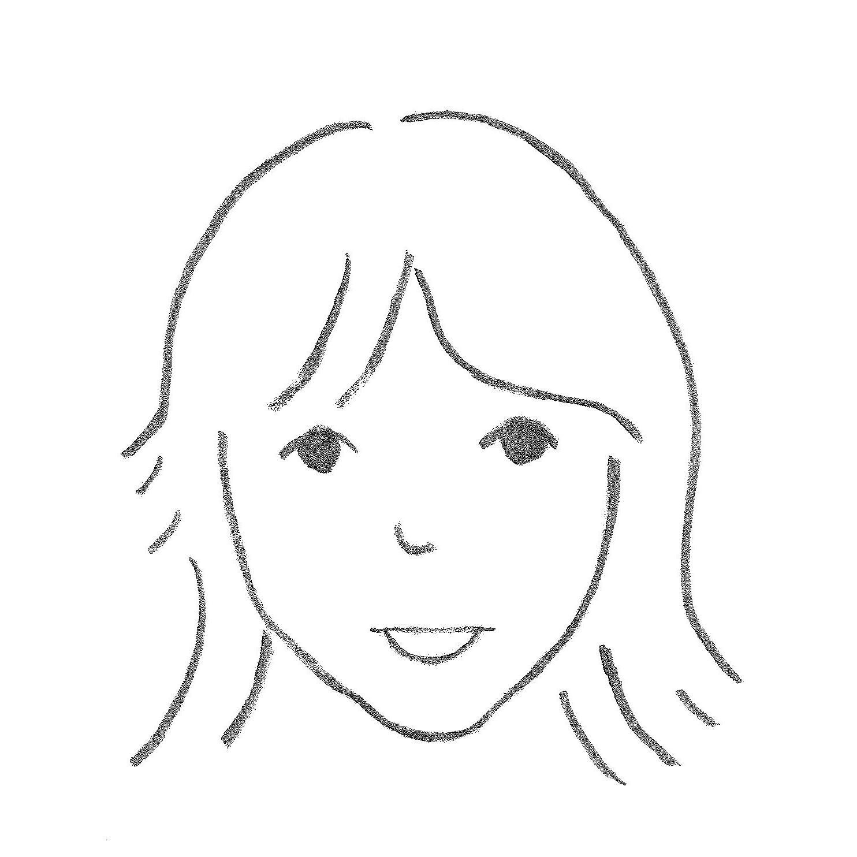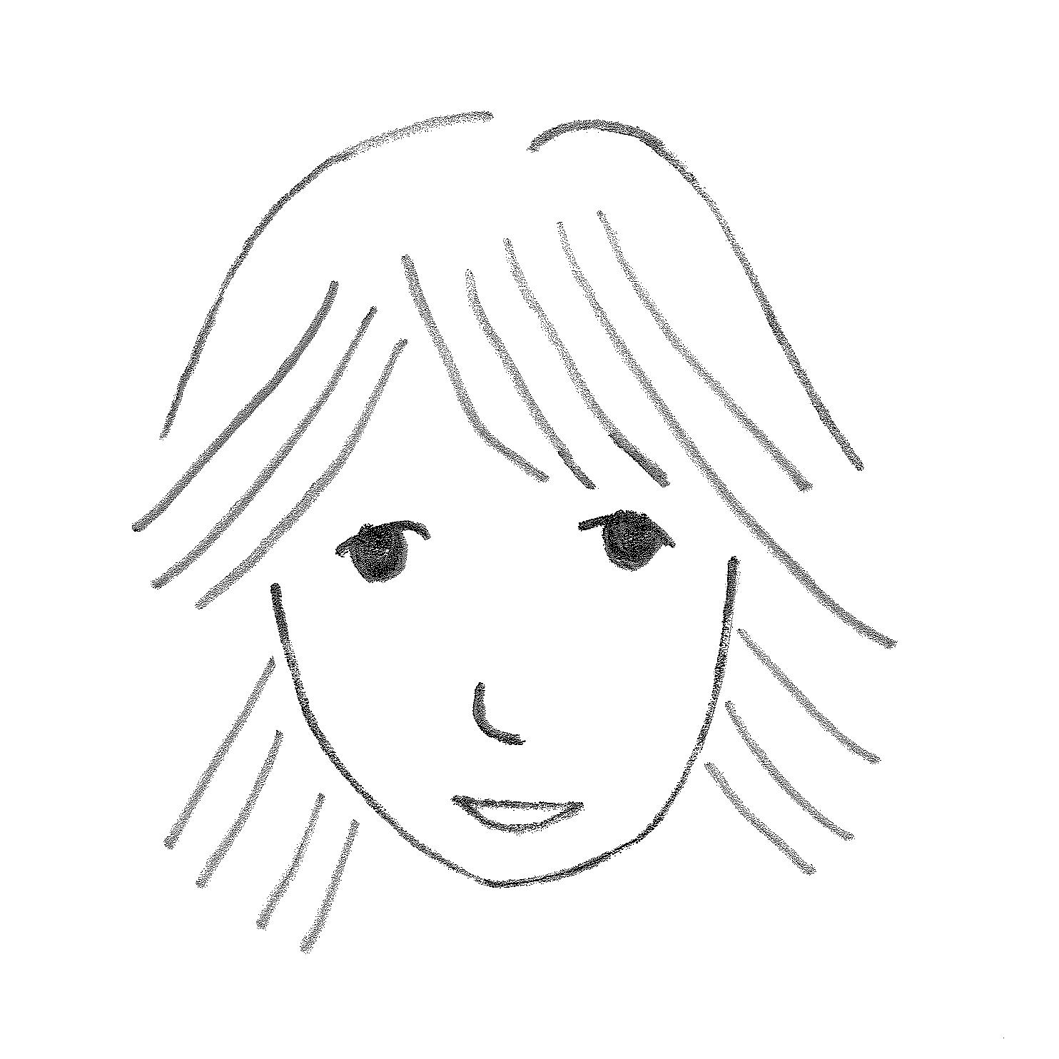

Chrissy Lody
Melody Marie Lawson is the funnest girl in the world. At least in all of Jackson.
But no one knows except Chrissy.
Chrissy is Melody’s twin sister.

[Picture of six year old Melody and Chrissy standing like in that 2 year old picture, side by side, Chrissy slightly in front, holding the stuffed dog, confident and unintimidated; Melody, leaning forward, somewhat curious at the intrusion, but weight on her back leg; background is softly out of focus]
When they were babies, Chrissy couldn’t say Melody, just “Lody”.
Now everyone calls her Lody. It just seems to fit.

[Close up picture of just Lody]

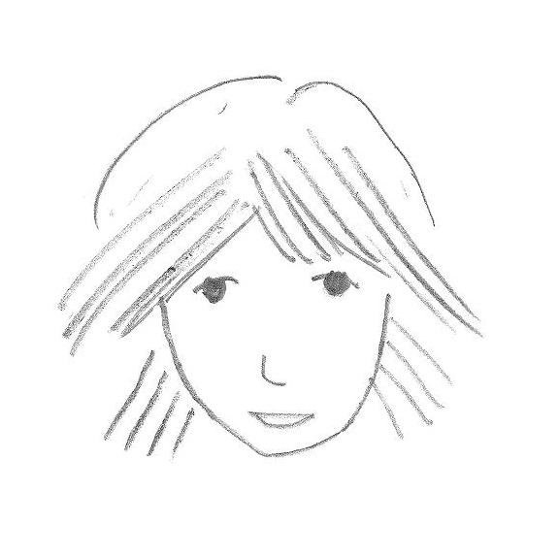

When someone asks Lody a question, Chrissy answers.

[Picture of Lody looking at Chrissy, who is talking to someone else; obviously answering for her]

See, Lody is VERY shy.
And, she is always happy just to be herself.
And just to be BY herself.

[Picture of Lody under a tree, playing alone, oblivious to anything else; coloring maybe; sun is shining]

Lody isn’t quite like anyone else. And that’s why she is ALWAYS getting in trouble. She doesn’t mean to do anything wrong…

[Picture of back of adult talking to Lody, with arm up, elbow crooker, forearm at an angle index finger up, making some sort of point about what Lody had been doing; Lody looks partly like she is in trouble, partly guileless]
And she has quite an imagination.

[Picture of Lody imagining she is a princess on a horse; on split rail fence, holding “reins” she had put on fence; some sort of tiara and blanket for a cape; shining aura around her]

And Lody is always disappearing.

[Picture of back of Lody, heading away; back door open somewhat, closing behind her, mom at stove, just starting to turn around, as if she had just said, “Lody?” and didn’t get an answer, but too late to see even the door shut]
And always doing something crazy.

[Picture of Melody upside down on couch, head over seat, feet up in the air, looking out at “camera”]

Sometimes, her mother wants to punish her.
But she is just too doggone cute.

[Picture of mom thinking, “She just can’t help it, that’s just the way God made her”]

Chrissy tries to keep Lody out of trouble. But sometimes she wishes Lody would get in trouble just once.
Still, she is Lody’s BIG sister after all.
Somebody needs to look after her.

[Picture of Chrissy explaining something to an adult]

Her brother wants to be mad at her sometimes, but she melts him with her big brown eyes.
You see? Lody is ‘dorable.

[Picture of her brother looking like he was just about to be mad, but has a “what the heck look” on his face, and Lody’s big brown eyes]

And Lody is always saying the cutest things. If you ask her if she likes brownies, she’ll say, “Yes please.” If she doesn’t know what to say, she just says, “hmmm”.
Only Chrissy understands her.

[Picture of Lody saying “hmmm”, holding lips kinda pursed and eyes looking kindof focused, like she means something by it]

If Lody agrees with you, she’ll say “’zactly.” She says “sigh” a lot.
And she’s always making up new words, or saying funny things like, “sheesh.”

[Picture of Lody looking serious, and like she is sighing, and saying the word “sigh”]

Her dad doesn’t understand her though.
Lody thinks her dad is mean.

[Picture of Chrissy looking happy and excited and saying, “I’ve got good news!” and Lody looking vaguely like she is serious but questioning, and asking, “We’re getting a new dad?”]

One day, they’re all in the living room of the big house. Well, except Lody of course.
Looking around, their dad asks their mom, “Where is Melody?”
“Where is Melody?” their mom asks.
“Where is Melody?” asks their brother.

[Picture of them all in big living room with curious looks to each other; show living room furniture and like they had been sitting around TV]

“I’ll bet I know,” says Chrissy.

[Close up picture of Chrissy with an “I’ll bet I know” look on her face; index finger up like, “A-ha”]

Chrissy looks in Lody’s favorite alone place.
But she isn’t there.

[Picture of Chrissy alone at Lody’s hiding place, a tree house you can see in to from the ground; obviously no one is in there]
Then, she hears Lody’s pet duck, Quackers.
Chrissy follows the sound and finds the duck.

[Picture of Quackers, who has a lot of personality and a cocked head expression on her face]
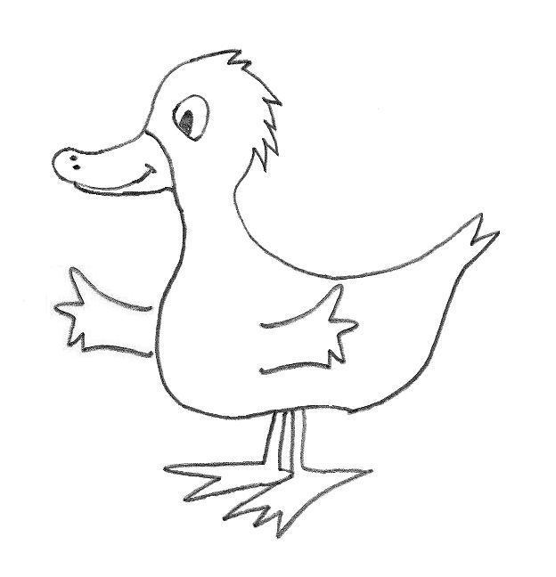
But Lody isn’t there either.

[Picture of Chrissy and the duck by a tree by a pond; show enough of scene to see no one else is there]

Then Chrissy hears her kitty, Sir Meowsalot.
She’s up in the tree.

[Picture of the kitty looking down from the tree; lots of leaves and a few branches; kitty has personality too, and a somewhat helpless look on her face, like she had been there a while]
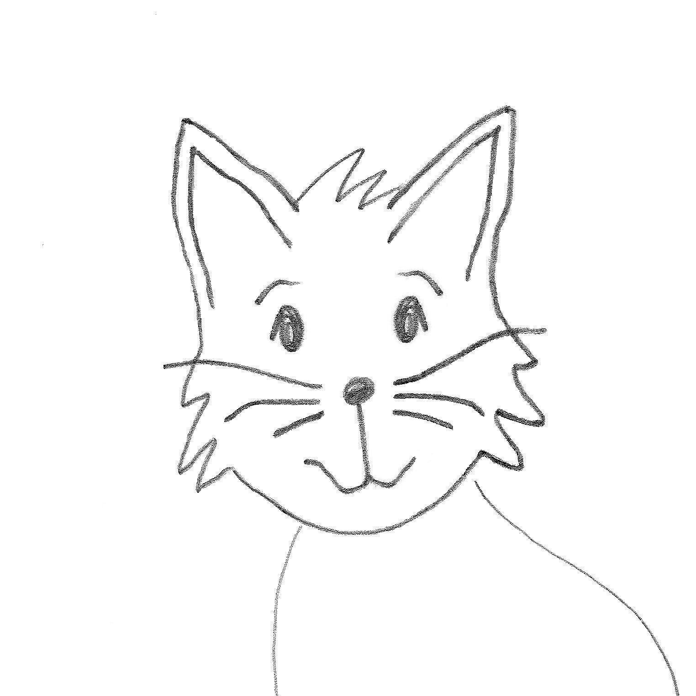
Chrissy doesn’t climb trees. Not like Lody, anyway. And, she doesn’t think their mom would like it very much if she fell out of a tree.
But she has to find Lody.
Up she goes.

[Picture of Chrissy warily climbing the tree]
Soon, Chrissy and Meowsie are both in the tree.
And they have no idea how to get down.

[Picture of Chrissy and Meowsie in the tree looking down at ground; obvious that they don’t have any idea how to get down and they have realized it]

Is Lody up there too? She could get them all down.
“Is Lody up here, Meowsie?”
“Meow,” the kitty says.

[Picture of kitty meowing; expression is “nooo…”]

“Did you follow her up here, and now you can’t get down?”
“Meow. MEOW.”
“Oh, my poor kitten. And then she climbed down, didn’t she?”
“Meow.”

[Picture of Chrissy shaking her head slowly side to side, seriously; holding her lip like “oh my…”, and like she expected this]
About that time, Lody just happens to be coming back from a secret mission.
“What ya doin up the tree, Chrissy?”

[Picture of Lody looking up at Chrissy like Chrissy is a little crazy, like “what are you doing?”; Chrissy sighing in resignation, and like this always seemed to happen this way]
This always happens.

THE END

Booty Prints

Chrissy Lody

“Lody, what ARE you doing?”
“Marching.”
“In circles?”
“Sure.”
“Why?”
“Because I can. Come on, follow me. I’m going to England.”

[Picture of Lody, in their bedroom, you can see their bed, and a teddy bear on the bed, and a window and a tree outside the window; Lody is marching in circles]

Chrissy joins in.
It is kind of fun actually.

[Picture of Chrissy following Lody, marching in circles]

Later that day, Chrissy is helping her mother get lunch ready. Her mother suddenly has a curious look. “What’s wrong mother?” Chrissy asks.
“Where’s your sister? I just realized I haven’t seen her all morning.”

[Picture of Chrissy and their mom by sink and stove, mom looking curious, Chrissy looking up at their mom]

Chrissy likes to be asked to do things.
“I’ll find her,” Chrissy says.
She is gone in a flash.

[Chrissy heading down the hall like she’s on a mission. It’s a big hall and there is a table with a telephone on it, and some pictures on the wall, and a couple of doors]

It isn’t hard to find her this time.
“Do a little dance, shake your BOOTY!”
The only thing louder than the CD player is Lody’s voice.

[Picture of Chrissy opening their bedroom door, music coming out]

It is even louder when she opens the door.

[Picture of open door, their room, record player, loud music, Lody dancing]

“Shake your booty, shake your BOOTY.”
And there she is.
Shaking her booty.

[Picture of Lody shaking her booty, other stuff has been blurred out]
“Oh, Lody, why do you have to be so silly?”
“It’s fun! “
“Melody…”
“Do a little dance… You do it with me!”
“No Lody, that looks ridiculous.”

[Picture of Lody, guileless, and Chrissy protesting]

But before you can say, “do a little dance”, Chrissy is doing it too.

[Picture of them both shaking their butts and the record player and the room]

After a minute, Lody stops. Chrissy doesn’t notice at first. She’s having too much… fun.

[Picture of Lody stopped and staring at Chrissy, Chrissy having fun, oblivious]

Then Chrissy stops. She looks embarrassed.
“What?” she asks.

[Picture of Chrissy stopped and perplexed, and a little embarrassed]
“My work here is done.”
Oh….
Lody always says that.

[Picture of just Lody stating something factually]

Chrissy feels kind of silly again. But, there is no turning back now.
“So, Lody, what are we gonna do now?” she asks.

[Picture of Chrissy behind Lody, who is heading out; asking her a question]
Lody is already heading down the hall.
She has something in her hand.
“Isn’t that dad’s flashlight?”
“No, it’s a secret detecting device.”
“Detecting?”

[Picture of Lody in the hall, holding flashlight, turning around, explaining something, and Chrissy asking her another question]

Lody has that Lody look about her as she walks up the stairs.
And she is turning OFF the lights as she goes.

[Picture of Lody walking up big stair case, flipping light switch down]

She turns the flashlight on and starts murmuring to herself, quite seriously.
“They HAVE to be here somewhere. I’ve seen them before. Just not here. But this is where they HAVE to be.”

[Picture of Lody pointing the flashlight down, looking at the floor, seriously; circle of light on floor from flashlight; hardwood floor]

“What Lody? What are we looking for? I don’t see anything.”
“Oh, there! And, there’s another one!”

[Picture of Lody excited pointing; floor and walls of the old house; hardwood, rug, pictures and shelves]

“What are they??”
“Booty prints.”
“What?”
“Booty prints. I think they’re mom’s.”

[Picture of Chrissie asking question and Lody explaining something seriously, less of the stuff in background shows]

After a while, Chrissy is sure she too sees booty prints.
They are on the floor, the stairs, the walls, everywhere!

[Picture of Chrissy finding booty prints, caught up in the moment; near spinning, again, some of the stuff showing, some blanked out]

But ten minutes later, Chrissy is examining a notoriously large collection in the corner of their mom and dad’s closet.
“Lody… come here!”

[Picture of Chrissy kneeling down in closet, clothes hanging over her head, shoes on the floor, yelling over her shoulder]

Louder still, “Lody!”
“Melody? Melody…. Melody?”
But she’s gone. The game is over.

[Picture of empty room; parent’s room, bed, dresser, adult stuff, big window with curtains; obviously empty…]

That weekend, the power goes out in the big old house.
“Where’s my flashlight?!” bellows their dad.

[Picture of their dad, yelling up into the air; he’s in the garage, there are two cars; it’s dark in there; in front of him is a cabinet with open doors, and an empty place where the flashlight was]

“Oh, Melody…”

[Picture of Chrissy looking “upset”; kitty behind her, looks as if it could be holding its front legs up, palms up in the air in the sign of “what ya gonna do?”]

This always happens…

The End

Cousin Callie

Chrissy Lody

Sometimes Lody babysits her little cousin Callie.
Callie is two and a half.

[Picture of Callie looking up at Lody]


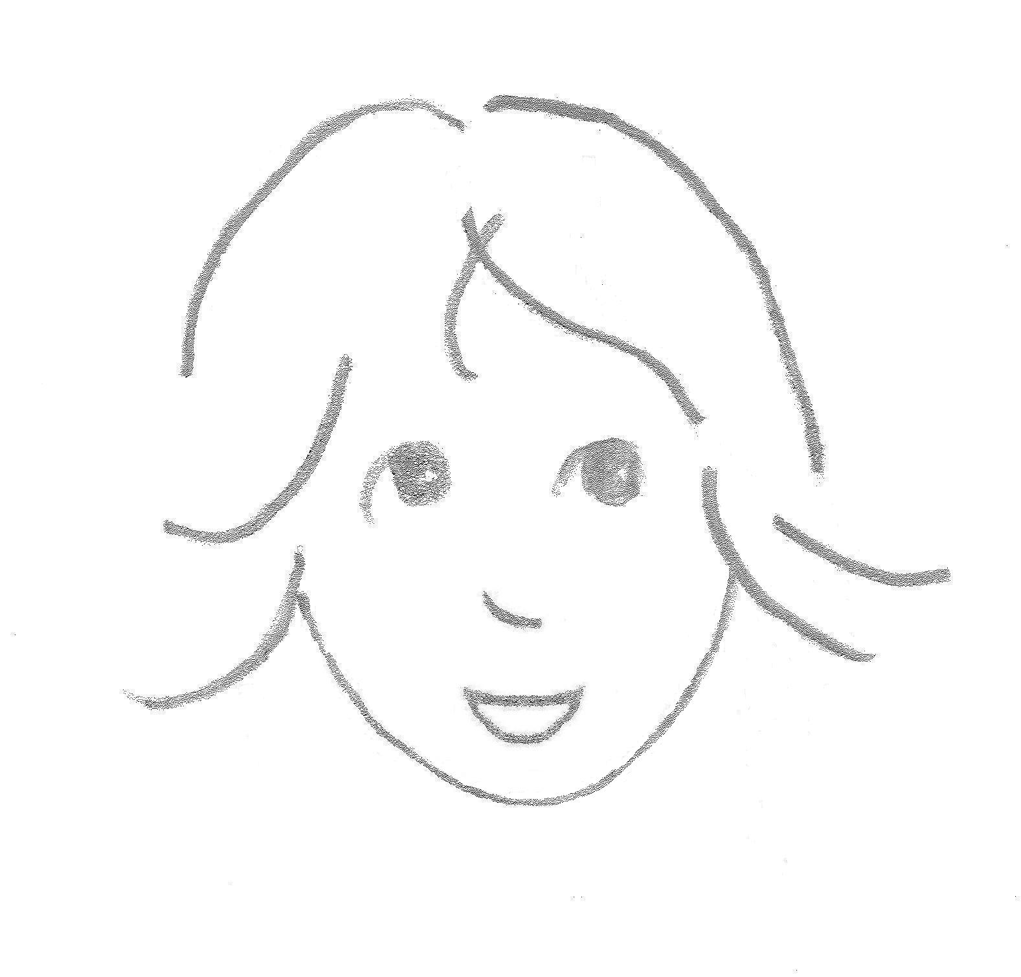
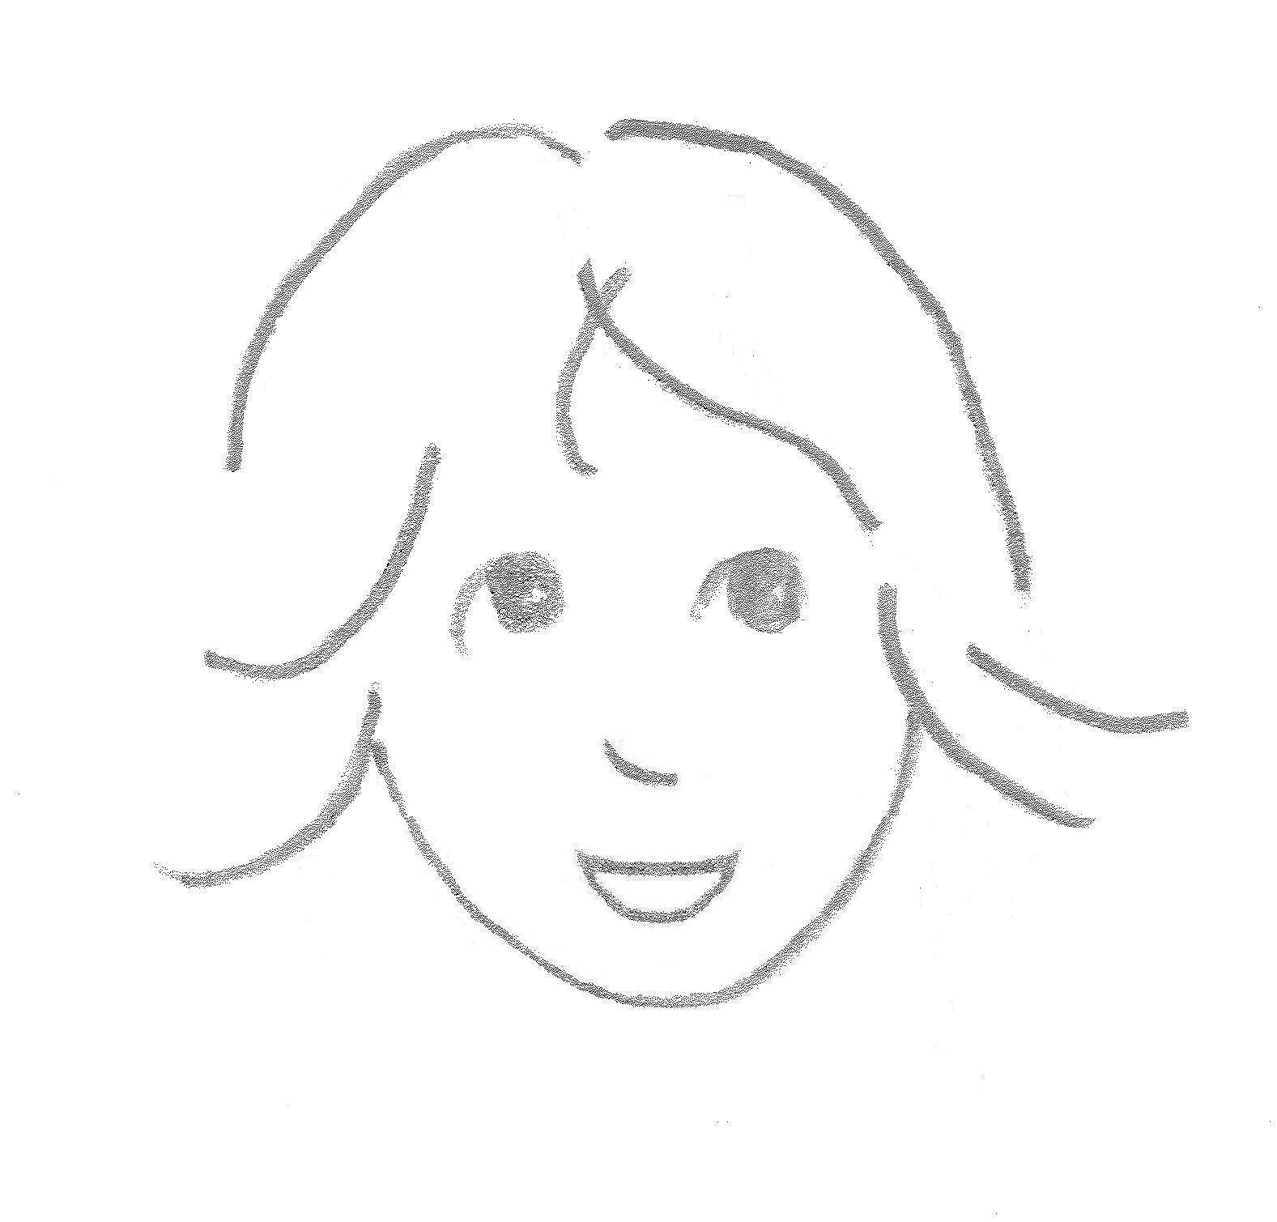
Callie is cute as a button, and always has a mischievous gleam in her eye.
She’s just like Lody was when she was that age.

[Picture of Callie, mischievous gleam in her eyes]
She is always up to something.
And she’s always making people laugh.

[Picture of Callie upside down on sofa, with a silly cute look on her face, Lody and Chrissy watching and laughing]
Callie is always jibber-jabbering. Or singing songs she makes up.
She has a lint roller that she uses for a microphone when she sings.

[Picture of Callie singing into the lint roller]
One day, Callie tiptoes over to the stereo.

[Picture of Callie tiptoeing over to the stereo, wearing overalls, one strap down]

“Shhhhh”

[Picture of Callie looking back over her shoulder, from her waist up, in overalls, one strap down, finger up to her lips, saying, “Shhhhh”]

Lody sees the lint roller in her hands and realizes she’s about to put it in the speakers.

[Picture of Callie holding lint roller and speaker with grates behind it]
It’s really hard to get stuff out of those speakers.
And Lody will have to be the one to get it out.
She just about never did get the last toy out of there.
“Don’t do that Callie.”

[Picture of Lody gently and patiently but firmly saying, “Don’t do that.”]

Callie turns to Lody and whispers, “Don‘t tell anybody.”

[Picture of Callie turning toward Lody, leaning her head closer, and whispering, “Don’t tell anybody.”]

Later that day, Lody and Chrissy and Callie are sitting at the kitchen table eating lunch.
Callie has a whole plate of spaghetti in front of her.

[Picture of Lody and Chrissy and Callie at the dinner table, Callie in center of picture with plate of food in front of her, looking out at “camera”?]

Callie starts wondering if there is anything on the bottom of her plate.

[Picture of Callie only, looking down at her plate which has xxx on it]

Callie carefully turns her plate over.
Upside down…

[Picture of Callie calmly turning plate over, looking bottom with her head somewhat sideways as she does]

She calmly looks up at Chrissy and Lody, and says, “Well, that wasn’t a good idea.”

[Picture of Chrissy and Lody in subtle disbelief, with some humor, looking at Callie, who is looking up at them, calmly saying something matter-of-factly]

That afternoon, when Lody’s dad gets home, they all decide to go out for ice cream.

[Picture of them in living room, looking happy and like they just decided something]
Everyone goes.

[Picture of everyone in the car, driving, Callie in one window, doggy hanging out another window]
And everyone has ice cream.

[Picture of quaint ice cream store, they are all eating on benches, Callie covered in ice cream, doggy eating ice cream out of a bowl]

On the way back, Lody and Callie are in the back seat.
Lody is holding her ice cream up a little bit so she can clean off…

[Picture of Lody and Callie in backseat, Lody holding ice cream up a little, cleaning herself off]
…the ice cream that Callie got on her.
“Oopsie…”

[Picture of Callie sitting on Lody’s lap at the ice cream place, looking at her face as Lody looks down at the ice cream ball on her lap, ice cream smear down her shirt]

Callie conducts a big orchestra on the way back.

[Picture of Callie swinging her arms around as though she was conducting music]

Oh no…
Callie’s hand goes into Lody’s ice cream.

[Picture of Callie’s hand, suspended for a minute, in Lody’s ice cream, Lody just looking]

Callie looks down at her hand.
“Mmmm… ice cream.”

[Picture of Callie staring down at her ice cream covered fingers, saying, “Mmmm…ice cream”]

Callie licks it off and starts conducting again, as if nothing has happened.

[Picture of Callie conducting again, looking as though nothing had happened, ignoring dumbstruck look on Lody’s face]

Chrissy and Lody start cracking up.

[Picture of Lody and Chrissy looking at each other across back of front seat, laughing hard]

After a minute, Callie turns to them.
“Calm down guys, it wasn’t that funny.”

[Picture of Callie, somewhat serious, “the boss” look, head slightly cocked, looking from under her brow, saying, “Calm down guys, it wasn’t that funny”]

That just makes everyone laugh even harder.

[Picture of Lody and Chrissy looking at each other across back of front seat, cracking up]

That night, Callie announces, “I’m the Jokester.”

[Picture of Callie making a declaration, “I’m the Jokester”. Standing and leaning forward from the waist, wearing her overalls]

“You are?”
“Yes.”

[Picture of Chrissy looking on, Lody humoring, expectantly, “You are?”, not expecting what would come next, Callie saying “Yes.” Like it was just a fact.]

“Why are you the jokester?”
“Cause I tell knock-knock jokes.”
“Oh…”

[Picture of Chrissy still looking on, Lody somewhat surprise, Callie just said this, and Lody saying, “Oh”]

“Knock, knock.”
“Who’s there?”

[Picture of Callie saying “Knock, knock” and Lody saying “Who’s there?”]

“Me.”

[Picture of Callie saying “Me,” like “Duh, don’t you know me?”]

“Me who?”

[Picture of Lody playing straight person and saying “Me who?”]

“The Jokester.”

[Picture of Callie saying this like it is who she is]

Of course.

[Picture of Lody and Chrissy looking at each other]

THE END

Lody Has a Boyfriend

Chrissy Lody

Oh, about that Davey...

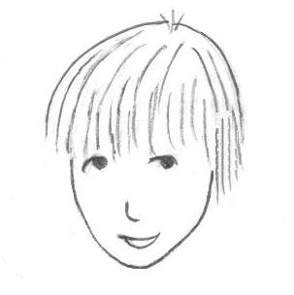

Davey lives on Lody’s street. AND, he’s in the same first grade class as Lody.

[Picture of Davey on his bike, on their street, street sign behind him, facing the “camera”; Lody standing next to his bike, arms folded]

He’s the one who is in love with Lody.
Only he always calls her Melody.

[Picture of Davey in his desk in a classroom, with other students at their desks, doing their work; Davey is looking at Lody, sort of like he wants to say something, or like he’s just staring at her; Lody is pretending not to notice]
Davey is skinny, with long blonde hair that falls in his eyes.

[Picture of Davey with hair falling in his eyes]
Davey loves to chase butterflies. So everyone calls him Chase.

[Picture of Davey chasing butterfly through an open field, trees on the sides, with a butterfly net]
And Davey is ALWAYS getting in trouble. More than Lody, cause he’s always doing something wrong.
Wherever he is, he is always doing things he shouldn’t be doing.
“It’s my job to save him,” Lody says.

[Picture of Lody at her desk, looking up at Davey, who is up at the teacher’s desk, saying to herself, “it’s my job to save him”]
“I’m gonna marry you, Melody Lawson,” is what Davey always says when he hears that.

[Picture of Davey, looking over to the side, head down a little, eyes looking out from underneath brows, saying this, serious faint smile on his face]
When Davey first started telling Lody she was beautiful, she would say, “I know.”
Cause she didn’t know.

[Picture of Lody in rolled up jeans, hair pulled back, saying, “I know.” with a trying to be confident look in her eye]

But when she saw the smitten look on his face, she started sweetly saying, “Thank you.”
Never just “Thanks”, always “Thank you”.

[Picture of Davey looking smitten at Lody, Lody batting her lashes, wearing a sun dress, saying “Thank you” sweetly]

But now she always says, “Am I?”
“You’re beautiful Melody.”
“Am I?”

[Picture of Davey saying, “You’re beautiful Melody” and Lody, looking up, tilting her head so slightly, and saying, “Am I?”]
Whenever Davey has to tell Lody goodbye, he says, “Au revoir, my Melodie. FPAUC.”

[Picture of Davey leaving Lody’s house, looking back and saying this, quite serious]
That’s the same thing he puts at the bottom of the letters he writes to her.
F – P – A – U – C.
Forever, Period, Always, Unconditionally and Completely.

[Picture of FPAUC written at bottom of letter, first grader handwriting]

Davey always addresses the letters to, “Dearest Honey Bear Sunshine,” or “My Darling Melody”.
And he calls her his sweet little Princess Melody Dawn.
Davey is twitterpated over Lody.

[Picture of Davey seeing Lody as a real princess]
Lody pretty much likes Davey half as much as twice how much he likes her.
That’s an awful lot.

[Picture of Lody on the side of the road, looking twitterpated toward Davey, who is playing street hockey with a couple other boys]
Davey makes up songs. But no one likes his songs.
No one except Lody that is.

[Picture of Davey playing guitar and singing to Lody, who is watching raptly]
He makes up songs about anything he is feeling.
Or anything that is pretty. The sky, the woods, the creek…
Mostly bout Lody though.

[Picture of Davey with guitar, thinking music and words and Lody]
“Make me into a song, Davey.”

[Picture of Lody looking at Davey sweetly and slightly pleading and like he would do anything for her, and asking him to write a song about her]
“You’re my Honey Bear Sunshine
My little warm brown fox
Stars for eyes, and a smile like sunshine”

[Picture of Davey singing this, looking peaceful and happy]

Davey comes over to Lody’s house every day after school. Her mother lets him in, or sometimes Chrissy does.

[Picture of big old porch with columns and big front door and Chrissy letting Davey in]
Lody comes down the stairs and just stands there, all quiet.
So quiet that sometimes Davey doesn’t even notice she is there.

[Picture of Lody standing at bottom of stairs quietly; show staircase and her looking toward Davey who doesn’t see her yet; parlor chairs with table to the side, big oval rug]
Every day, after school, they go outside and sit on the split rail fence that surrounds the big old property

[Picture of them sitting on split rail fence, close to each other, Lody looking down at her knees with her feet swinging, one out, one in, and Davey also looking kind of down but over and talking to Lody, big trees behind them and lots of grass and birds and stuff]

One warm and breezy summer day, Davey is saying something to Lody, but Lody is pretending to be busy watching a busy squirrel.

[Picture of warm breezy day and Davey looking at Lody, saying something, and Lody with feet on lower rail, and hands out to side on upper rail, looking at a squirrel scampering around]
A different day, after thinking about it all week, Davey asks Lody to marry him.

[Picture of Davey saying, “Marry me Melody Lawson”]
“Give me a piece of paper,” she says.

[Picture of Lody turned to ask Davey something]
Davey reaches into his book bag and hands Lody a piece of paper.

[Picture of Davey handing her paper with his book bag open, head down slightly, hand up in line from having pulled it out of bad]
Lody starts writing.
Davey tries to peek over her shoulder.
But Lody keeps turning so he can’t see what she’s doing.

[Picture of Davey trying to look over her shoulder as Lody writes, sort of hunched over just a little]
Finally, Lody is finished.
She hands him the paper.

[Picture of Lody hiding her emotions, but looking vaguely proud of her accomplishment with him taking the paper and looking down at it]
To whom it may concern,

I just cannot stay here, with my heart broke cause Lody won’t marry me.
I am running away to write sad songs about my Melody.
Please do not wait up for me,

Davey

[Picture of Davey looking down at the note]
Davey reads the note, and looks so sad he looks like he might start crying.

[Picture of Davey, looking up from the note, looking so sad he looks like he might start crying, at Lody]
Lody’s smile turns sad and upset. Like she had realized she had done something really bad.
She grabs the paper back and smushes it up into a little ball.

[Picture of Lody smushing paper into ball]
“Sorry babe,” she says.
Lody always says “sorry babe”. Even to her mom.

[Picture of Lody, looking sad, and saying “sorry babe”]
“How bout a kiss instead, babe?”

[Picture of Lody asking a question, seriously but sweetly and concernedly]

“Yes please.”
Now Davey is using her line.

[Picture of Davey saying “yes please” and surprised, and smiling happily]
“Close your eyes.”
Davey closes his eyes and leans toward Lody.

[Picture of Davey closing his eyes, leaning in for a kiss]
“Come get me!”

[Picture of Davey looking up, unsure of what just happened

[Picture of Lody running down the road, turning around hollering, “Come get me!”]
Lody always says, “Come get me.”

THE END

Lody Lawson Goes Too Far

Chrissy Lody

“Guess what?”
Lody always asks “Guess what?”

[Lody asking Chrissy “Guess what? head cocked, face is open but serious”]

“What?”
Chrissy never wants to ask “What?” but she can’t help herself. Cause Lody is always up to something exciting.

[Chrissy asking “What?” like she can’t help herself]

Sometimes, Lody just says something silly, though.
Like,
“Guess what?”
“What?”
“Chicken butt.”
Chrissy never thinks that’s funny.

[Picture of Lody looking kind of silly, Chrissy looking exasperated, they are outside and the duck is looking at the “camera”]

“What is it Lody?”
“Well, it’s not about you, and it’s not about me, really, and it’s not about mom, and it’s not a new pet, and we aren’t getting a new dad, but it’s still good, and…
Well, it’s amazing and it’s crazy... and I just can’t say.”

[Picture of Lody talking excitedly, you can see the split rail behind her]
“What is it Lody?!”
“It’s… crazy!”
“Oh no, Lody, if you think it’s crazy….” But Chrissy couldn’t finish that sentence.

[Picture Chrissy looking a little worried; split rail, Lody, tree]

“Tell me what it is.”
“No”
“Tell me!”
“Nope. Not going to…”

[Lody looking resolute and Chrissy too eager, still see split rail only]

After a minute, Lody gets a different look on her face.
“Okay.”

[Just Lody, like she said “okay” and was agreeing to something]
“Okay what Lody?”
“Okay, I’ll tell you if you promise not to tell anyone.”
“I promise.”
“Especially our dad.”
“I promise…”
“And our mom.”
“I promise…”
“And our brother.”
“I promise Lody. What is it?!”

[Picture of Chrissy, completely adrenalized and ready to promise anything, asking “What is it?!”]
“Cross your heart and hope to kiss a boy?”
“Yes Lody!”

[Picture of both of them]
“I’m making up a book.”

[Picture of Lody showing Chrissy a book]
“A book?”
“Yes.”
“That’s the surprise? A book??”
“Not just any book. A secret book.”
“A secret book?”
“A secret book of secrets.”
“Why is it a secret?”
“Cause it’s full of secrets.”

[Picture of Lody whispering “secrets” conspiratorially]

“Melody-Marie Lawson!

[Picture of mom yelling out back door; head all the way out, hands cupped over mouth as though yelling out doors, screen door is open, on a back porch]

“Oh no, Melody… what have you done now?
[Picture of Chrissy looking, a little distraught and exasperated, and “what now”-ish, outside scene]

Melody runs across the yard, and over to the back porch where her mother is waiting.

[Picture of Melody running, in a dress, blowing, across yard, kitty and duck watching; toward back porch with mom at screen door]
“Your teacher just called.”
Lody just looks at her mother with that sweet, somewhat interested look of hers.

[Picture of Lody’s mom looking serious, Lody looking cute and somewhat interested but quiet; Lody on porch, mom still holding screen door open]
“She said you have not been turning in your work.”
Lody does not look surprised.
“May I ask why?”

[Picture of Lody’s mom looking perplexed and not happy, but thinking she was going to get a good explanation; screen door is fully open]
“I needed the paper for something else.”

[Picture of Lody explaining this matter-of-factly; porch rail and steps behind her]
“What? You’re in first grade now. What could be more important than your schoolwork?”
“I can’t tell you. It’s a secret.”

[Picture of Lody shaking her head, and matter of fact; Lody’s mom looking shocked]
“Lody Lawson, this time you’ve gone too far!”

[Picture of Lody’s mom saying this and looking mad]

Lody’s dad is mad.
Lody’s brother just looks at her, shaking his head, and saying, “tsk, tsk.”

[Picture of brother shaking his head, with a “I can’t believe you” look, and saying, “tsk, tsk.”]
Even Chrissy won’t help.

[Picture of Chrissy shaking her head “no”; serious, somewhat disappointed look on her face]
Lody’s mother grounds her to her room.
Her brother is mad.
Chrissy doesn’t care.
And her dad is still mean.

[Picture of Lody seeing them all in the air above her in visions as they looked in last drawings]

Lody is sad.
“Nobody loves me.”

[Picture of Lody sad and hurt]
“I’m gonna run away,” she tells Chrissy.
“You better not. You’ll get in even more trouble!”

[Picture of them in their bedroom, Lody telling Chrissy and Chrissy scolding her that she’ll get in more trouble]
“Nobody understands. Nobody wants me here. And I’m tired of having two moms!”

[Picture of Lody, still in bedroom, Chrissy gone, she is packing her backpack and talking to herself, her book on her bed]

After she finishes packing, she pokes her head out into the hall.
“Looks like the coast is clear.”

[Picture of Lody poking her head into the hall through bedroom door, looking like she is checking to see if coast is clear]
She hurries down the hall and quietly opens the front door, and just as quietly closes it behind her.
She’s a little bit sad that no one notices.

[Picture of Lody gently opening front door, in big room, looking back, looking a little sad and careful of getting caught; can see a peak of outside, porch and trees view]
Every now and then she looks back as she walks to the end of her street.

[Picture of Lody walking down her street, looking behind her; almost to end of street; street sign; squirrel watching]
Lody’s not sure if she should go down Sharon Street or up to Short Street.
“I wonder which way is New York City?”

[Picture of Lody at the street sign, looking up at it; holding her backpack, looking a little perplexed]
Back at home, someone does notice she’s missing.
“Lody... Lody?”

[Picture of Chrissy peeking her head in their bedroom]
“What’s this? Lody’s secret book…”

[Picture of Chrissy standing over their bed, looking through book]
“Mom, Lody’s not in our room, but look what I found.”

[Picture of Chrissy looking kind of stumped, but open, handing book to their mom]
Her mom begins to read the stories, and after a minute, she starts smiling to herself.
“This is really good! I’m going to give this to her teacher.”

[Picture of mom holding book open and looking up from book at Chrissy and smiling.]

Lody’s mom calls her teacher back.
Her teacher is still at school grading papers.

[Picture of teacher at her desk holding stack of papers, talking on phone]
“That must be what Melody was doing with her paper.”
“We could have given her more paper…” her teacher says.
“I know. But… well, it’s Lody.”

[Picture of teacher and mom on phone, mom in kitchen, teacher in classroom at her desk]
“Oh no, I forgot my book!”
So, Lody decides to go back home, just to get her book.

[Picture of Lody turning around and heading back home, back toward that street sign; squirrel cocking his head]

She tries to open the back door quietly.

[Picture of Lody tiptoeing through opened door]
“Melody Marie!”
Her mom startles her.

[Picture of her mom exclaiming “Melody Marie” and Lody startled]

“I just read your story to your teacher. She wants to get your book published in a magazine!”
“So, I’m not in big trouble for running away?”
“Running away? Oh Melody…”

[Picture of her mom hugging her, show Lody’s face over the hug, thinking, maybe like two year old picture]

“No sweetie.”
“Thanks!”
Lodie always says, “Thanks!” Even when it doesn’t hardly make sense.

[Picture of Lody’s mom, somewhat sad for Lody, sorry, and relieved, love; Lody saying, “Thanks!”]
Just then, Chrissie walks in, and looks very happy to see Lody.
“Oh Lody, I’m so glad you’re back.”
“Thanks!”

[Picture of Lody saying, “Thanks!”]

“Melody, just ask me if you ever need anything. You should have turned in your homework.”
“Sorry babe.”
Lody always says “sorry babe”.

[Picture of Lody looking up at her mom, saying, “Sorry babe”]
Even to her mom.

The End

Other stuff

Another thing Lody says:
“Sure”

Do story of picnic on floor?

Picture of Callie with rain boots (on wrong feet), yellow shorts, purse, and butterfly night. Catching the cat.

Still have to draw Callie, their mom, Meowsie in that order. Some time, Quackers, their teacher, their brother, their dad and Doggy.

Sea Roaches
Lody, please tell your sister it is time to eat. We’re having her favorite, shrimp pasta!
Chrissie, dinner time! Your favorite, sea roaches!
Chrissie looked down at her plate and felt a little queasy. But she still managed to enjoy her dinner.

