OFLAMERON - technology for learning foreign words
Print the tape with the text (text box). The student must correctly divide the tape into fragments and make of them a phrase in Germany See http://bretell.blogspot.com/
biegen sie rechts <- turn right
English
Germany
biegensierechts - remove spaces
biechtssiergene - rearrange the fragments of words
Tape for printing
biechtssiergene
- type

You need to cut the tape into fragments, and to make a phrase “biegen sie rechts”
einem satz - to make a phrase
einemsatz - remove spaces
eisatznem - rearrange the fragments of words
Tape for printing
eisatznem

You need to cut the tape into fragments, and to make a phrase “einem satz”
ins büro kommen - to come to the office
insbürokommen - remove spaces
inskomrobümen - rearrange the fragments of words
Tape for printing
inskomrobümen
- type

You need to cut the tape into fragments, and to make a phrase “ins büro kommen”
senden sie eine nachricht - send a message
sendensieeinenachricht - remove spaces
siesendenachneinericht - rearrange the fragments of words
Tape for printing
siesendenachneinericht

You need to cut the tape into fragments, and to make a phrase “senden sie eine nachricht”

How to learn. Example
siesendenachneinericht

senden sie eine nachricht

um die arbeit zu tun - to do the job
umdiearbeitzutun - remove spaces
eitzdieumarbutun - rearrange the fragments of words
Tape for printing
eitzdieumarbutun
- type

You need to cut the tape into fragments, and to make a phrase “um die arbeit zu tun”
bushaltestelle - bus stop
bushaltestelle - remove spaces
ellehalbustest - rearrange the fragments of words
Tape for printing
ellehalbustest

You need to cut the tape into fragments, and to make a phrase “bushaltestelle”
bitte zeigen sie mir - please show me
bittezeigensiemir - remove spaces
tezebitigenirsiem - rearrange the fragments of words
Tape for printing
tezebitigenirsiem
- type

You need to cut the tape into fragments, and to make a phrase “bitte zeigen sie mir”
wie zu erreichen - how to reach
wiezuerreichen - remove spaces
eichzuerwieren - rearrange the fragments of words
Tape for printing
eichzuerwieren
http://www.shmeleff.com

You need to cut the tape into fragments, and to make a phrase “wie zu erreichen”
Ich brauche ein ticket - I need a ticket
Ichbraucheeinticket - remove spaces
tickIcheeibrauchnet - rearrange the fragments of words
Tape for printing
tickIcheeibrauchnet
- type

You need to cut the tape into fragments, and to make a phrase “Ich brauche ein ticket”
öffnen sie eine einzahlung - to open a Deposit
öffnensieeineeinzahlung - remove spaces
eineefneöfnsieinlungzah - rearrange the fragments of words
Tape for printing
eineefneöfnsieinlungzah

You need to cut the tape into fragments, and to make a phrase “öffnen sie eine einzahlung”
der zinssatz - the interest rate
derzinssatz - remove spaces
zinsdersatz - rearrange the fragments of words
Tape for printing
zinsdersatz
- type

You need to cut the tape into fragments, and to make a phrase “der zinssatz”
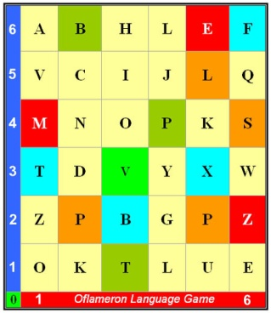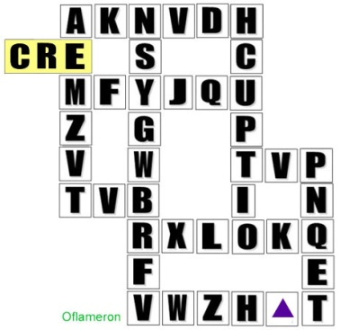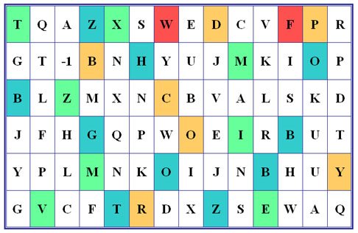
See http://www.shmeleff.com

buchen sie ein zimmer - book a room
buchensieeinzimmer - remove spaces
merbusieecheninzim - rearrange the fragments of words
Tape for printing
merbusieecheninzim

You need to cut the tape into fragments, and to make a phrase “buchen sie ein zimmer”
ein taxi rufen - to call a taxi
eintaxirufen - remove spaces
- rearrange the fragments of words
Tape for printing
taufenxirein

You need to cut the tape into fragments, and to make a phrase “ein taxi rufen”

How to learn. Example 2
taufenxirein

- cut the tape

ein taxi rufen
- make a
phrase

You need to cut the tape into fragments, and to make a phrase “ein taxi rufen”
mittagessen für drei - lunch for three
mittagessenfürdrei - remove spaces
dreimitessentagfür - rearrange the fragments of words
Tape for printing
dreimitessentagfür

You need to cut the tape into fragments, and to make a phrase “mittagessen für drei”
zu senden per post - to send by post
zusendenperpost - remove spaces
perpsendzuenost - rearrange the fragments of words
Tape for printing
perpsendzuenost

You need to cut the tape into fragments, and to make a phrase “zu senden per post”
© by Valery V Shmeleff http://www.shmeleff.com http://www.oflameron.ru

