OFLAMERON - technology for learning foreign words http://www.shmeleff.com
Print the tape with the text (text box). The student must correctly divide the tape into fragments and make of them a phrase in Spanish
abrir un depósito - open a deposit
English
Spanish
abrirundepósito - remove spaces
deabrirsitounpó - rearrange the fragments of words
Tape for printing
deabrirsitounpó
- tape for print

You need to cut the tape into fragments, and to make a phrase “abrir un depósito”
alquilar un coche - rent a car
alquilaruncoche - remove spaces
chealquiruncola - rearrange the fragments of words
Tape for printing
chealquiruncola
- tape

You need to cut the tape into fragments, and to make a phrase “alquilar un coche”
obtener dinero en efectivo - get cash
obtenerdineroenefectivo - remove spaces
roenedinobtenerefectivo - rearrange the fragments of words
Tape for printing
roenedinobtenerefectivo

You need to cut the tape into fragments, and to make a phrase “obtener dinero en efectivo”
dos entradas - two tickets
dosentradas - remove spaces
dasentrados - rearrange the fragments of words
Tape for printing
dasentrados

You need to cut the tape into fragments, and to make a phrase “dos entradas”

How to learn. Example
sageyerunenvomes
envoyer un message

llamar a un taxi - call a taxi
llamarauntaxi - remove spaces
unxitallamara - rearrange the fragments of words
Tape for printing
unxitallamara
- tape

You need to cut the tape into fragments, and to make a phrase “llamar a un taxi”
dos días - two days
dosdías - remove spaces
asdosdí - rearrange the fragments of words
Tape for printing
asdosdí

You need to cut the tape into fragments, and to make a phrase “dos días”
cómo llegar - how to reach
cómollegar - remove spaces
legcólarmo - rearrange the fragments of words
Tape for printing
legcólarmo
- tape

You need to cut the tape into fragments, and to make a phrase “cómo llegar”
enviar un mensaje - send a message
enviarunmensaje - remove spaces
menviarenunsaje - rearrange the fragments of words
Tape for printing
menviarenunsaje

You need to cut the tape into fragments, and to make a phrase “enviar un mensaje”
cuánto es - how much is
cuántoes - remove spaces
ántoescu - rearrange the fragments of words
Tape for printing
ántoescu
- tape

You need to cut the tape into fragments, and to make a phrase “cuánto es”
cómo llegar - how to get
cómollegar - remove spaces
ollcóegarm - rearrange the fragments of words
Tape for printing
ollcóegarm

You need to cut the tape into fragments, and to make a phrase “cómo llegar”
para el equipaje - to luggage
paraelequipaje - remove spaces
uipeleqparaaje - rearrange the fragments of words
Tape for printing
uipeleqparaaje
- tape

You need to cut the tape into fragments, and to make a phrase “para el equipaje”
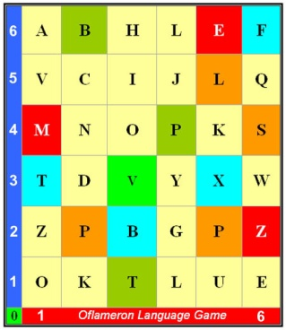 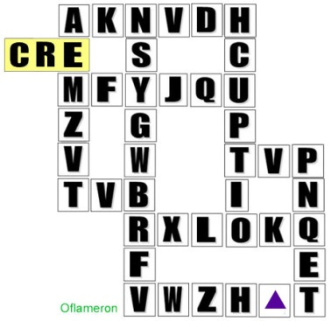 See http://www.shmeleff.com

para obtener una visa - to obtain a visa
paraobtenerunavisa - remove spaces
rusapanaviraobtene - rearrange the fragments of words
Tape for printing
rusapanaviraobtene

You need to cut the tape into fragments, and to make a phrase “para obtener una visa”
obtener asesoramiento - get advice
obtenerasesoramiento - remove spaces
mientosestenoberaora - rearrange the fragments of words
Tape for printing
mientosestenoberaora

You need to cut the tape into fragments, and to make a phrase “obtener asesoramiento”

How to learn. Example 2
ntapeleapruxi
appeler un taxi

- cut the tape

- make a phrase

You need to cut the tape into fragments, and to make a phrase “appeler un taxi”
la contraseña para conectarse - password to connect
lacontraseñaparaconectarse - remove spaces
señectalacontraaparaconrse - rearrange the fragments of words
Tape for printing
señectalacontraaparaconrse

You need to cut the tape into fragments, and to make a phrase “la contraseña para conectarse”
encender la luz - turn on the light
encenderlaluz - remove spaces
luzenderlacen - rearrange the fragments of words
Tape for printing
luzenderlacen

You need to cut the tape into fragments, and to make a phrase “encender la luz”
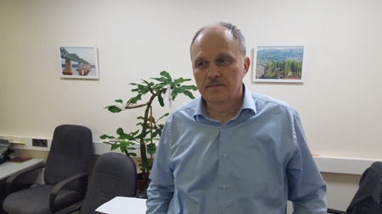
© by Valery V Shmeleff http://www.shmeleff.com http://www.oflameron.ru
Blog http://bretell.blogspot.com/

