OFLAMERON - technology for learning foreign words http://www.shmeleff.com
Print the tape with the text (text box). The student must correctly divide the tape into fragments and make of them a phrase in Spanish
por supuesto - of course
Spanish (learn)
English (native)
porsupuesto - remove spaces
stosupporue - rearrange the fragments of words
Tape for printing
stosupporue
- tape for print

You need to cut the tape into fragments, and to make a phrase “por supuesto”
cuál es tu nombre - what is your name
cuálestunombre - remove spaces
brelestcuáunom - rearrange the fragments of words
Tape for printing
brelestcuáunom

You need to cut the tape into fragments, and to make a phrase “cuál es tu nombre”
la estación de tren - train station
laestacióndetren - remove spaces
estalatrenciónde - rearrange the fragments of words
Tape for printing
estalatrenciónde
- tape

You need to cut the tape into fragments, and to make a phrase “la estación de tren”
Cuál es la especial del día? - What is today’s special?
cuáleslaespecialdeldía - remove spaces
deldíalaecuálesspecial - rearrange the fragments of words
Tape for printing
deldíalaecuálesspecial

You need to cut the tape into fragments, and to make a phrase “Cuál es la especial del día”

How to learn. Example
sageyerunenvomes
envoyer un message

Qué hora es? - What time is it?
quéhoraes - remove spaces
eshoraqué - rearrange the fragments of words
Tape for printing
eshoraqué
- tape

You need to cut the tape into fragments, and to make a phrase “Qué hora es”
No me siento bien - I don't feel good
nomesientobien - remove spaces
bienesiennomto - rearrange the fragments of words
Tape for printing
bienesiennomto

You need to cut the tape into fragments, and to make a phrase “No me siento bien”
Me siento enfermo - I feel sick
mesientoenfermo - remove spaces
sienmefermotoen - rearrange the fragments of words
Tape for printing
sienmefermotoen
- tape

You need to cut the tape into fragments, and to make a phrase “Me siento enfermo”
Mi nombre es - My name is
minombrees - remove spaces
reesnomimb - rearrange the fragments of words
Tape for printing
reesnomimb

You need to cut the tape into fragments, and to make a phrase “Mi nombre es”
De donde eres? - Where are you from?
dedondeeres - remove spaces
eresdondede - rearrange the fragments of words
Tape for printing
eresdondede
- tape

You need to cut the tape into fragments, and to make a phrase “De donde eres”
estancias de una semana - staying for one week
estanciasdeunasemana - remove spaces
semaciasdestaneunana - rearrange the fragments of words
Tape for printing
semaciasdestaneunana

You need to cut the tape into fragments, and to make a phrase “estancias de una semana”
Muchas gracias - Thank you very much
muchasgracias - remove spaces
sgracmuiascha - rearrange the fragments of words
Tape for printing
sgracmuiascha
- tape

You need to cut the tape into fragments, and to make a phrase “Muchas gracias”
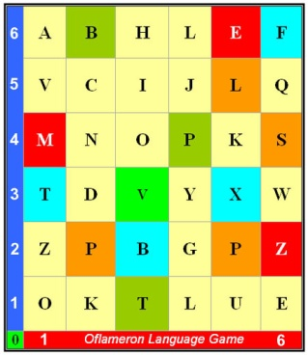 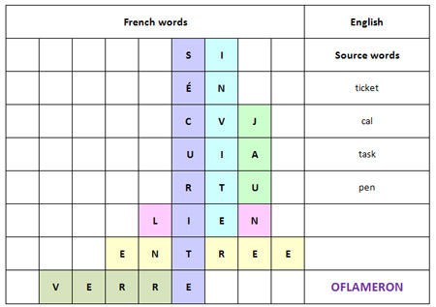 See http://www.shmeleff.com

Usted es bienvenido - You are welcome
ustedesbienvenido - remove spaces
vendesbusteienido - rearrange the fragments of words
Tape for printing
vendesbusteienido

You need to cut the tape into fragments, and to make a phrase “Usted es bienvenido”
Entiende usted ? - Do you understand?
entiendeusted - remove spaces
teddeusentien - rearrange the fragments of words
Tape for printing
teddeusentien

You need to cut the tape into fragments, and to make a phrase “Entiende usted”

How to learn. Example 2
ntapeleapruxi
appeler un taxi

- cut the tape

- make a phrase

You need to cut the tape into fragments, and to make a phrase “appeler un taxi”
Sí, yo entiendo que - Yes, I understand
sí,yoentiendoque - remove spaces
tiendoquesíyoen - rearrange the fragments of words
Tape for printing
tiendoquesíyoen

You need to cut the tape into fragments, and to make a phrase “Sí, yo entiendo que”
Lo siento - I am sorry
losiento - remove spaces
tosienlo - rearrange the fragments of words
Tape for printing
tosienlo

You need to cut the tape into fragments, and to make a phrase “Lo siento”
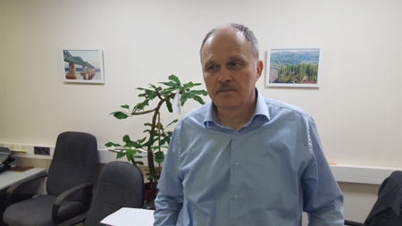
© by Valery V Shmeleff http://www.shmeleff.com http://www.oflameron.ru
Blog http://bretell.blogspot.com/

