OFLAMERON - technology for learning foreign words http://www.shmeleff.com
Print the tape with the text (text box). The student must correctly divide the tape into fragments and make of them a phrase in French
ouvrir un dépôt - open a deposit
English
French
ouvrirundépôt - remove spaces
pôtvrirunoudé - rearrange the fragments of words
Tape for printing
pôtvrirunoudé
- tape for print

You need to cut the tape into fragments, and to make a phrase “ouvrir un dépôt”
louer une voiture - rent a car
louerunevoiture - remove spaces
voituerulounere - rearrange the fragments of words
Tape for printing
voituerulounere

You need to cut the tape into fragments, and to make a phrase “louer une voiture”
obtenir de l'argent - get cash
obtenirdel'argent - remove spaces
del'atenobirrgent - rearrange the fragments of words
Tape for printing
del'atenobirrgent
- tape

You need to cut the tape into fragments, and to make a phrase “obtenir de l'argent”
deux billets - two tickets
deuxbillets - remove spaces
letuxbidels - rearrange the fragments of words
Tape for printing
letuxbidels

You need to cut the tape into fragments, and to make a phrase “deux billets”

How to learn. Example
sageyerunenvomes
envoyer un message

appeler un taxi - call a taxi
appeleruntaxi - remove spaces
untapelaperxi - rearrange the fragments of words
Tape for printing
untapelaperxi
- tape

You need to cut the tape into fragments, and to make a phrase “appeler un taxi”
deux jours - two days
deuxjours - remove spaces
ursuxjode - rearrange the fragments of words
Tape for printing
ursuxjode

You need to cut the tape into fragments, and to make a phrase “deux jours”
comment arriver à - how to reach
commentarriverà - remove spaces
rivemencomtarrà - rearrange the fragments of words
Tape for printing
rivemencomtarrà
- tape

You need to cut the tape into fragments, and to make a phrase “comment arriver à”
envoyer un message - send a message
envoyerunmessage - remove spaces
ageunmevoyenerss - rearrange the fragments of words
Tape for printing
ageunmevoyenerss

You need to cut the tape into fragments, and to make a phrase “envoyer un message”
combien coûte - how much is
combiencoûte - remove spaces
ûtembieconco - rearrange the fragments of words
Tape for printing
ûtembieconco
- tape

You need to cut the tape into fragments, and to make a phrase “combien coûte”
comment se rendre - how to get
commentserendre - remove spaces
mentrencomsedre - rearrange the fragments of words
Tape for printing
mentrencomsedre

You need to cut the tape into fragments, and to make a phrase “comment se rendre”
récupérer vos bagages - to luggage
récupérervosbagages - remove spaces
garévosbacupérerges - rearrange the fragments of words
Tape for printing
garévosbacupérerges
- tape

You need to cut the tape into fragments, and to make a phrase “récupérer vos bagages”
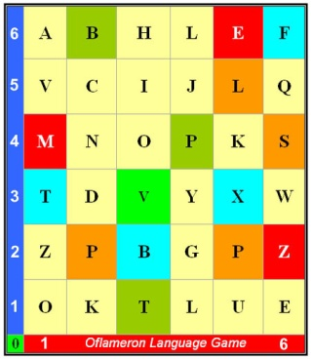 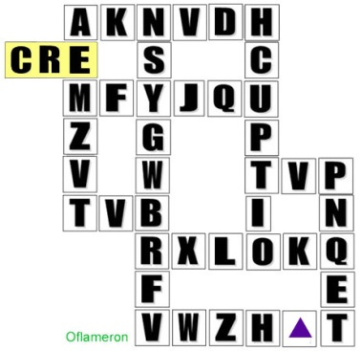 See http://www.shmeleff.com

obtenir un visa - to obtain a visa
obtenirunvisa - remove spaces
vistenobiruna - rearrange the fragments of words
Tape for printing
vistenobiruna

You need to cut the tape into fragments, and to make a phrase “obtenir un visa”
obtenir des conseils - get advice
obtenirdesconseils - remove spaces
scontenobirdeseils - rearrange the fragments of words
Tape for printing
scontenobirdeseils

You need to cut the tape into fragments, and to make a phrase “obtenir des conseils”

How to learn. Example 2
ntapeleapruxi
appeler un taxi

- cut the tape

- make a phrase

You need to cut the tape into fragments, and to make a phrase “appeler un taxi”
passe de connexion - password to connect
passedeconnexion - remove spaces
nexsedepasconion - rearrange the fragments of words
Tape for printing
nexsedepasconion

You need to cut the tape into fragments, and to make a phrase “passe de connexion”
allumer la lumière - turn on the light
allumerlalumière - remove spaces
lumalemièrlalure - rearrange the fragments of words
Tape for printing
lumalemièrlalure

You need to cut the tape into fragments, and to make a phrase “allumer la lumière”
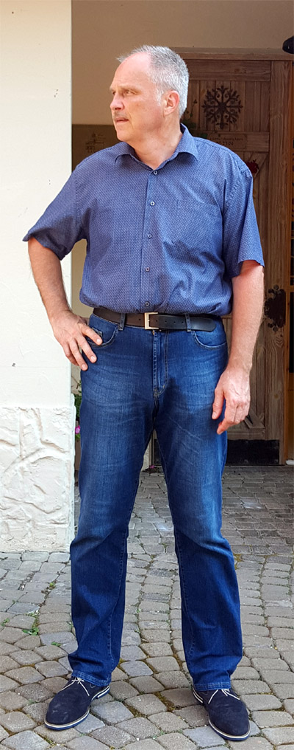
© by Valery V Shmeleff http://www.shmeleff.com http://www.oflameron.ru
Blog http://bretell.blogspot.com/

