Khan–Sharif rivalry:-
Between 2011 and 2013, Khan and Nawaz Sharif began to engage each other in a bitter feud. The rivalry between the two leader grew in late 2011 when Khan addressed his largest crowd at Minar-e-Pakistan in Lahore. From 26 April 2013, in the run up to the elections, both the PML-N and the Pakistan Tehreek-e-Insaf started to criticize each other.
2013 elections campaign:-
On 21 April 2013 Khan launched his final public relations campaign for 2013 elections from Lahore where he addressed thousands of supporters at The Mall, Lahore. He announced that he would pull Pakistan out of the U.S.-led war on terror and bring peace in the Pashtun tribal belt. Khan addressed different public meetings in Malakand, Lower Dir District, Upper Dir District and other cities of the Pakistan where he announced that PTI will introduce uniform education system in which the children of rich and poor will have equal opportunities. Khan ended his south Punjab campaign by addressing rallies at Bahawalpur, Khanpur, Sadiqabad, Rahim Yar Khan and Rajanpur. Khan ended campaign by addressing a rally of supporters in Islamabad via a video link while lying on a bed at a hospital in Lahore. According to the last survey before the elections by The Herald showed 24.98 percent of voters nationally planned to vote for his party, just a whisker behind former prime minister Nawaz Sharif’s Pakistan Muslim League (PML-N). On 7 May, just four days before the elections, Khan was rushed to ShaukatKhanum hospital in Lahore after he tumbled from a forklift at the edge of a stage and fell headfirst to the ground. He survived. Pakistan's 2013 elections were held on 11 May 2013 throughout the country. The elections resulted in a clear majority of Pakistan Muslim League (N). Khan's PTI also emerged as the second largest party in Karachi Khan's party PTI won 30 directly elected parliamentary seats.

Khyber Pakhtunkhwa Government:-
Khan's party swooped the militancy-hit northwestern Khyber Pakhtunkhwa, and has formed the provincial government. PTI-led Khyber Pakhtunkhwa government presented a balanced, tax-free budget for the fiscal year 2013-14.

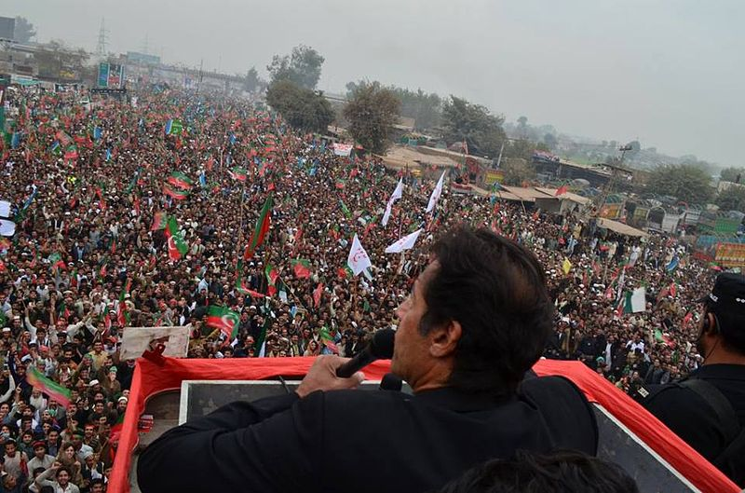

In Opposition:-
Khan led Pakistan Tehreek-e-Insaf became the opposition party in Punjab and Sindh. Khan became the parliamentary leader of his party. On 31 July 2013 Khan was issued a contempt of court notice for allegedly criticizing the superior judiciary, and his use of word "shameful" for the judiciary. The notice was discharged after Khan submitted before the Supreme Court that he criticized the lower judiciary for their actions during the May 2013 General election while those judicial officers working as returning officers.

Action against Ministers of QaumiWatan Party:-
On 13 November 2013, Imran Khan being party leader, ordered Chief Minister KPK to dismiss ministers of QaumiWatan Party who were involved in corruption. BakhtBaidar and IbrarHussanKamoli of QaumiWatan Party were ministers for Manpower & Industry and Forest & Environment respectively, were dismissed. Khan ordered Chief Minister KPK to end the alliance with QaumiWatan Party. Chief Minister KPK also dismissed Minister for Communication and Works of PTI "YousufAyub" due to fake degree. It happened for first time in Pakistan history.

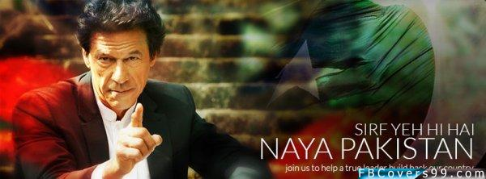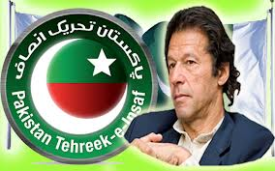
Back TO Previous Page Back To Home

