CRICKET CAREER
Khan made a lackluster first-class cricket debut at the age of sixteen in Lahore. By the start of the 1970s, he was playing for his home teams of Lahore A (1969–70), Lahore B (1969–70), Lahore Greens (1970–71) and, eventually, Lahore (1970–71). Khan was part of University of Oxford's Blues Cricket team during the 1973–1975 seasons. At Worcestershire, where he played county cricket from 1971 to 1976, he was regarded as only an average medium-pace bowler. During this decade, other teams represented by Khan included Dawood Industries (1975–1976) and Pakistan International Airlines (1975–1976 to 1980–1981). From 1983 to 1988, he played for Sussex.
Khan made his test cricket debut against England in 1971 in the city of Birmingham. Three years later, he debuted in the One Day International (ODI) match, once again playing against England at Nottingham for the Prudential Trophy. After graduating from Oxford and finishing his tenure at Worcestershire, he returned to Pakistan in 1976 and secured a permanent place on his native national team starting from the 1976–1977 season, during which they faced New Zealand and Australia.Following the Australian series, he toured the West Indies, where he met Tony Greig, who signed him up for Kerry Packer's World Series Cricket. His credentials as one of the fastest bowlers of the world started to become established when he finished third at 139.7 km/h in a fast bowling contest at Perth in 1978, behind Jeff Thomson and Michael Holding, but ahead of Dennis Lillee, Garth Le Roux and Andy Roberts.
As a fast bowler, Khan reached the peak of his powers in 1982. In 9 Tests, he got 62 wickets at 13.29 each, the lowest average of any bowler in Test history with at least 50 wickets in a calendar year. In January 1983, playing against India, he attained a Test bowling rating of 922 points. Although calculated retrospectively (ICC player ratings did not exist at the time), Khan's form and performance during this period ranks third in the ICC's All-Time Test Bowling Rankings.
Khan achieved the all-rounder's triple (securing 3000 runs and 300 wickets) in 75 Tests, the second fastest record behind Ian Botham's 72. He is also established as having the second highest all-time batting average of 61.86 for a Test batsman playing at position 6 of the batting order. He played his last Test match for Pakistan in January 1992, against Sri Lanka at Faisalabad. Khan retired permanently from cricket six months after his last ODI, the historic 1992 World Cup final against England at Melbourne, Australia. He ended his career with 88 Test matches, 126 innings and scored 3807 runs at an average of 37.69, including six centuries and 18 fifties. His highest score was 136 runs. As a bowler, he took 362 wickets in Test cricket, which made him the first Pakistani and world's fourth bowler to do so. In ODIs, he played 175 matches and scored 3709 runs at an average of 33.41. His highest score remains 102 not out. His best ODI bowling is documented at 6 wickets for 14 runs.
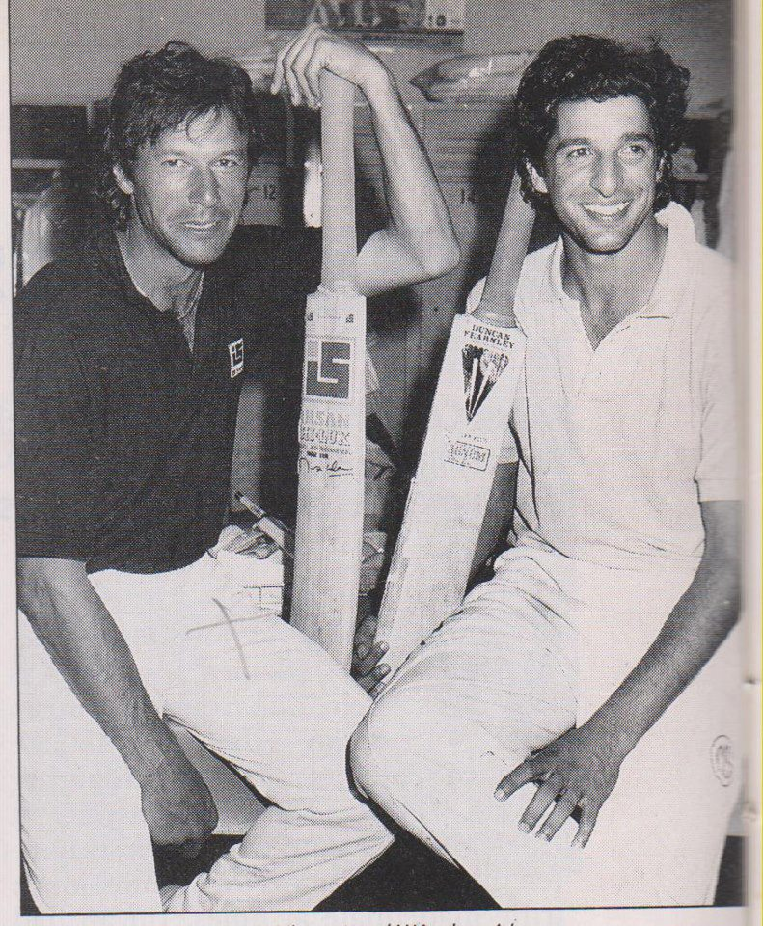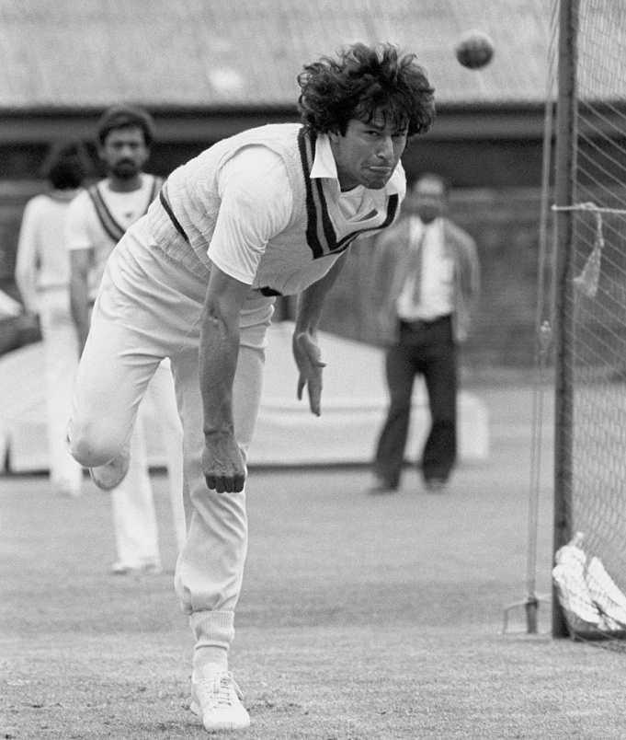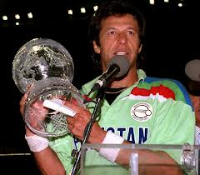
Imran Khan With Wasim Akram Imran Khan In Training Net Session Imran Khan With World Cup 1992

Back To Previous Page Go To Next Page Back To Home

