Home
Politics
Cricket Career
Background
History
Home

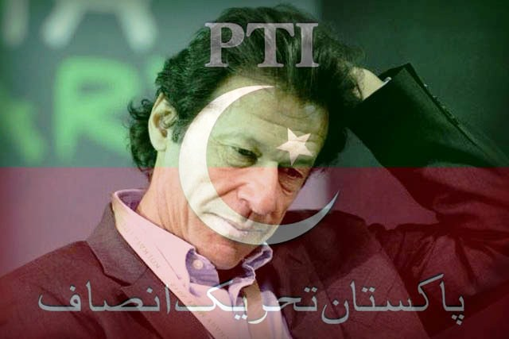

http://www.umt.edu.pk
http://www.pu.edu.pk

