Ejercicio de Visual Basic net

Crearemos una aplicación que nos permitirá ejecutar aplicaciones de Windows 7, office2010 y usar nuestro navegador

Primero Generamos el formulario

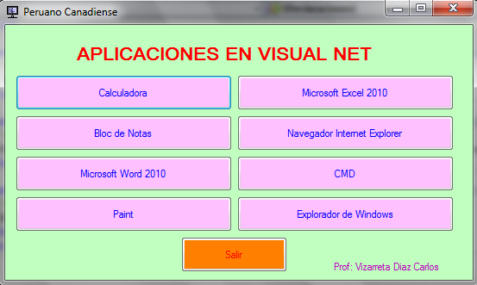

Luego ingresaremos el código

Public Class Form1
Private Sub btncal_Click(ByVal sender As System.Object, ByVal e As System.EventArgs) Handles btncal.Click
'Ejecutar la Calculadora
Shell("C:\WINDOWS\system32\calc.exe", AppWinStyle.NormalFocus)
End Sub

Private Sub btnPaint_Click(ByVal sender As System.Object, ByVal e As System.EventArgs) Handles btnPaint.Click
'Ejecutar Paint
Shell("C:\WINDOWS\system32\mspaint.exe", AppWinStyle.MaximizedFocus)
End Sub

Private Sub btncmd_Click(ByVal sender As System.Object, ByVal e As System.EventArgs) Handles btncmd.Click
'Ejecutar CDM
Shell("C:\WINDOWS\system32\cmd.exe", AppWinStyle.MaximizedFocus)
End Sub

Private Sub btnSalir_Click(ByVal sender As System.Object, ByVal e As System.EventArgs) Handles btnSalir.Click
'Boton para cerrar la aplicación
Me.Close()
End Sub

Private Sub btnBN_Click(ByVal sender As System.Object, ByVal e As System.EventArgs) Handles btnBN.Click
'Ejecutar el BLoc de notas
Shell("C:\WINDOWS\system32\notepad.exe", AppWinStyle.NormalFocus)
End Sub

Private Sub btnword_Click(ByVal sender As System.Object, ByVal e As System.EventArgs) Handles btnword.Click
'Ejecutar microsoft word
Shell("C:\Program Files\Microsoft Office\Office14\winword.exe", AppWinStyle.NormalFocus)
End Sub

Private Sub btnexcel_Click(ByVal sender As System.Object, ByVal e As System.EventArgs) Handles btnexcel.Click
'Ejecutar excel
Shell("C:\Program Files\Microsoft Office\Office14\excel.exe", AppWinStyle.NormalFocus)
End Sub

Private Sub btnnav_Click(ByVal sender As System.Object, ByVal e As System.EventArgs) Handles btnnav.Click
'Ejecutar internet explorer
Shell("C:\Program Files\Internet Explorer\iexplore.exe", AppWinStyle.NormalFocus)
End Sub

Private Sub btnWE_Click(ByVal sender As System.Object, ByVal e As System.EventArgs) Handles btnWE.Click
'Ejecutar el Explorador de Windows
Shell("C:\WINDOWS\explorer.exe", AppWinStyle.MaximizedFocus)
End Sub
End Class

