Practice de Visual Net

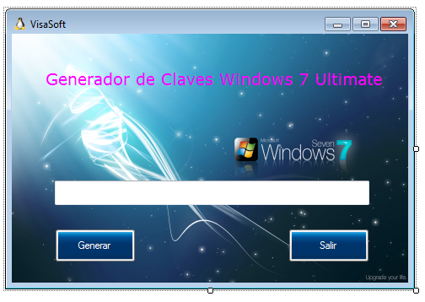

Public Class Form1
Private Sub Button2_Click(ByVal sender As System.Object, ByVal e As System.EventArgs) Handles Button2.Click
End
End Sub

Private Sub Button1_Click_1(ByVal sender As System.Object, ByVal e As System.EventArgs) Handles Button1.Click
TextBox1.Text = Int(Rnd() * 6)
Select Case TextBox1.Text
Case 0
TextBox1.Text = "767JC-MJ8G9-PF6W2-W4RDM-B8HRJ "
Case 1
TextBox1.Text = " GMMVB-CR2MG-MVKBH-VV94Q-6KHBQ "
Case 2
TextBox1.Text = " KC4MB-4W66J-CG4TP-YRKMC-2F6YC"
Case 3
TextBox1.Text = " BX2H2-GY94K-FQFJY-FXDY6-XQHV4"
Case 4
TextBox1.Text = " YK9G6-HKY7V-CBHFD-X2BFP-29BQJ "
Case 5
TextBox1.Text = " KB8WD-H4C2B-28C6Q-8RQQ6-KB96T "
End Select
End Sub
End Class

