2015
CARRICULUM VITAE

Masters in Engineering- VLSI & EMBEDDED SYSTEMS
(University of PUNE)

Er. VipinKumar Rajendra Pawar
www.vipinpawar.in
Contact -: +91-78 75 899873

E-Mail -: me@vipinpawar.in


MEMBERSHIP NO MEMBERSHIP NO MEMBERSHIP NO MEMBERSHIP NO

8545093 92821262 156484 AP-536

HONGKONG
USA
USA
USA
USA
यंत्र तंत्रादि विज्ञानम, लोक-कल्याणम् साधनम:


In quest of provide good knowledge in Technology with
an organization of high repute.

SYNOPSIS

Proficient at executing good safety and health improvement practices for optimum utilization of resources and providing them with a safe working environment. Excellent interpersonal & negotiation skills with strong problem solving & organizational abilities.
KEY SKILLS

RESEARCH & DEVELOPEMENT QUALITY CONTROL MAINTENANCE

TEAM MANAGEMENT TRESS MANAGEMENT PSYCHOLOGY COUNSELING

INTERNAL AUDITOR INTELLECTUAL PROPERTY RIGHTS

HIGHLIGHTED PROFILE

- Invited as RESOURCE PERSON for
- Workshop on “Microcontroller & Embedded Systems”(Dec’2015):- One day workshop conducted by Kadwa polytechnic, Rajaramnagar, Dist. Nashik
- Technical Paper Presented at National level ePG-Conference-2014 on “Wireless Rescue Caller & Data Analyzer” at K.K.Wagh College of Engineering & Research Centre, Nashik
- State Level Workshop on “PCB ARTWORK DESIGN”(25th & 26th Nov’2013):- State Level Two days workshop conducted by Sandip Polytechnic, Mahiravani, Dist. Nashik
- Workshop on “Embedded Systems & PCB Design”(25th & 26th Nov’2013):- One day workshop conducted by Kashinath Mengal Polytechnic, Ghoti, Dist. Nashik

RESEARCH PUBLICATIONS

Research Paper  Published/Present | Details
Paper Published on “Emotion Recognition from Hindi Speech using MFCC and Sparse DTW” | International Journal of Engineering Research & Technology (IJERT)/ ISSN: 2278-0181/ Volume. 4 - Issue. 06 , June - 2015
Paper Published on “Introduction-Wireless Local Area Sensor  Network Protocol for Rescue Calling” | International Journal of Engineering Research & Technology (IJERT)/ ISSN: 2278-0181/ Vol. 3 Issue 6, June - 2014
Paper Presented on “Wireless Rescue Caller & Data Analyzer” | ePG-Conference-2014 at K.K.Wagh College of Engineering & Research Centre, Nashik

TECHNICAL PROFILE

Research & Development
- Introduced innovative ideas for maintaining the Production & Quality ratio
- Maintaining the Quality as per Industrial Standards.
- Developing complex and tiny circuits for cost effectiveness and efficient.
- Improving quality level of Design through updated reference book, Software & training programs related to Design..
- Giving priority for Client requirement & Satisfaction.
PCB Designing
- Solving all types of curries regarding PCB Layout.
- Maintaining the Production ratio.
- Single sided and for complex design, double OR multilayered PCB can be design.
- Improving quality level of Design through updated reference book, Software & training programs related to PCB artwork Design..
- Giving priority for Client requirement & Satisfaction.
Management
- Improving contacts & relations with fastest growing firm to provide good quality of service.
- Organize Client and Vendor meetings & event for better result & good reputation.
- Organizing practical and theoretical training programs to enhance skills and motivational levels.
- Maintaining the discipline and happy environment for team members.
- Improving the skill and work efficiency of team
Interpersonal Skill
- Ability to handle large scale team
- Ability to handle all problems in team.
- Ability to plan the project as per the available team with its skills.
- Maintaining the discipline and happy environment for team members.
- Improving the skill and work efficiency of team

PROFESSIONAL JOURNY

- ORGANIZATION | -:Sanghavi College of Engineering, NAshik
- DURATION | -:June 2014 to Till Date
- DESIGNATION | -:Assistant Professor
- KEY DELIVERABLE | - Knowledge of Documentation regarding Monitoring Committee, Student’s Records, Departmental Activity file, LAB utilization Files…etc  - Departmental Documentation.  - Laboratory establishment as per university rules.  - Knowledge of Subject, Team Management, Mentainance of Practical Equipments.  - Having great experience in University Exam Department  - Having best experience for event management (ANTARANG’15).
- ORGANIZATION | -: Shatabdi Engineering College & Research Centre
- DURATION | -:01 June 2012- May 2014
- DESIGNATION | -:Assistant Professor
- KEY DELIVERABLE | - Knowledge of Documentation regarding Monitoring Committee, Student’s Records, Departmental Activity file, LAB utilization Files…etc  - Knowledge of Subject, Team Management, Mentainance of Practical Equipments &documentation of Department.  - Conducting troubleshooting activities including training for students and testing of product  - Knowledge of instruments used for practical Assessment.
- ORGANIZATION | -:A.P.Enterprises(Bajaj Electrical Vendor Company)
- DURATION | -:01st November 2011 to 31st May 2012
- DESIGNATION | -: Plant Supervisor
- KEY DELIVERABLE | - Knowledge of Quality Control, Team Management, Mentainance & packaging Department.  - Supervising the shift to achieve daily production plan with desired quality of product.  - Conducting troubleshooting activities in daily Quality including training for workers and testing of product.  - Knowledge of instruments used for testing the product for Quality.  - Working with continuous improvement team.

ACADEMIC REPORT

COURSE | BRANCH / SPECIALIZATION | BOARD / UNIVERSITY | YEAR of Passing | %/CGPA
PhD | WSN | CENTRAL UNIVERSITY OF GUJRAT | PET CRACKED | NATIONAL RANKED 54
Masters in Engineering | VLSI & EMBEDDED SYETMS | University of PUNE | 2014 | 7.25 CGPA
Bachelors of Engineering | Electronics & Telecommunication | University of MUMBAI | 2011 | 60.19%.
HSC | Science | Maharashtra State Board | 2005 | 63.17%
SSC | Hindi-Sanskrit | Maharashtra State Board | 2003 | 62.66%
IT KEY SKILLS

SOFTWARE | SPECIFICATIONS | EXPER LEVEL out of 5(*****)
- MultiSim | : Electronics Circuit Simulation | *****
- ProteUs | : Digital Electronics Circuit  Simulation | *****
- Eagle PCB | : PCB layout designer software | *****
- Xilinx ISE | : VLSI based circuit simulation | **
- Microsoft Office | : Office documentation | ****
- EdSim51 | :Assembly Programmer for 8051 | *****
- MPLAB | :Assembly & C Programming for PIC Controllers | ****
- MATLAB | :Advanced Coding for Engineering | ***
- Keil MDK | : C Editor/Assembler/Debugger for 8051 & ARM7,9,10,11(CORTEX) | *****
- VISUAL STUDIO | Visual Basics IPE | ***

CERTIFICATES & ACHIEVEMENT
Certificate Topics | Workshop /seminar | Locations | Durations
MATLAB & It’s Applications | Workshop | Department of E&Tc Engg., Sandip Polytechnic, Nashik | 23rd & 24th January’2014
Artificial Neural Network | Seminar | SND College of Engineering & Research Centre, Yeola, Dist. Nashik | 8th & 9th March’2013
Web Designing | Diploma | IT Professionals, Nashik | 11th Oct. 2012 to 22nd January’2013
Hardware & Networking Engineering | Diploma | IT Professionals, Nashik | 11th Oct. 2012 to 11th December’2012
Embedded Robotics | Workshop | Department of Instrumentation Science, University of PUNE | 6th & 7th October’2012
Embedded Systems Developer | Diploma | PROLIFIC AUTOMATION, CHINCHWAD, PUNE | 11th July 2011 to 22nd Sep.’2011
Cisco Certificate Network Administration | Seminar | IETE Students forum and SMT. Indira Gandhi College of Engineering, Navi Mumbai | 16th April’2010
राष्ट्रभाषा बालबोधिनी | Competitive Exam | Maratha High School, Nashik | Sept.’1997

EMBEDDED SYSTEMS PROTOTYPES

- NAME OF PROJECT |  |  |  | -: WIRELESS RESCUE CALLER & DATA  ANALYZER
- KEY ROLE |  |  |  | -: Fire, Hazardous GAS leakage, Unauthorized Entry and  calls Ambulance, Police & Fire Brigade for Rescue  operation.
- TOOLS USED |  |  |  | -: Proteus, MultiSim, Eagle 6.1
- DETAILS |  |  |  | -: Especially Designed for Industrial as well as residential  areas for  providing alert message when accident is going to occurred  as Fire,  Hazardous GAS leakage, Unauthorized Entry and calls  Ambulance,Police & Fire Brigade for Rescue operation.
- NAME OF PROJECT |  |  | -: RS-232 to USB Serial Communication (Module)
- KEY ROLE |  |  | -: Designed for Laptops which do not have Serial port(DB-9  Connector).
- TOOLS USED |  |  | -: Proteus, Eagle 6.1
- DETAILS  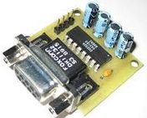 |  |  | -: Convert RS-232 serial data to USB synchronous Serial Data
- NAME OF PROJECT |  | -: Infrared Object Detector (Module)
- KEY ROLE |  | -: Object tracking, Counter circuit, Unauthorized entry  detectors..etc.
- TOOLS USED |  | -: Proteus, MultiSim, Eagle 6.1
- DETAILS 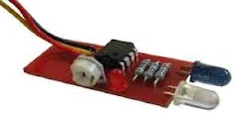 |  | -: Sense the object comes near to Module and gives positive  pulse toInterfacing Device like µC, µP, etc.
- NAME OF PROJECT |  |  | -: Remote Controlled HOME AUTOMATION  SYSTEM
- KEY ROLE |  |  | -: RC-05 Protocol Follower System
- TOOLS USED |  |  | -: Proteus, Eagle 6.1
- DETAILS 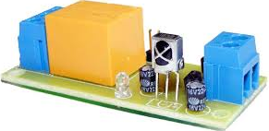 |  |  | -: RC-05 Protocol Follower systems can drive lots of Relays as  per the requirement of User/Consumer driven by  AT89C2051/AT89C89C51/AT89S52 µC.
- NAME OF PROJECT | -: UltraSonic Distance Tracker (Module)
- KEY ROLE | -: Sense the object comes near to Module and calculate the  distance in centimeter(cm.) & send the result to Computer  port via RS-232(DB-9)
- TOOLS USED | -: Proteus, Eagle 6.1
- DETAILS 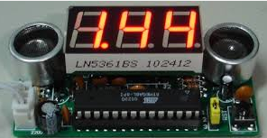 | -: Object tracking, Distance calculator..etc.
- NAME OF PROJECT | -: Anti-collision Vehicle Module
- KEY ROLE | -: Especially Designed for Industrial as well as residential trailer  or Car for preventing collision with wall/another vehicle
- TOOLS USED | -: Proteus, Eagle 6.1
- DETAILS 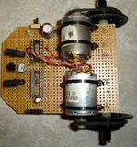 | -: Senses object come into the path of vehicle and automatically  Apply the breaks
- NAME OF PROJECT | -: Wireless Multiple Detector
- KEY ROLE | -: Especially Designed for Industrial as well as residential areas  for providing Alert message when accident is going to  occurred
- TOOLS USED | -: Proteus, Eagle 6.1
- DETAILS  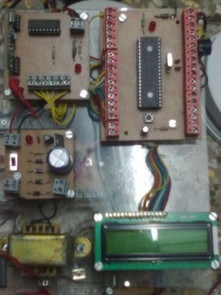 | -: Senses Fire, Hazardous GAS leakage, Unauthorized Entry and  Calls Ambulance, Police & Fire Brigade for Rescue operation.  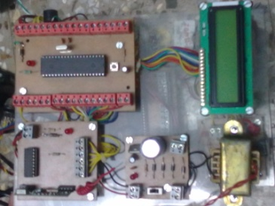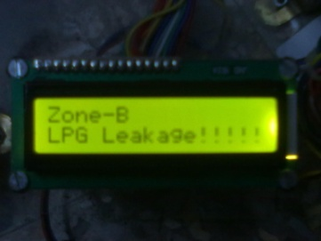
- NAME OF PROJECT | -: VKz 8x8 DOT Matrix LED Display
- KEY ROLE | -: AMS8X8AB is a kind of integrated serial input/ output common cathode display driver, it connects microprocessor and 8-digit seven period of digital LED display, also can be connected to the bar graph display or 64 independent LED. Easy to interface with arduino, Raspberry Pi or any other microcontroller.
- TOOLS USED | -: Proteus, Eagle 6.1
- DETAILS  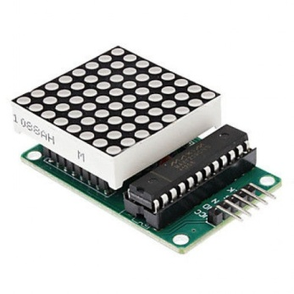 | -:  - Brand new AMS8X8AB Red LED Dot Matrix Module MCU Control Module  - A single module can drive one 8x8 common cathode lattice  - With 4 fixed screw holes for easy installation  - Module with input and output interfaces, supports multiple modules cascade  - Great for projects DIY
- NAME OF PROJECT | -: VKz LPC2148 ARM Header Board
- KEY ROLE | -: Low Cost Board that can be used to quickly evaluate and demonstrate the capabilities of NXP LPC2148 (ARM7TDMI) microcontroller.
- TOOLS USED | -: Proteus, Eagle 6.1
- DETAILS  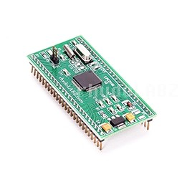 | -: The Header board is designed as DIP package with access to all Port pins for external connection. The LPC2148 ARM Header Board consists all basic components required to function the microcontroller. The board is populated with voltage regulators, RTC crystal ,Main Crystal and necessary de-coupling capacitors. Simply give 5V to the header; it will starts to execute your code!
- NAME OF PROJECT | -: VKzWireless Door Break Sensor
- KEY ROLE | -: Transmits unique ID for brief moment when magnet goes far of internal reed switch. Useful as door window entry wireless alarm. RF transmitter at 433 Mhz, around 100 meters range
- TOOLS USED | -: Proteus, Eagle 6.1
- DETAILS  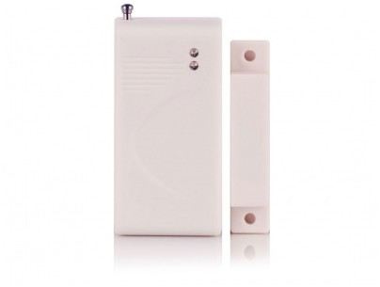 | -: Each unit has unique 32 bit ID, which is transmitted on 433 Mhz frequency upon detection of door/window opening. The sensing concept is magnetic reed switch which gets triggered when distance between two units increase more than 1.5cm. One unit has magnet inside and another has reed switch which senses the magnet.

PCB PROTOTYPES

DESIGN | COMPLEXITY | PCB MATERIAL
Sensor Node(Rescue Caller) | 2 Layer | Paper Phenolic
Master Node(Rescue Caller) | 2 layer | Paper Phenolic
Ultrasonic Distance Meter | 2 layer | Glass Epoxy
IR sensor(Home Automation) | 1 layer | Paper Phenolic
RS-232 to USB Serial Communication (Module) | 1 layer | Glass Epoxy
Infrared Object Detector (Module) | 1 layer | Paper Phenolic
Wireless Multiple Detector | 1 layer | Paper Phenolic
LED Emergency Lamp | 1 layer | Paper Phenolic
LED & 7-Segment combination module | 2 layer | Glass Epoxy
AT89C51RD2 Trainer Kit | 1 layer | Glass Epoxy
LED add-on card | 1 layer | Glass Epoxy
Anti-Collision Robot mother board | 2 layer | Glass Epoxy
DC Motor Controller (Module) | 1 Layer | Glass Epoxy
Robot car motherboard | 1 Layer | Paper Phenolic
Robotics SMPS | 2 layer | Glass Epoxy
Led matrix array decoder | 1 layer | Paper Phenolic
VKzWireless Door Break Sensor | 2 layer | Glass Epoxy
VKz LPC2148 ARM Header Board | 2 layer | Glass Epoxy
VKz 8x8 DOT Matrix LED Display | 1 layer | Paper Phenolic

PERSONAL INFORMATION

- FULL NAME | -:Er. VipinKumar Rajendra Pawar
- DATE OF BIRTH | -:18th August 1987
- BIRTH PLACE | -:Kopargaon, Dist. Ahamad Nagar, Maharashtra, India
- HOBBY | -: * TRAVELING  * DRIVING  * Reading Marathi Novels  * Net Surfing  * Walking  * Gardening
- PERMANENT ADDRESS | -: 4, Roop-Sangam society-B  Snehanagar, Dindori Road,  Mhasrul, Nashik, Maharashtra, INDIA-422004
- CONTACT NUMBER | -: +91-78 75 899873  -: (0253)2532396
- EMAIL | -:  me@vipinpawar.in  -:  vipinkumar.pawar@gmail.com  -:  vipinkumar_pawar@yahoo.co.in
- WEBSITE | -: www.vipinpawar.in
Place-: Nashik  Date-: / /201 |  | 

