CASE STUDY, MITROVICA, MARCH 2012
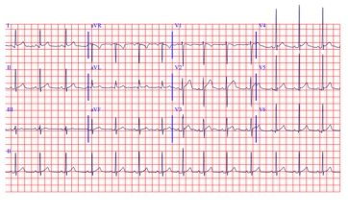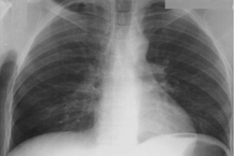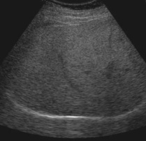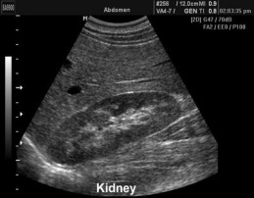
Patient , 43 years old , has been admitted into the ED with the signs of altered consciousness. He is in stupor, with the reaction (withdrawal) to stronger physical irritation (pinching, stretching). He reacts to loud calls by opening his eyes slightly and moaning single words, but is unable to formulate understandable sentences.
The patient lived alone. The emergency call was received from the house maid who came to the apartment twice a week, she could also tell to paramedics that the patient had diabetes, received tablets for lowering his blood glucose, but was otherwise well, except that during the last visit when he said to maid he was not feeling so good and felt tired but otherwise was conscious and mobile. Because of the increased bodyweight patient’s mobility was rather limited and he have been going out of his apartment only occasionally with the maid doing most of the acquisitions required.
She also provided some medical documentation on visits to the diabetologist one month ago; the last one shows morning glycemic level 15.2 mmol/l, Hgb A1c 7.5 %, triglyceride 5.7mmol/l, total cholesterol 8.1, HDL 1.36 and LDL cholesterol 5.12 mmol/l. Except for the mild anemia (er 3.500 000/ml, Hgb 105 mmol/l), and mild leucocitosis (12000/ml), other laboratory tests were within the normal range. The earlier prescribed therapy contained metformin (Gluformin 500 mg 3x1 tbl.), Cizalapril 5 PLUS (cilazaapril + hydrochlortyazide 17.5 mg) while sulfonylurea (Predian 2x1 tbl.) and pentoxyfilline (Trental 400mg 2x1) were introduced during the last visit to endocrinologist. No other known diseases were known to the maid. Hospital administrative services are about to contact his relatives and the endocrinologist whom he has been visiting in order to gain additional data.
TASK 1: ASSESS CONSCIOUSNESS IMPAIRMENT USING GLASGOW COMA SCALE
Glasgow Coma Scale is provided at http://www.mdcalc.com/glasgow-coma-scale-score/

The patient is in stupor, non-febrile, breathing normally with the respiratory rate of about 18-20/min, obese, his BMI 39 kg/m2 (body weight 115 kg, height 1.71) with no visible deformities. Skin is pale and dry and mucous membranes are very dry with no visible cyanosis.
The patient was in a messy state due to diarrhea with watery stools. He also had one stool during the transport to the hospital and vomited a little.
The skull is normally shaped with no visible deformities. The face is symmetric, including eyelids, the eyes are sunken, conjunctiva and sclera are normally colored but dry, the pupils react to light symmetrically, but somewhat sluggish. Ears and nose are symmetric, nostrils movements are normal and the canals are not obstructed. The oral mucous membranes are dry, the color is normal, upper surface of the tongue is white and coated. The neck is cylindrical, with no visible deformities. No palpable lymph nodes on neck were noticed. There is no visible thyroid enlargement, the consistency during palpation is normal. Thyroid is moving freely during swallowing. The carotid pulsations are normal, carotid pulse rate is 100/min, but jugular venous pulse pressure is decreased (hardly palpable).
The chest wall is cylindrical with no visible deformities. Respiratory movements are normal, including the intercostal spaces and diaphragm mobility. There is some diffuse percussion dullness due to the increased thickness of the fat tissue on the chest, but no focal changes. Respiratory auscultation reveals normal breathing sounds.
The heart frequency rate is 100/min, no rhythm disturbances were registered. Heart sounds are normal, no pathologic murmurs. TA=90/60 mmHg.
The abdomen is protuberant. No tenderness or masses were discovered. Liver span 7 cm in right mid-clavicular line; edge smooth, palpable 1 cm below right costal margin. Bowel sounds are hyperactive. Spleen and kidneys not felt. No costo-vertebral angle tenderness is noted. External genitalia show no lesions.
Extremities are cold and without edema. Metabolic signs negative. Withdrawal and flexion movements in response to pain are symmetrical. Passive resistance to movements is bilaterally normal. No involuntary movements were recognized. Moderate varicosities of saphenous veins both lower extremities. No stasis pigmentation or ulcers. Arterial pulses on lower extremities decreased.
Differential Diagnosis

Our considerations on differential diagnosis can be found on:
http://www.geocities.ws/urgentnamwu/CASE1/Case%201%20DIFFERENTIAL%20DIAGNOSIS.htm

TASK 2: CONSIDER DIFFERENTIAL DIAGNOSIS USING:
http://internamedicina.wikispaces.com/COMA%2C+DIFFERENTIAL+DIAGNOSIS .

- Fingertip stick measurement on admission revealed high blood glucose levels > 25 mmol/l
- ECG on admission:
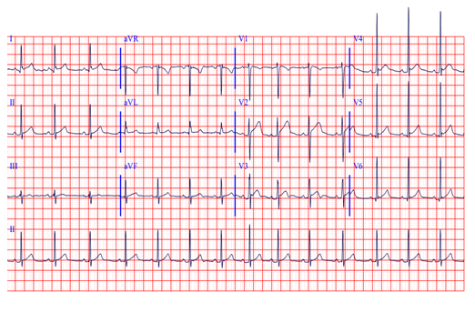
- Laboratory findings on admission:
- The basic hematologic analysis results (1 h after admission) can be found on:
http://www.geocities.ws/urgentnamwu/CASE1/Case1%20HEMATOLOGIC%20ANALYSIS%201h.htm
- The biochemistry analysis results (1h after admission) can be found on:
http://www.geocities.ws/urgentnamwu/CASE1/Case1%20Biochemical%20HHS.htm
- The urine analysis results (1h after admission) can be found on:
http://www.geocities.ws/urgentnamwu/CASE1/Case1%20URINARY%201h.htm

The referent values of common biochemistry analyses can be found on
http://themedicalbiochemistrypage.org/bloodtests.php

TASK 3: ASSESS URINE OUTPUT ml/kg/hour

- The acid-base parameters analysis (1h after admission) can be found on:
http://www.geocities.ws/urgentnamwu/CASE1/CASE1%20ACIDBASE%201h.htm
- The Serum lactate and ketone bodies analysis can be found on:
http://www.geocities.ws/urgentnamwu/CASE1/Serum%20lactate.htm
- The interpretation of the serum lactate values can be found on:
http://emedicine.medscape.com/article/768159-overview
- The interpretation of the serum ketone values can be found on:
http://type1diabetes.about.com/od/technologyandequipment/p/How-To-Read-Blood-Ketone-Test-Results.htm
http://emedicine.medscape.com/article/2087381-overview
http://emedicine.medscape.com/article/2087135-overview#aw2aab6b2

TASK 4: MAKE ASSESSMENT OF ACID-BASE STATUS USING http://harrisons.unboundmedicine.com/harrisons/ub/view/Harrisons-Manual-of-Medicine/148736/all/acid_base_disorders

- The serum electrolyte analysis results(1h after admission) can be found on:
http://www.geocities.ws/urgentnamwu/CASE1/Case1%20ELECTROLYTES%201h.htm
TASK 5: CALCULATE SERUM OSMOLALITY USING:
2Na (mmol/l) + serum glucose (mmol/l) + urea (mmol/l)
TASK 6: DOES THE PATIENT NEEDS INTRODUCTION OF CENTRAL VENOUS LINE
The criteria for installation of CVK are listed here:
http://www.geocities.ws/urgentnamwu/CASE1/Case1%20CRITERIA%20CVK.htm
TASK 7: CALCULATE ANION GAP USING
Anion Gap = Na - (Cl + HCO3-)
TASK 8: CONFIRM THE INITIAL DIAGNOSIS OF THE CONDITION USING:
http://www.geocities.ws/urgentnamwu/CASE1/Case1%20HHSvsDKA.htm

TASK 9: CALCULATE TOTAL BODY WATER DEFICIT USING
TBW deficit (L) = ( 0.6 * Wt * [(Na/140) - 1] )
TASK 10: CALCULATE WATER/ELECTROLYTE DEFICIT USING:
http://www.geocities.ws/urgentnamwu/CASE1/Case1%20AverageWEdeficit%20HHS.htm
TASK 11: PLAN FLUID RESUSCITATION FOR 24h USING:
http://www.geocities.ws/urgentnamwu/CASE1/Case1%20FLUIDsub%20HHS.htm
TASK 12: PLAN POTASSIUM SUBSTITUTION FOR FIRST 4 HOURS USING:
http://www.geocities.ws/urgentnamwu/CASE1/Case1%20POTASSIUMsub%20HHS.htm

First hour after the initiation of the therapy
Glycemia 33.2 MMOL/L
Urine output 65 ml
Ta 90/60 mmHg
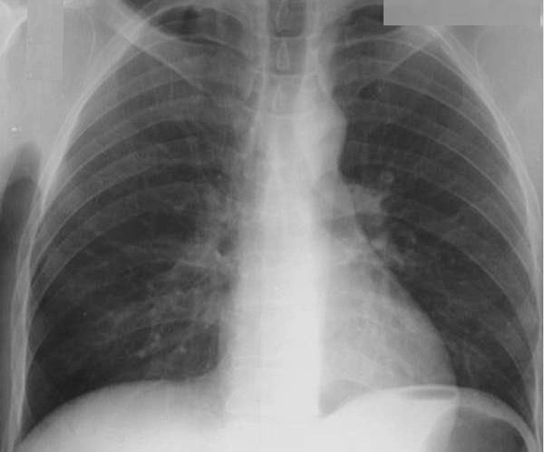
NEUROLOGIC EXAMINATION: Patient stuporous, no lateralizing signs, no pathologic reflexes. Meningeal signs negative. Dg: Metabolic coma.
TASK 13: PLAN THERAPY FOR THE NEXT HOUR
PRINCIPLES OF HHS THERAPY CAN BE FOUND ON: http://www.geocities.ws/urgentnamwu/CASE1/PRINCIPLES%20OF%20HHS%20THERAPY.htm
The referent values of common biochemistry analyses can be found on
http://themedicalbiochemistrypage.org/bloodtests.php

Second hour
Glycemia 33.0. mmol/l
Na++ 158 mmol/l
K+ 3.9
P—1.4
Mg++ 1.6
TA 95/60 mmHg
Urine output 75 ml
TASK 14: TITRATE I.V. INSULIN DOSE PER HOUR USING IV INFUSION PUMP OR VIA COUNTING DROPS/MIN USING FOLLOWING PROTOCOL FOR DIABETIC KETOACIDOSIS. http://www.geocities.ws/urgentnamwu/CASE1/Case1%20INSULIN.htm
PLAN THERAPY FOR THE NEXT HOUR.
Third hour
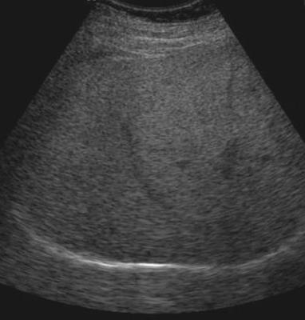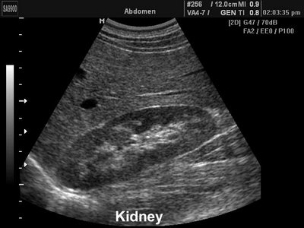
Abdominal ultrasound: liver moderately enlarged - 17.8cm on MCL, hyperechogenic (steatotic). Portal vein 1.3 cm. gallbladder 3.0 cm, gallbladder wall 2.8mm. Spleen 12cm. Pancreas could not be seen. Kidneys bilaterally enlarged (15 and 15.5cm, respectively) but otherwise normal.
Glycemia 29.5 mmol/l
Na+ 153 mmol/l
K+ 3,6 mmol/l
Urine output 80 ml
pH 7.35
PCO2 39
PO2 87
SO2 98%
Serum bicarbonates 25mmol/l
Serum lactate 2.8 mmol/l
Blood ketones 1.7 mmol/l
3-OH butyrate 1.5 mmol/l
TA 95/70 mmHg
TASK 15: PLAN THERAPY FOR THE NEXT HOUR

Fourth hour
Glycemia 24.1
Na+147
K+ 3.8
Urea 12.8
Creatinine 149
Urine output 85ml
TA 100/65 mmHg
TASK 16: PLAN THERAPY FOR THE NEXT HOUR

Fourth hour
Glycemia 24.1
Na+147
K+ 3.8
Urea 12.8
Creatinine 149
Urine output 85ml
TA 100/65 mmHg
TASK 17: PLAN THERAPY FOR THE NEXT HOUR
Fifth hour
Glycemia 21.3 mmol/l
Urine output 85 ml
TASK 18: PLAN THERAPY FOR THE NEXT HOUR
Sixth hour
Glycemia 17,9 mmol/l
Na+ 146 mmol/l
K+ 4.0
pH 7.38
PO2 87
PCO2 38
SO2 98
Serum bicarbonates 30 mmol/l
Urine output 90ml
TA 100/70 mmHg
TASK 19: PLAN THERAPY FOR THE NEXT HOUR
Seventh hour
Glycemia 14.4 mmol/l
Urine output 90 ml
TA 110/70 mmHg
TASK 20: PLAN THERAPY FOR THE NEXT HOUR

Eight hour
Na+ 144
K+ 4.2
pH 7.38
PO2 38
PCO2 38
SO2 97
Serum bicarbonates 32 mmol/l
Serum lactate 3.9 mmol/l
Blood ketones 1.1mmol/l
3-OH butyrate 0.9 mmol/l
TA 110/70 mmHg
TASK 21: Despite the good progression in TBW resuscitation, a fall in serum osmolality, improvement of the acid-base parameters and serum electrolytes, fall in serum ketones, the patient is still unconscious, and there is some unexpected rise in serum lactate levels. What would you do?

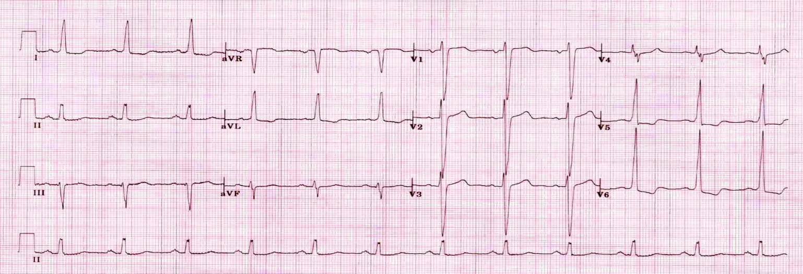

Ninth hour
Glycemia 11.2
Urine output 100 ml
Clotting factors
Clot retraction— 75% (normal)
Platelet aggregation—normal
Fibrinogen level 3.27 g/l (elevated)
Factor II— 230% (increased)
Factor V— 182% (increased)
Factor VII 130% (normal)
Factor VIII— 170% (slightly elevated)
Factor X—120% (normal)
Fibrinogen degradation products— 7 mcg/L (normal)
TA 115/80 mmHg
Neurologic finding:

The patient is febrile and exhibited apnoeic phases, along with the , facial paresis - flattening of the nasolabial fold on left asymmetry of the palpebral fissures. Left shoulder, arms, wrist and fingers are in hemiplegic position, leg is extended. (Glasgow Coma Scale score 7).
Electroencephalography, showed a slow basic rhythm consistent with the manifestation of encephalopathy. CT scan showed right hemisphere ischemic (embolic) stroke.
This course was based on our clinical experiences and the new recommendations issued by Joint British Diabetes Societies in August2012. There are also other views on management with the slight differences comparing to these recommendations, reflecting some controversial areas in management of HHS. One of the examples is provided on http://www.geocities.ws/urgentnamwu/CASE1/HHNS%20management%20-%20other%20views.htm .
TASK 22: COMPARE THE TWO APPROACHES AND FIND DIFFERENCES

