Joshua Card
GRA 410 Process Book
Joshua.Card@SNHU.edu
https://unbendingdesign.000webhostapp.com/Index.html

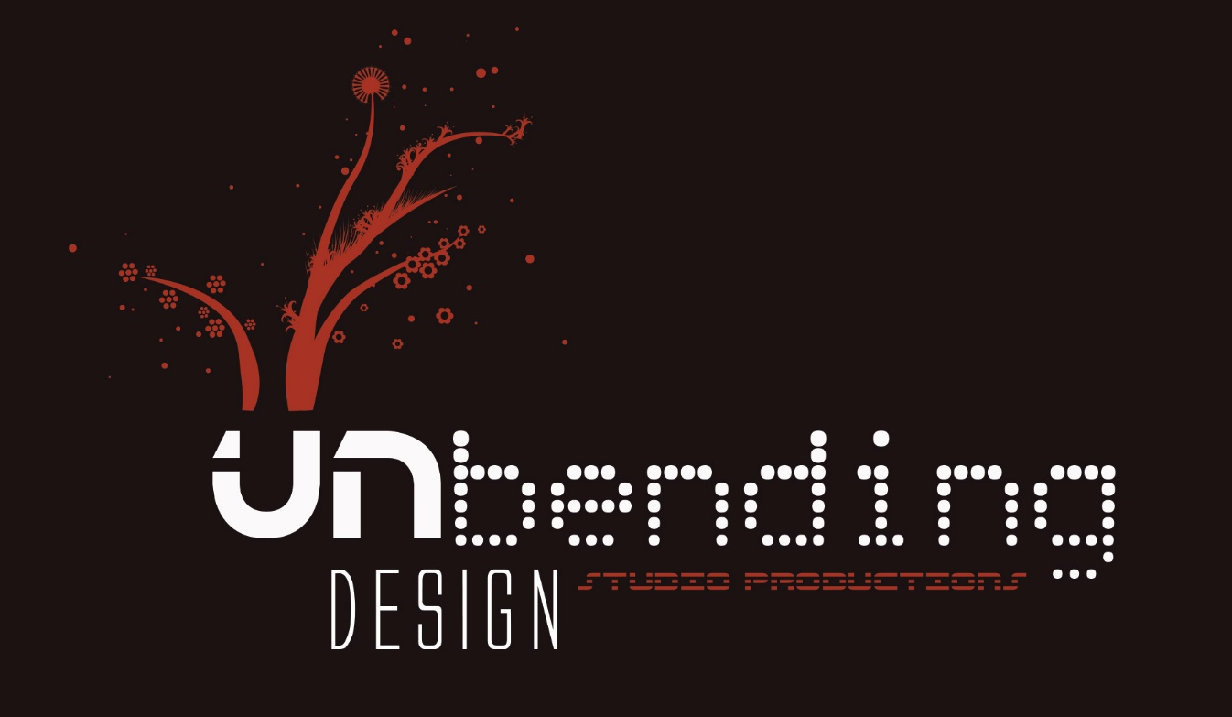

Sitemap

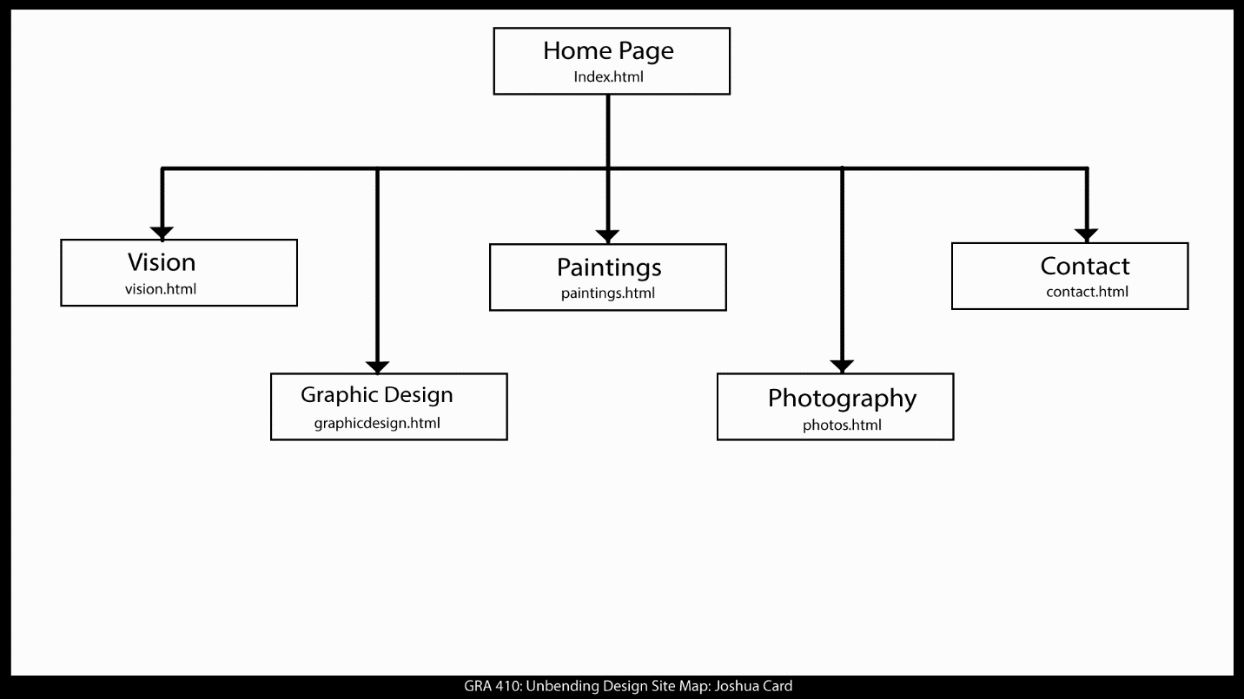

Comments:

Wireframe Breakpoints

Desktop

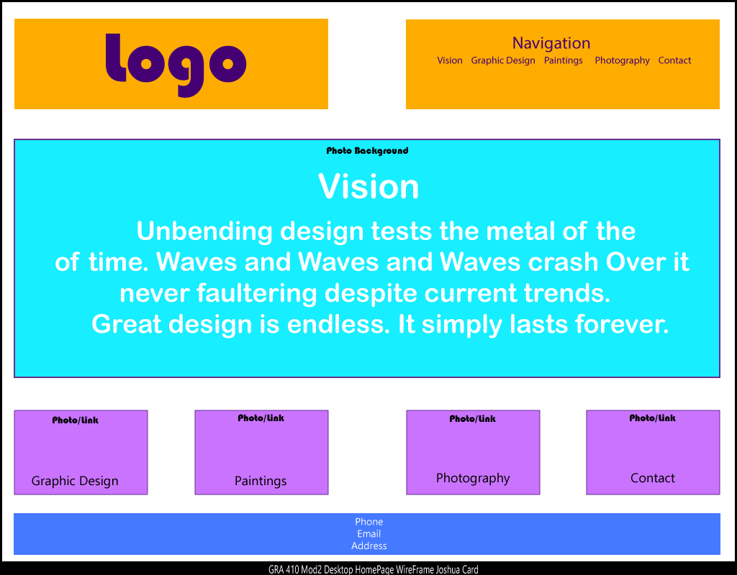

Tablet

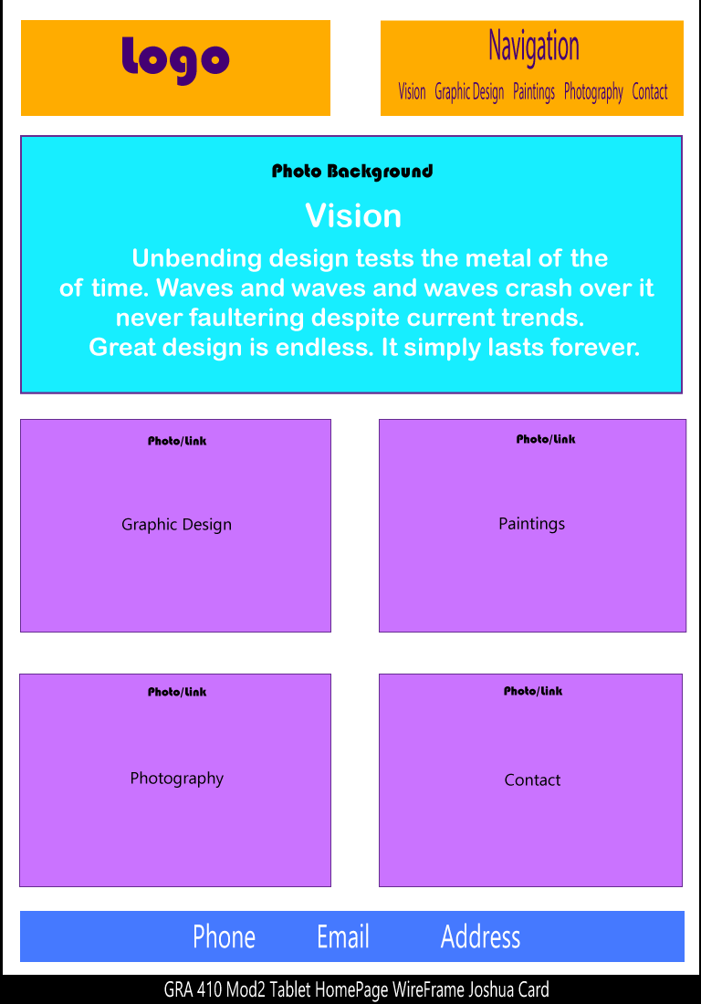

Mobile

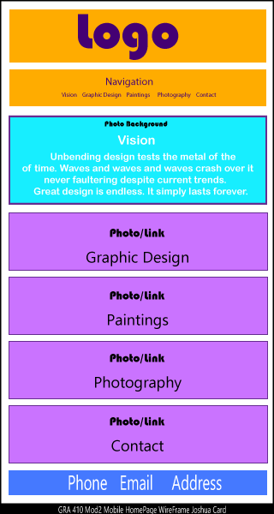

Comments:

Short Paper:
User Experience

Web design and user experience have evolved tremendously over the years of their existence. What started off as a giant PBS like project eventually has become a heavily commercialized and marketed platform with very sophisticated systems and information gathering techniques. What was once used solely by a sub class of individuals has become a socially popular tool used for almost everything in our daily lives. Need information? Ask Google! Need groceries? Order them online! Want live footage of an event? Go to YouTube!
Websites today not only provide information. Many of them perform various tasks which were unavailable at the beginning of the internet. In fact, many websites today even have applications which can be downloaded for an even better user experience.
In the past website design was approached by incorporating all the latest bells and whistles of modern technology, however this didn’t always justify a pleasant user experience. Balance of composition was sacrificed in order to maintain the appearance of ingenuity. Functionality took a back seat to a grotesque display in design.
Along with our needs the needs of our devices have also increased and varied. Where once we only viewed the world wide web through one set of lenses now, we move delicately cross platform in our accounts multiple times per day. Even the physical manner in which we access these avenues has changed. Dialup, to ethernet, DLS, and WIFI. Most of us are connected everyday through the use of our phones, towers, and satellites.
Keeping designs simple is an approach which has benefited the biggest of corporations with the most complex and saturated libraries of content as well as aided to small businesses which have limited resources and personnel to commit towards maintenance and delivery.
How do you want your audience to navigate? Or more importantly how does your audience need to navigate? Design patterns, flow charts, wire frames, profiles, and storytelling can assist in the evolution of a navigational structure. Content and consistency are key. Knowing what your followers want and need is a must and their input is valuable to any would be or established company. Feedback is necessary in order to know what direction should be taken from the present coordinates.

Each market is different and what drives one demographic of customers may not drive another. Each market must truly be approached with an intimacy concerning design for that specific audience. Like a custom-tailored suit, we should tailor the structure and experience of our brands and professional identity.

Comments:

Digital Mock-Ups

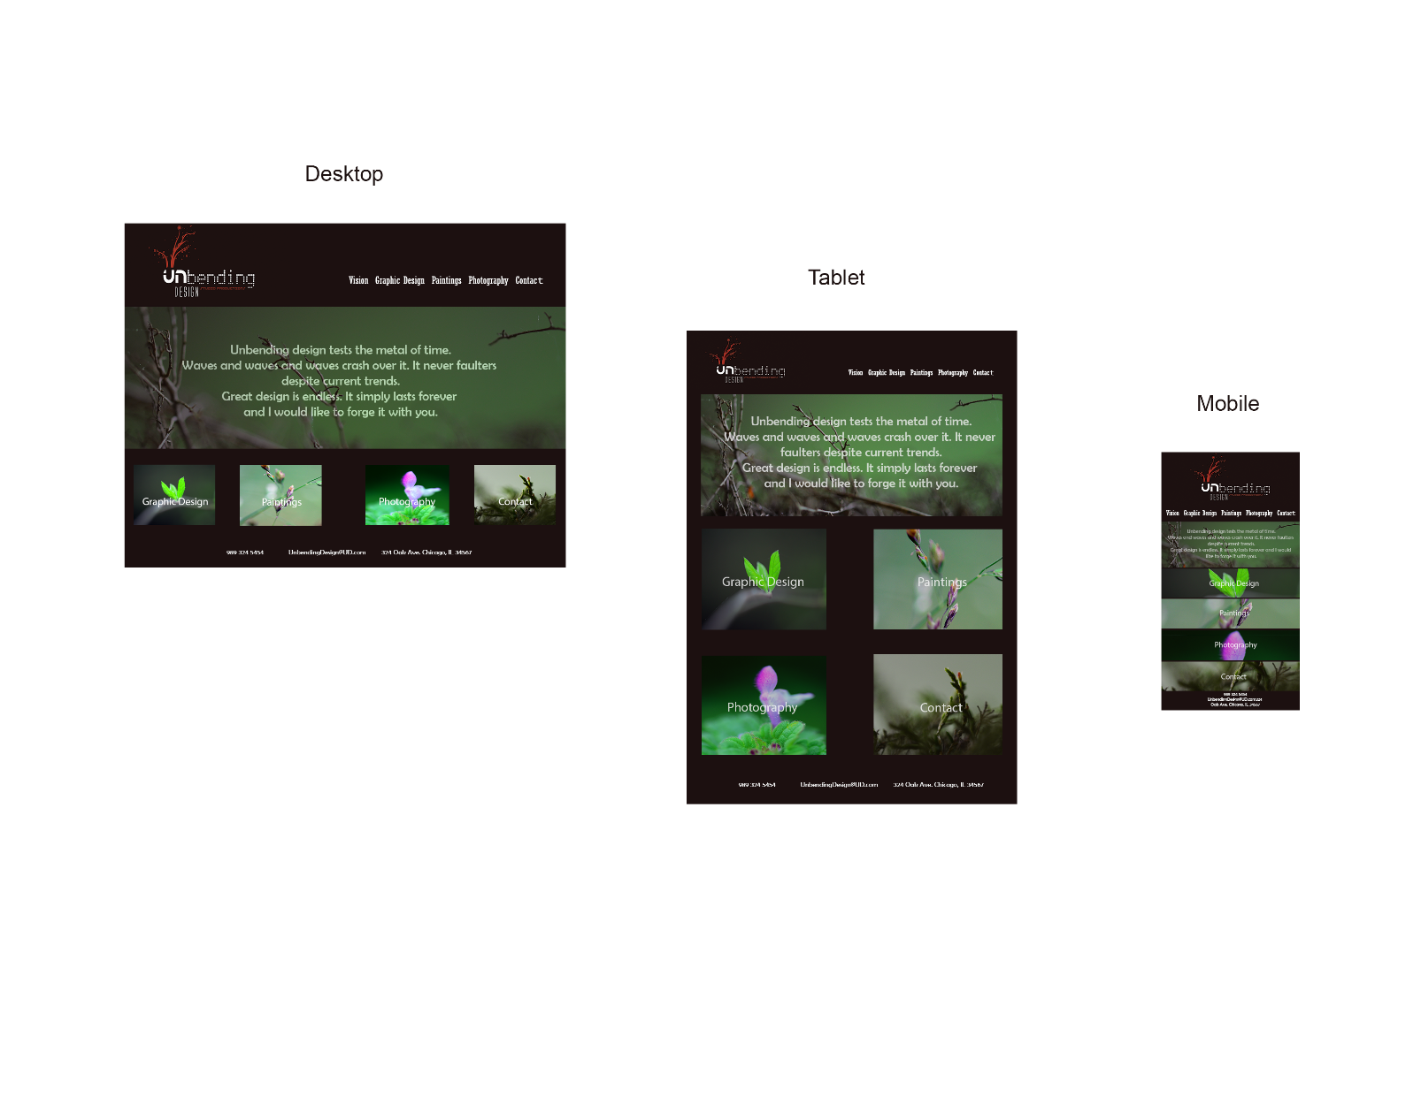

Comments:

Screenshot of
Coding Snippets (highlighted)
in File Directory
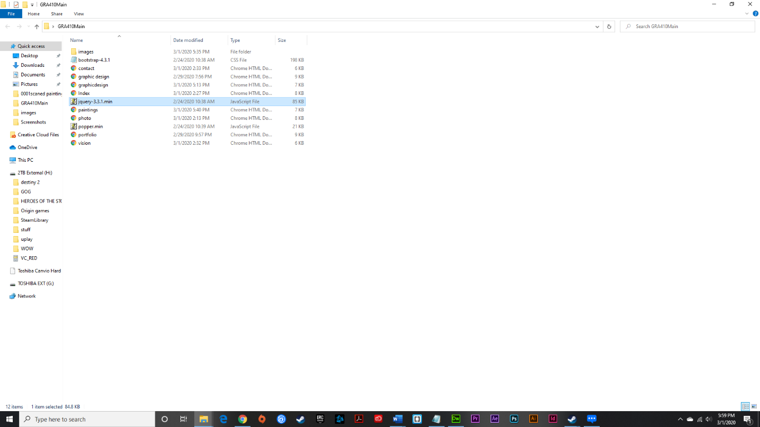

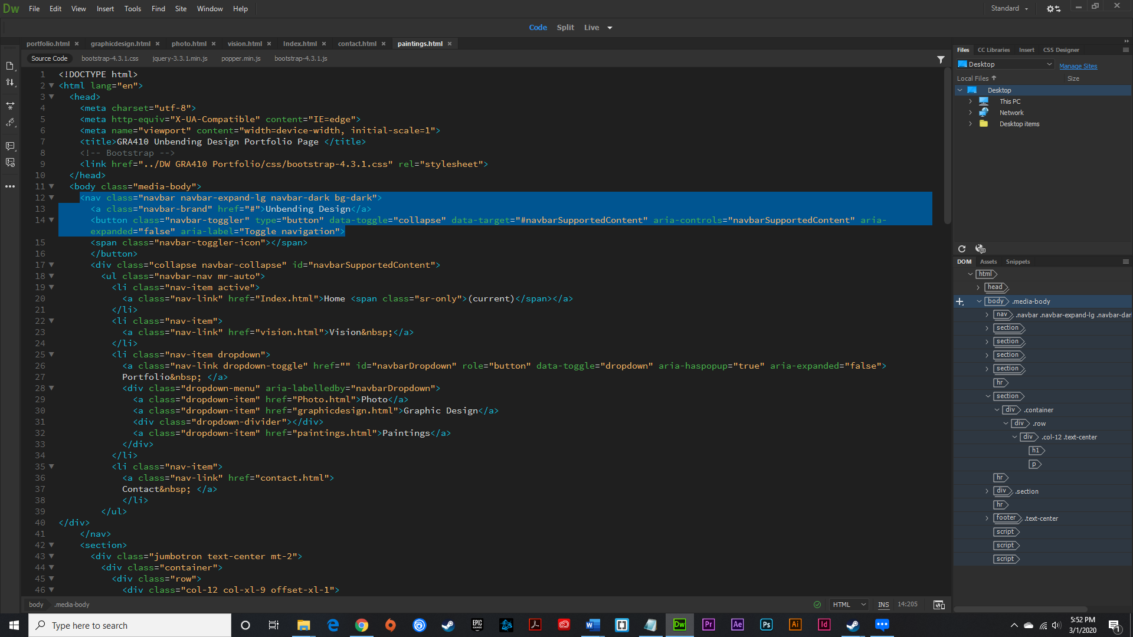

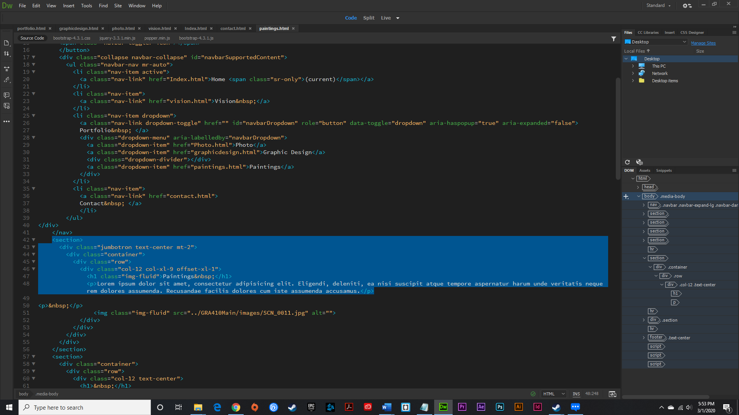
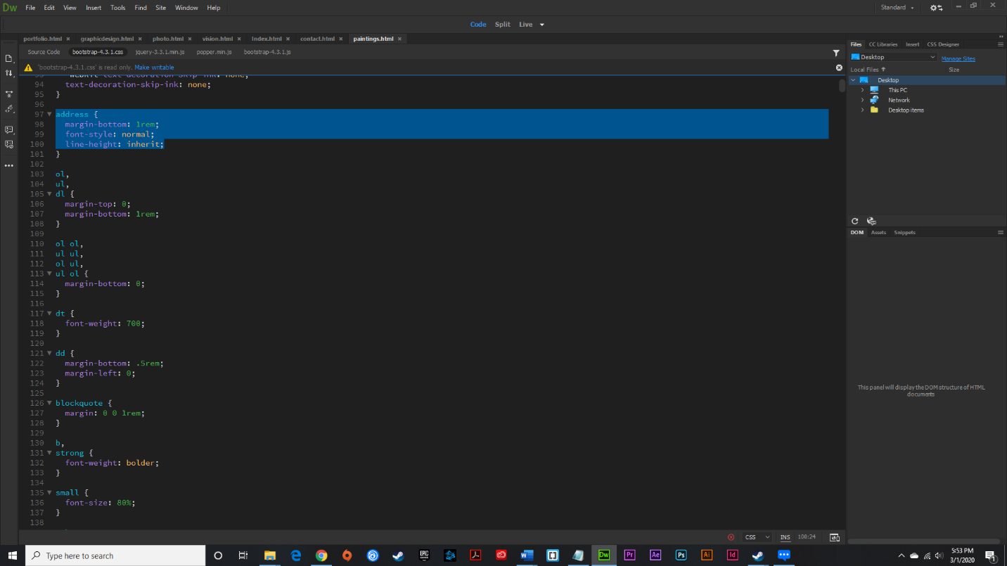
Comments:
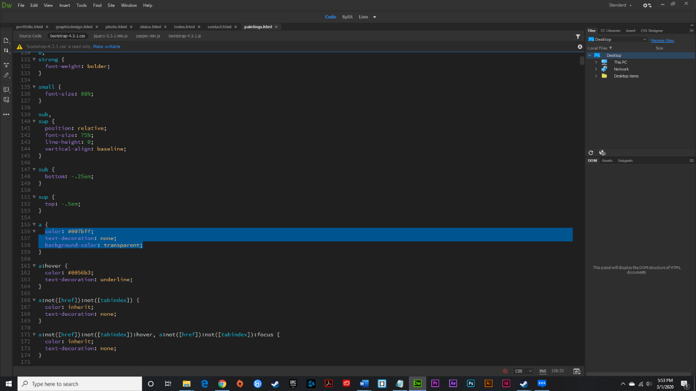

Troubleshooting Screenshots of
Website
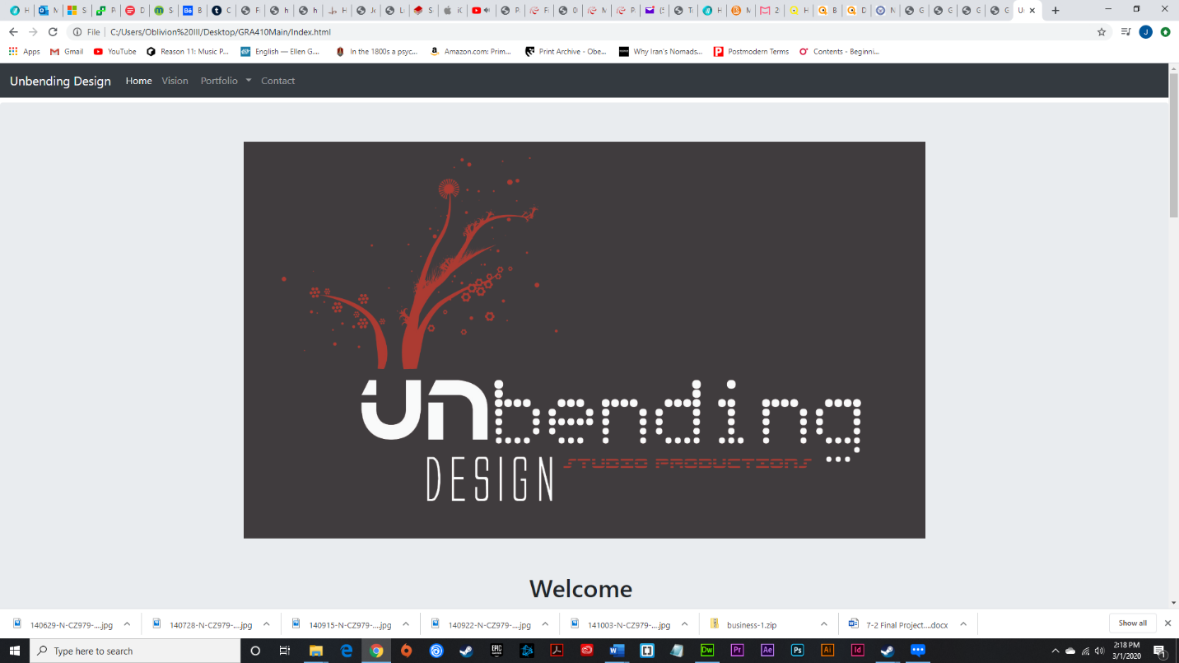

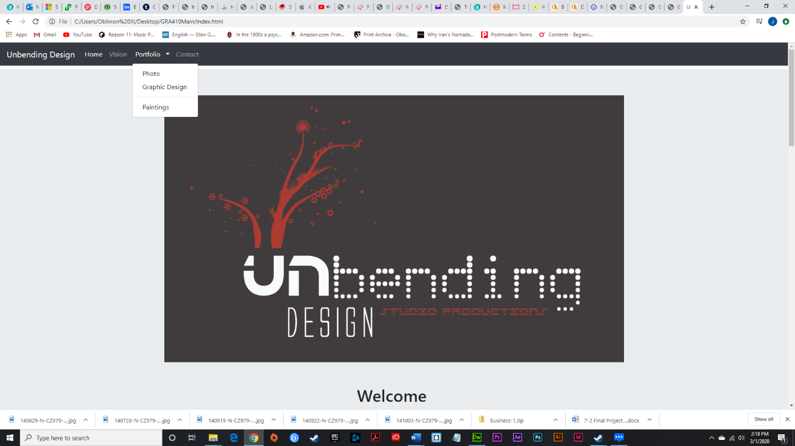

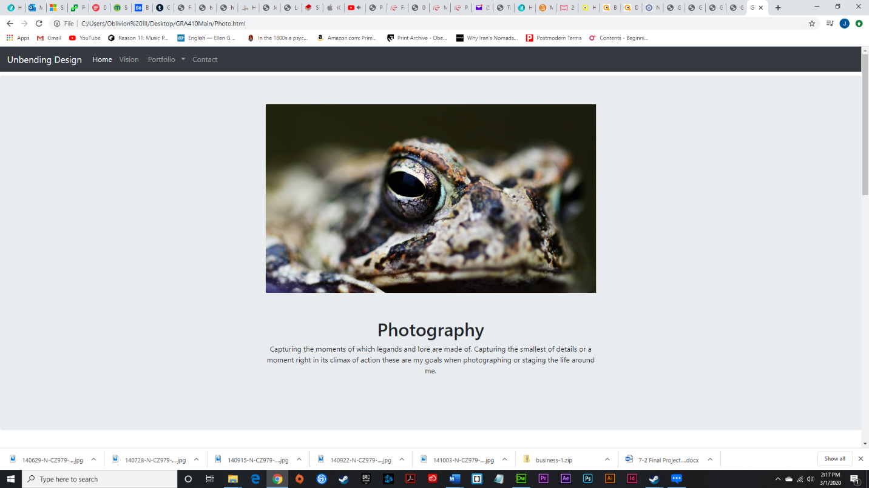

Comments:
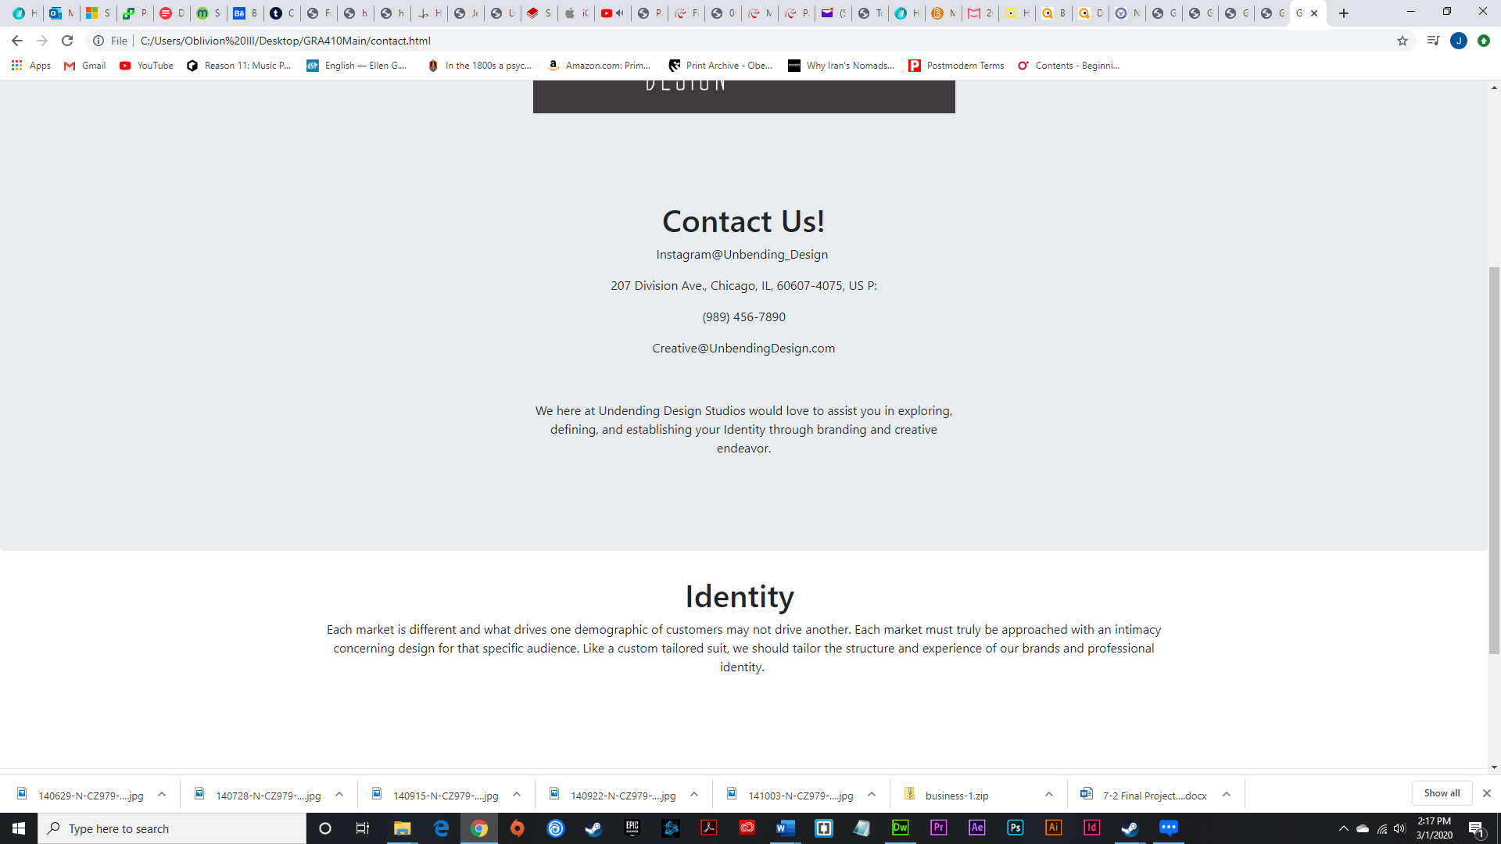

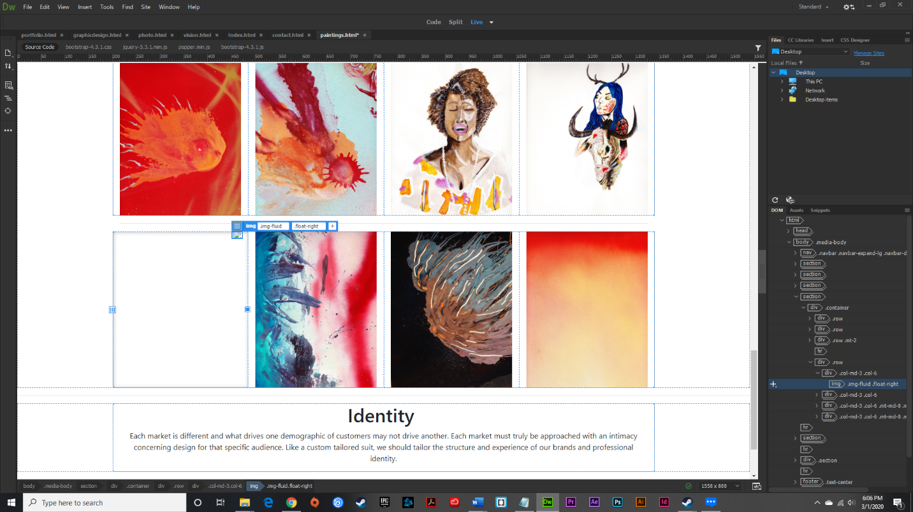
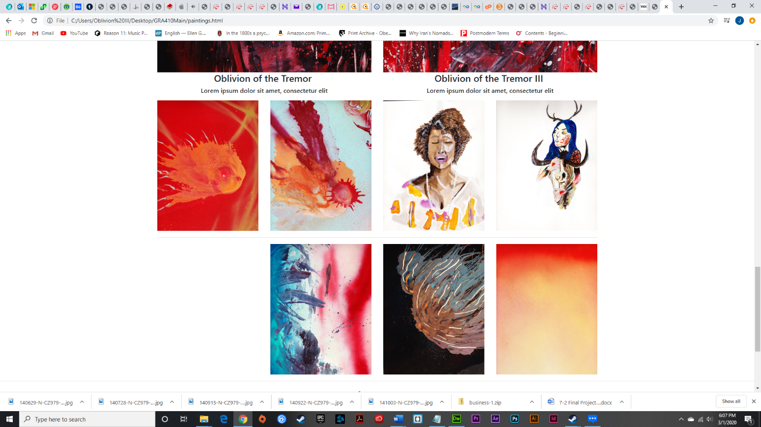

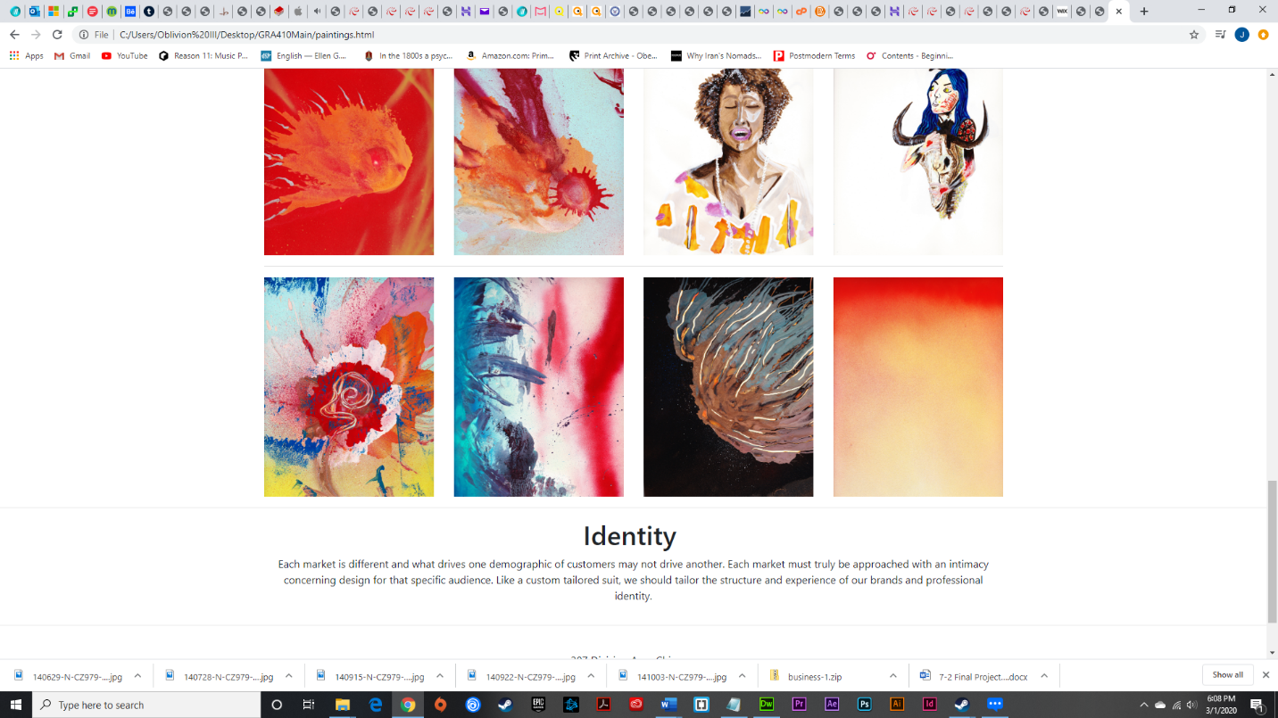

Live Link to Website Online
( http://gra410unbendingdesignportfolio.000webhostapp.com/public_html/GRA410Main/Index.html )

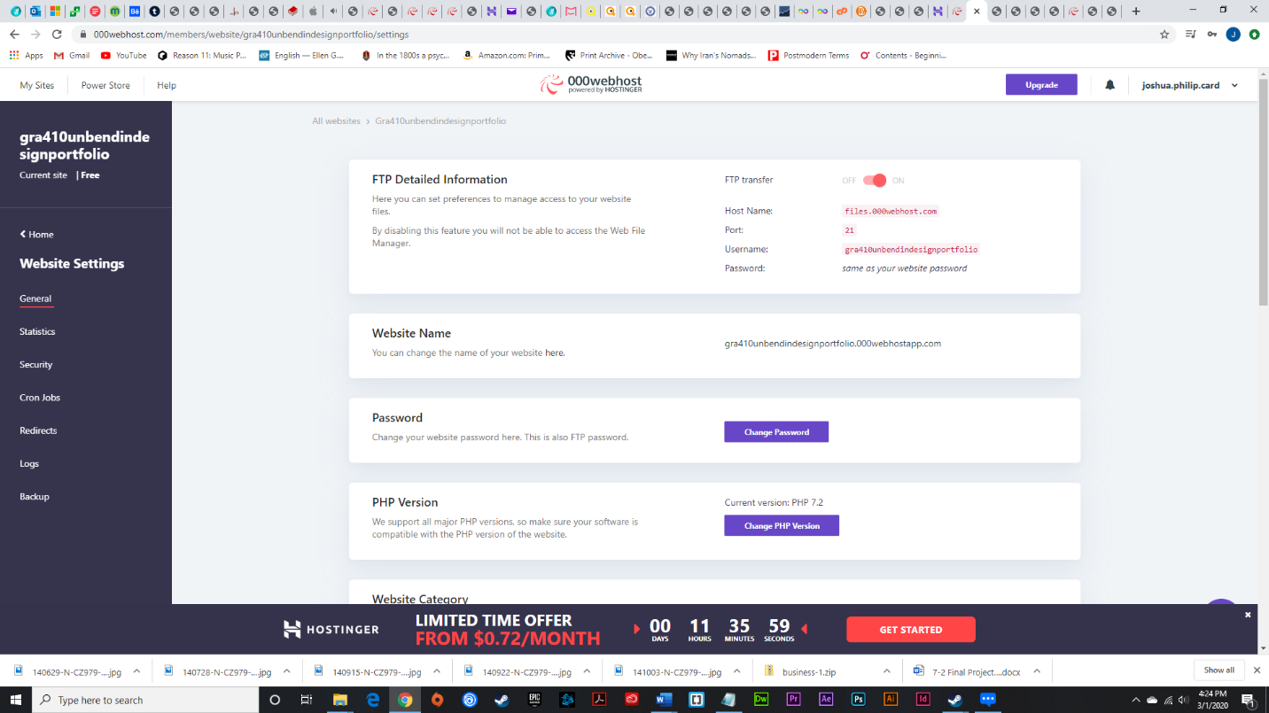

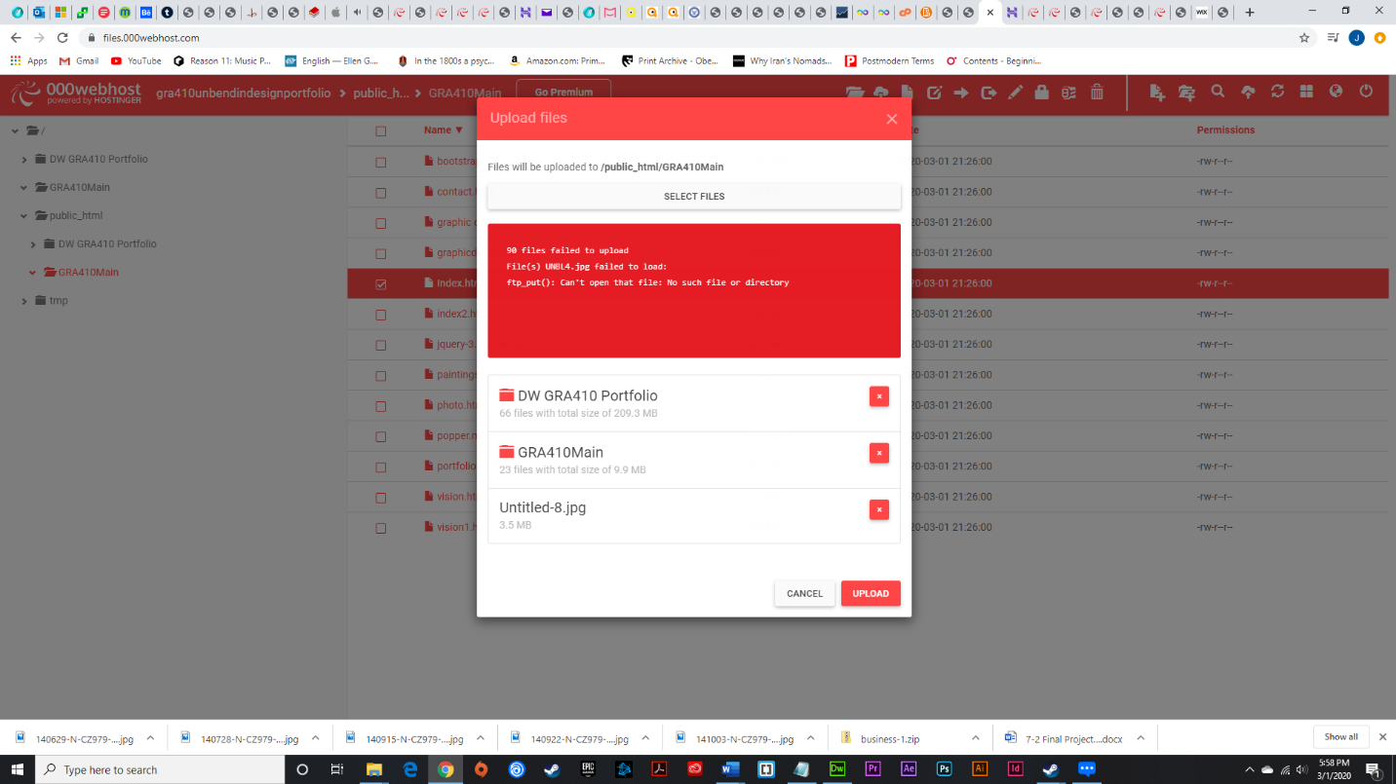

Comments:

