Support & FAQ
Dear costumer, thank you for purchasing this responsive Coming Soon Template, made in HTML5.
I am willing to help you with any questions related to this Template.
You can edit your files using a specific Software (Ex. Notepad++).
If you have specific questions that are not presented here, please contact me:
rubenddtbr@gmail.com

Esquema da página
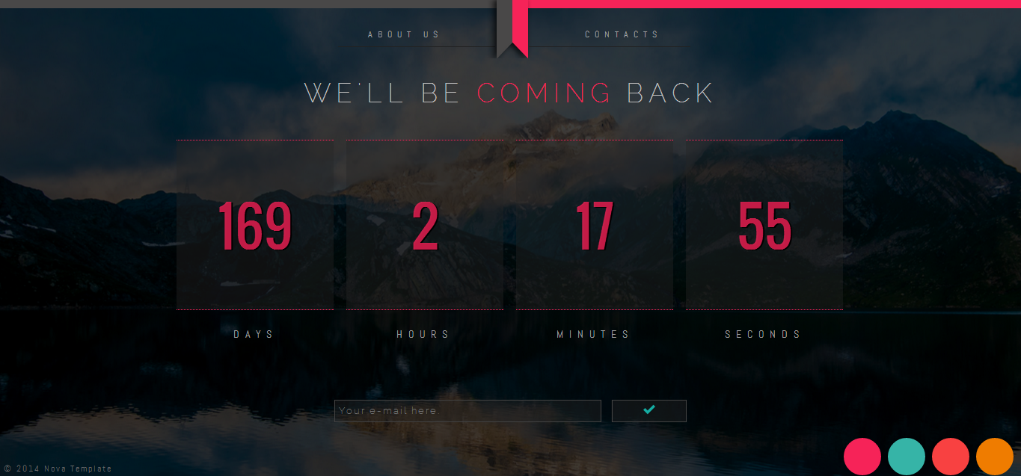
1
3
2
Legendas:
- How can i set up my page?

- How can i set up my Menu?

- How can i set up my Counter?

1 – How can i set up my page?
You will learn how to set up your page, changing your Theme and Background.
Choose one of these directories.
1.1 – Directories
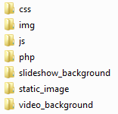
Fig. 1

Fig. 1 – Click at assets/ and choose a Background.

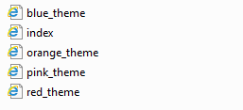
Fig. 2

Fig. 2 – Delete the selected file.

Choose your Theme and change the name to “Index”.

Now, you can go to /assets/static_image/ to see the changes.

2 – How can i set up my menu?
2.1 – Mudar o nome dos Menus.
Fig. 1
Fig. 1 – Open you Index file and search for a class called “menu”.
Code: <div class=”menu”>Content</div>

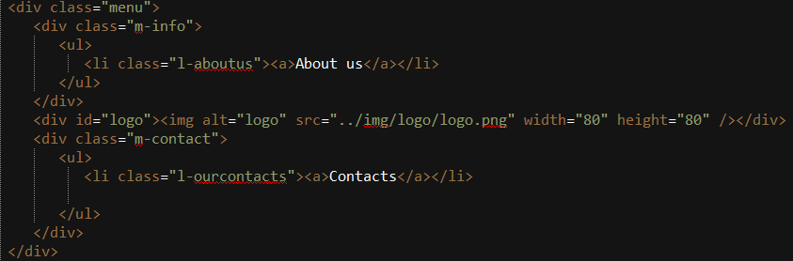
Fig. 2
Fig. 2 – Remove the “About us”, and “Contacts”, and change the name. Ex. (Company + Gallery).

2.2 – Add a new section
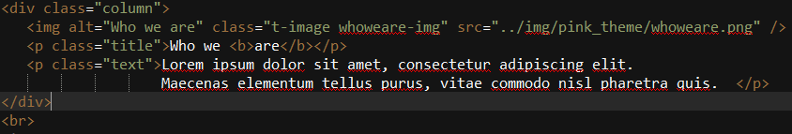
Fig. 1
Fig. 1 –Search for a class called “Column” and copy everything inside this class, now you just need to paste below.

Change the content inside the columns (Image + Title + Content).

2.3 – Add photos to a gallery
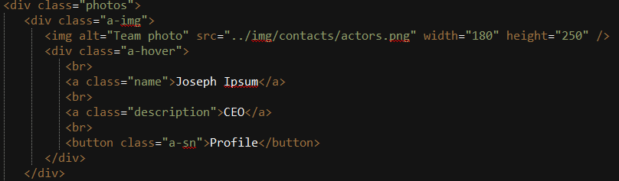
Fig. 1
Fig. 1 – Search for a class called “Photos”and copy everything inside this class, now you just need to paste below.

If you want to add a new link to your profile you just need to change the Link around the button:

<a href=”YOUR LINK HERE”><button class=”a-sn”>Profile</button></a>

2.4 – Add more Skill tags.
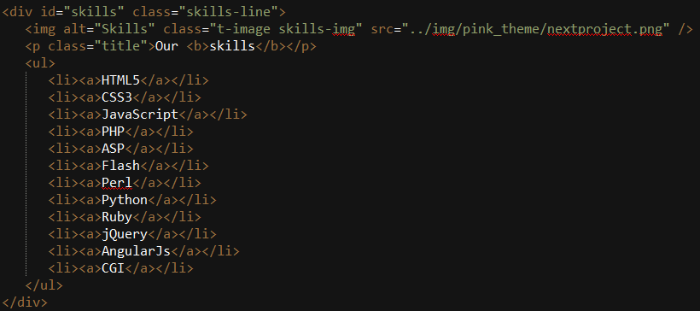
Fig. 1
Fig. 1 – Search for a class called “skills”, search for a Tag called “<li>”, now you just need to copy the Tag and the content inside. Paste below the selected area in Fig. 1.

2.5 – Change the contact E-mail receiver.

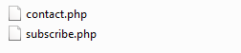
Fig. 1
Fig. 1 – Go to a folder called php, and double click a file called “contact.php”.

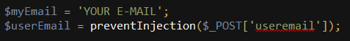
Fig. 2

Fig. 2 – Do CTRL + F and search for a variable called “$myEmail”. Rename “Your E-mail”, and put your E-mail adress there.

2.6 – Change the subscription E-mail receiver.
Fig. 1
Fig. 1 – – Go to a folder called php, and double click a file called “subscribe.php”.

Fig. 2

Fig. 2 – Do CTRL + F and search for a variable called “$myEmail”. Rename “Your E-mail”, and put your E-mail address there.
3 – How can i set up my counter
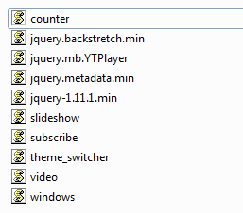
Fig. 1
Fig. 1 – Go to a folder called “js” and double click a file called “Counter”.
Fig. 2
Fig. 2 – Do CTRL + F and search for a variable called “date2”. Now you can change the date.

