JARED RAMSEY
SNHU
9-28-2020

PROJECT CLOSURE DOCUMENT
SECURING PARENTUNE.COM

Table of Contents
Table of Contents 1
1. Introduction 3
1.1 Purpose 3
1.2 Significance 3
1.3 Proposal 4
1.4 Methodology 4
1.5 Risks 5
2. Verification Plan 5
2.1 Feedback Plan 5
2.2 Feedback Criteria 5
2.3 Test Cases 6
3. Postmortem Summary 6
3.1 Methodologies 6
3.2 Method Evaluation 7
3.3 Risk Mitigation 7
4. Project Status 7
4.1 Objectives 7
4.2 Issues 8
4.3 Alternatives/Recommendations 8
4.4 Communications 8
5. Future Enhancements 8
6. Implementation Support 9
7. Maintenance Plan 9
8. Appendix 10
8.1 Network diagram. 10
8.2 Gantt Chart of WBS 10
8.3 VPN test case results. (Taylor, 2020) 11
8.4 Encrytion test case results. (Issam Damaj, 2008/06/03) 12
References 13

Introduction

Purpose
Keeping user data secure is extremely important in this day and age. If their data were not secured their identities could be stolen or ransomed, there private things posted on the internet for everyone to see, many bad things can happen if data is not secured. As of this moment our current security protocols are not up to snuff and I believe that they can easily be improved. Employing a secure VPN for parents(users) to connect to the company site/app with encrypted IaaS database and VPNaaS will keep user data safer.

1.2 Significance
The significance of securing the data supplied by the users is immense because it is one of the company’s main obligations to its customers. “Parents are usually wary of sharing sensitive details about their children on social networking sites. So, ensuring the security of information is critical,” Pandey added. (Prashar, 2017) If the parents’ information were used inappropriately it could also break certain laws (HIPPA, CIPA, COPPA, etc.…), morals, and ethical rules as well as company policy. (Grama) If this solution is not implemented a breach of data is much more likely and the company may not recover from a significant breach, which is why “an ounce of prevention is worth a pound of cure.” (Benjamin Franklin)
Scope: 6 months? $500,000?
Goal: Secure the users sessions and data.
Objectives: Research a secure encrypted VPNaaS provider and encrypted IaaS Database provider. Enlist these providers and set up the connections. Test the system. Launch the new secure system.

1.3 Proposal
I propose that we outsource an encrypted database for user data and outsource a VPN to connect to the company site/app through. My rough work breakdown schedule starts with researching IaaS encrypted database and VPNaaS providers. First researching and finding the best company for our needs, second negotiating the service. After these are implemented, the system will be tested then launched. After the launch and Alpha and Beta tests are complete and everything is well maintaining the new system will be the last part of the WBS which will continue indefinitely.

1.4 Methodology
An Agile methodology architecture will be used for this project because the scope is not well defined. Specifically a Scrumban methodology would be most beneficial because it has the structure of a Scrum and the flexibility of a Kanban and would provide the maintenance needed for this project. (Aston, 2019) Scrumban is also a good option in general because every team is different and if you are a new project manager or if your team is new you need to get to know their strengths and weaknesses and this methodology provides flexibility in doing so as well as being able to react to unforeseen issues that may arise. These methodologies were selected because of their flexibility since there are a lot of variables in this project, specify the time need to complete these tasks.

1.5 Risks
One potential risk is that by implementing a VPN and encrypted database the time it takes to access this service will have a much slower reply time than before, speed seems to be a major selling point for this service. This can be mitigated by researching different VPNaaS providers to make sure we get the fastest one or by enlisting different ones for different parts of the world in order to split the processing power needed to two different companies instead of all of the traffic going thru one service.

Verification Plan
My system verification plan will in include verifying the authenticity, integrity, availability, and encryption of the data on the encrypted database of the IaaS provider. I also plan to verify that the data being transferred over the VPNaaS is encrypted, authenticated, and the integrity of the data is correct. This whole system plan is about security. I believe including other security practices during the process is a great idea. Including risk assessments during the process will aid in the success of this plan. Security monitoring should also be included, assuming the VPNaaS provider does not include this in its service.

Feedback Plan
My feedback plan will include feedback from the users, employees, stakeholders, and service providers. This feedback will be collected via surveys, testing of the system, and verbal feedback. I intend to collect feedback from the stakeholders by holding meetings where they can ask questions to the development team directly after demonstrating the system’s performance.

Feedback Criteria
The criteria for successful tests will be that the data is secure all the way from the user to the database and that the data is properly encrypted on arrival and that the data is authenticated, its integrity is maintained and it is available for the user to access at any time. All non-stakeholder feedback will be reviewed by the team in a meeting where the feedback will be discussed and evaluated for relevance and actionability.

Test Cases
A basic VPN test would include if there are DNS leaks, IP address leaks, and WebRTC leaks. A simple test could be accomplished by connecting to the VPN and visiting https://ipleak.net/ or https://www.perfect-privacy.com/en/tests/dns-leaktest , or one of the many other sites like these, this will provide general testing for these leaks. If there are to many leaks the VPNaaS provider will need to be reconsidered. See 8.3 of the appendix.
An encryption test would include a report from the IaaS provider ensuring on their end that the encryption and the tests they run come back ok. See 8.4 of the appendix.

Postmortem Summary

Methodologies
An Agile methodology architecture will be used for this project because the scope is not well defined. Specifically, a Scrumban methodology would be most beneficial because it has the structure of a Scrum and the flexibility of a Kanban and would provide the maintenance needed for this project. (Aston, 2019) Scrumban is also a good option in general because every team is different and if you are a new project manager or if your team is new you need to get to know their strengths and weaknesses and this methodology provides flexibility in doing so as well as being able to react to unforeseen issues that may arise. These methodologies were selected because of their flexibility since there are a lot of variables in this project, specify the time need to complete these tasks.

Method Evaluation
The agile methodology gave this project the ability and time to react to situations that popped up along the way like conflict in the group. It also gave time to mitigate the risks that popped up such as the delay in acquiring an IaaS provider.

Risk Mitigation
- There was a delay on the IaaS provider due to the encryption requirements for HIPAA and other such regulations on the PII and PHI of users. Mitigated.
- One potential risk is that by implementing a VPNaaS and encrypted database IaaS providers lengthens the time it takes to access this service and will have a much slower reply time than before, speed seems to be a major selling point for Parentune.com. Mitigated.

Project Status

Objectives
The objectives originally proposed, and their Status are as follows.
- VPNaaS: Acquired. The Perimeter 81VPNaaS provider has been enlisted for this project. They were chosen because of their speed and security, providing all CIA triad factors.
- Integration using client software: Complete. The VPNaaS provider’s client IPsec software has been installed on the in-house workstations to allow access for employees.
- Encrypted IaaS: Acquired. The Microsoft Azure IaaS provider has been enlisted for this project. They were chosen because of their speed and security, providing all CIA factors. They also comply with HIPAA and other regulations regarding PII and PHI.

Issues
There was a delay on the IaaS provider due to the encryption requirements for HIPAA and other such regulations on the PII and PHI of users.

Alternatives/Recommendations
- Using the in-house database currently in use during this project was used as a work around to accommodate the company until the proper IaaS provider was found.
- The risk of slow speeds can be mitigated by researching different VPNaaS providers to make sure we get the fastest one or by enlisting different ones for different parts of the world in order to split the processing power needed to two (or more) different companies instead of all of the traffic going thru one service.

Communications
Regular status reports were sent via email to the team, employees, testers, sponsors and stakeholders. Weekly meetings with the stakeholders were also held to keep everyone on track and to provide feedback. The meeting minuets were sent to those not able to make these meetings via email and feedback was requested.

Future Enhancements
The system could be enhanced by using more local providers for each region or at least country to reduce bandwidth traffic conflicts.

Implementation Support
A smooth transition between the pre-project system and the post-project system was accomplished by lots of communication. Communication between the different providers and the in-house staff via meetings, email, and training. Transparency was maintained to properly communicate between providers and Parentune.com. (Krakoff, n.d.) Monitoring the process is crucial to insure everything goes smoothly and that if an unforeseen problem occurs there is more time to react to this issue. The system is scalable by changing the plan with the providers. If the system needed more storage, a request to rent more servers and databases would be made to the IaaS provider. If the system needed more throughput on the VPN, a request for additional support from the VPNaaS provider would be made. The monthly fees will go up to accommodate the scaling, but if the scaling is needed the company can afford it.

Maintenance Plan
Since most of the services are now provided by other companies the maintenance of most of the system is included in the service plan. However, a few changes have been made to the current staff to accommodate the changes. The former network team has been reassigned to monitor and collaborate with the VPNaaS providers to insure proper communication between user and server. The former team in charge of maintaining the in-house database is now in charge of collaborating with the IaaS providers to ensure the encryption, confidentiality, integrity, and availability of the data is as good as possible.

Appendix
  - Network diagram.

Gantt Chart of WBS
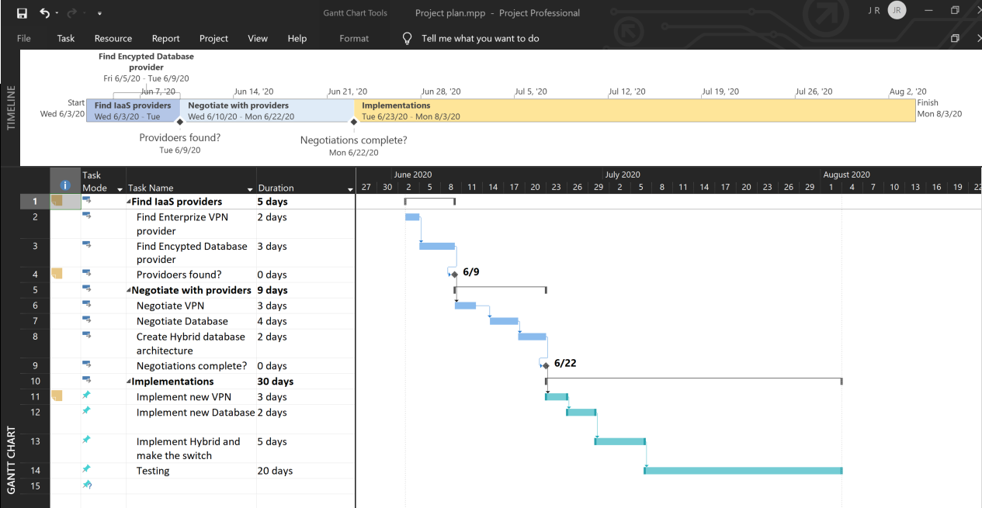

8.3 VPN test case results. (Taylor, 2020)
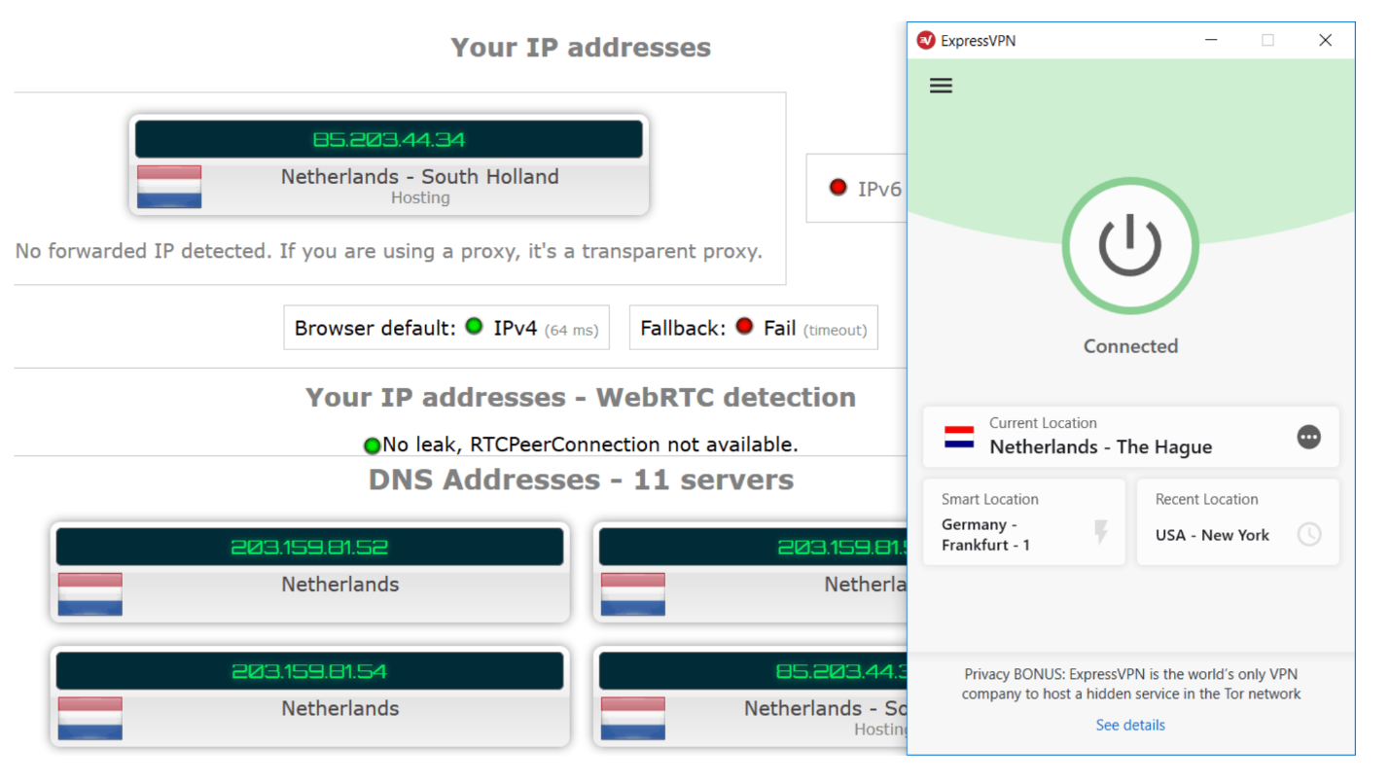

8.4 Encrytion test case results. (Issam Damaj, 2008/06/03)


References
Andrew Makar, T. M. (2013, October 27). IT project management terms you should know. Retrieved from TechRepublic: https://www.techrepublic.com/blog/it-consultant/it-project-management-terms-you-should-know/
Aston, B. (2019, September 9). 9 Of The Most Popular Project Management Methodologies Made Simple. Retrieved from dpm: https://thedigitalprojectmanager.com/project-management-methodologies-made-simple/#prince2
Grama, J. L. (n.d.). Southern New Hampshire University IT412 Custom VitalBook. Retrieved from VitalSource Bookshelf: http://bookshelf.vitalsource.com/#/books/9781284082654/
Issam Damaj, S. H. (2008/06/03, 6). Efficient tine harware cipher under Verilog. Retrieved from ResearchGate: https://www.researchgate.net/figure/Test-Case-Encryption-Testing-Input-Key-0x0-Plaintext-0x0-Ciphertext_fig4_255179878
Krakoff, S. (n.d.). The 10 Best Organizational Change Management Strategies. Retrieved from Champlain College Online: https://online.champlain.edu/blog/best-organizational-change-management-strategies
Prashar, A. (2017). Parentune.com: partnering parents. Ivey Publishing.
Taylor, S. (2020, 6 25). VPN Tests and Checks. Retrieved from RestorePrivacy: https://restoreprivacy.com/vpn/test-check-vpn-working/
VPN as a Service (VPNaaS). (n.d.). Retrieved from perimeter 81: https://www.perimeter81.com/resources/vpn-as-service

