TO: The Stakeholders, including the Regatta Academic Advisors and the Office of Enrollment Management?

FROM: Jared Ramsey, IT team member

DATE: 1/21/2020

SUBJECT: Student Degree Progress Project

The purpose of the student degree progress project is to create a student degree progress tool. This tool with allow students to view their progress toward program and degree completion accurately and instantly. The desired end goal of the project will be a tool, that will be easy to use but also accurate. The information used in this memo are documented in the Student Degree Progress Project Charter, the Gannt Chart, and the Project Management Documents.

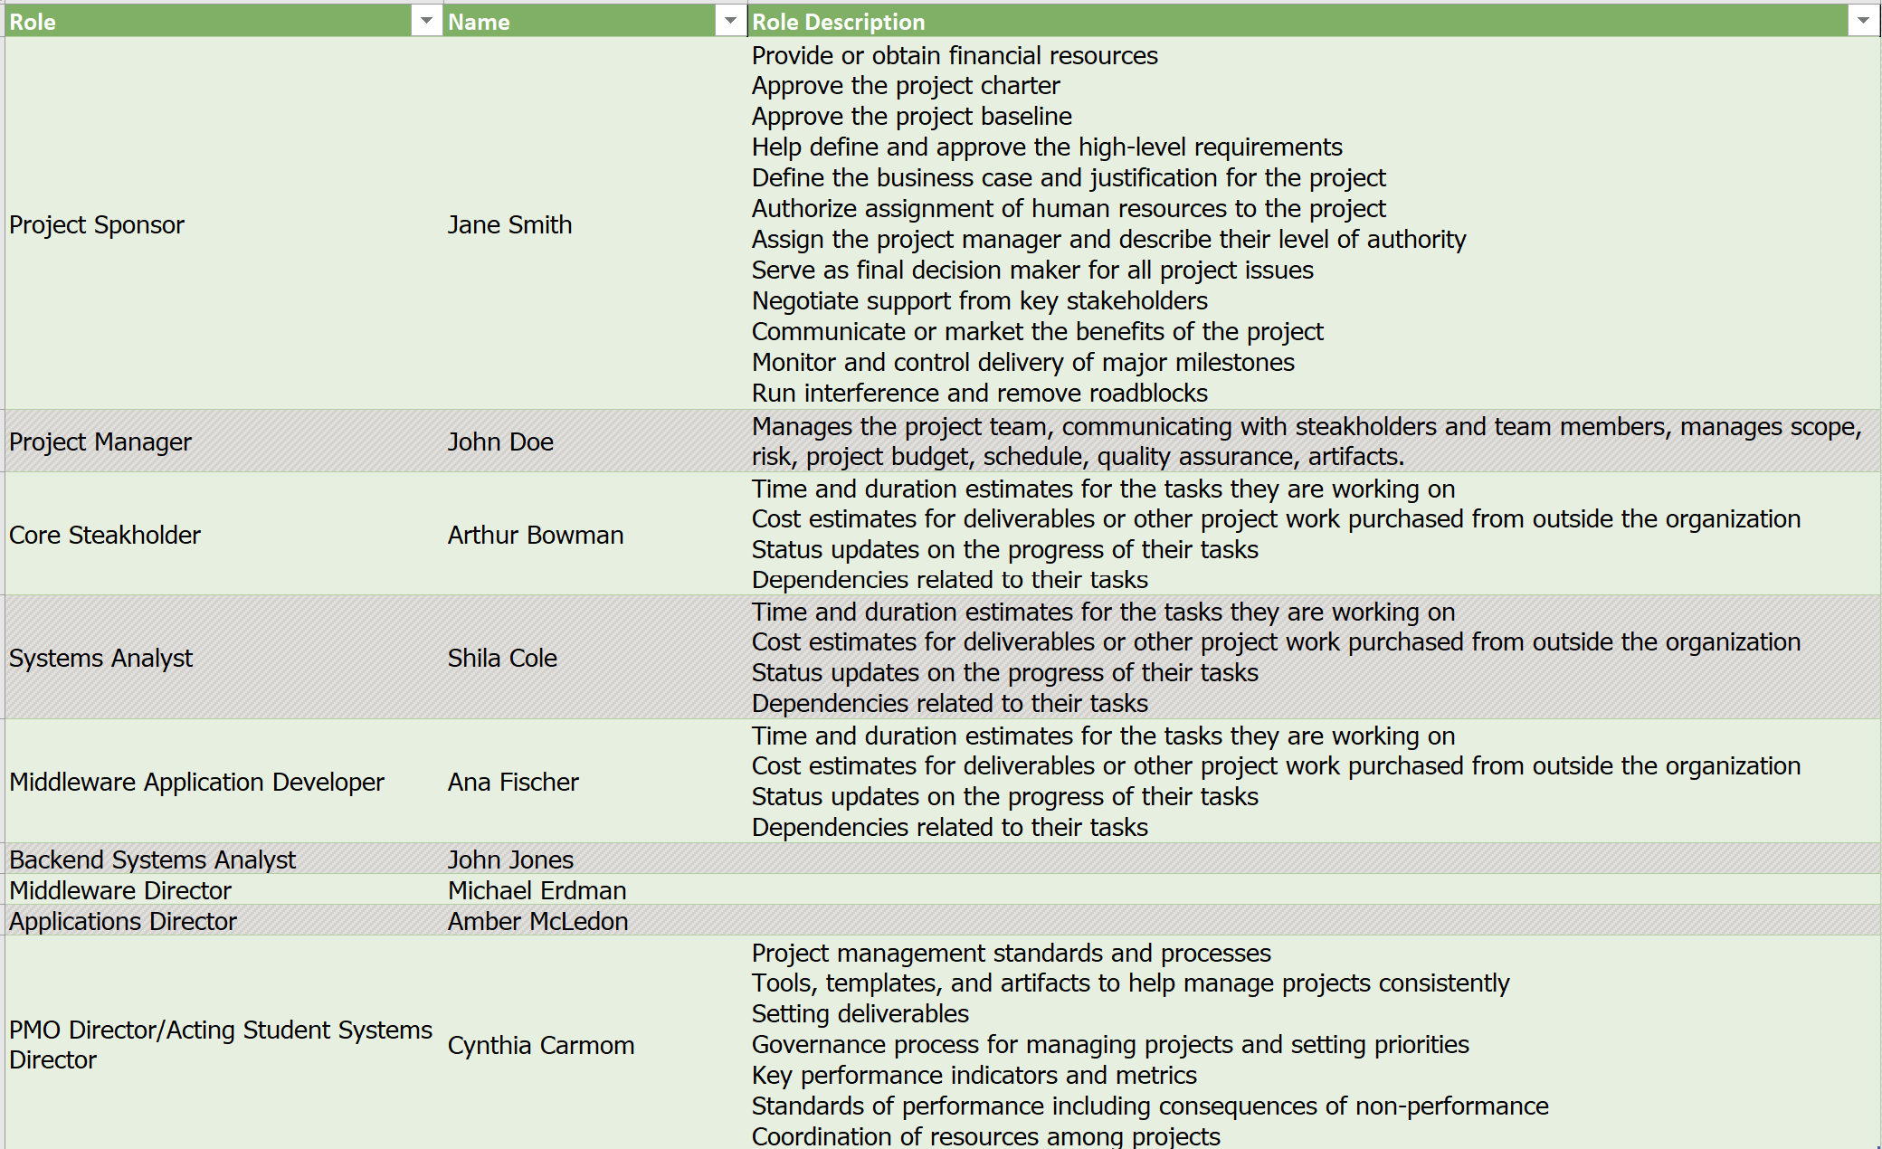
The team members for this project, their roles, and descriptions of those roles are explained in the table below:

The Significance of each member’s role in specific phases of the project, in which the role is involved in are as follows:
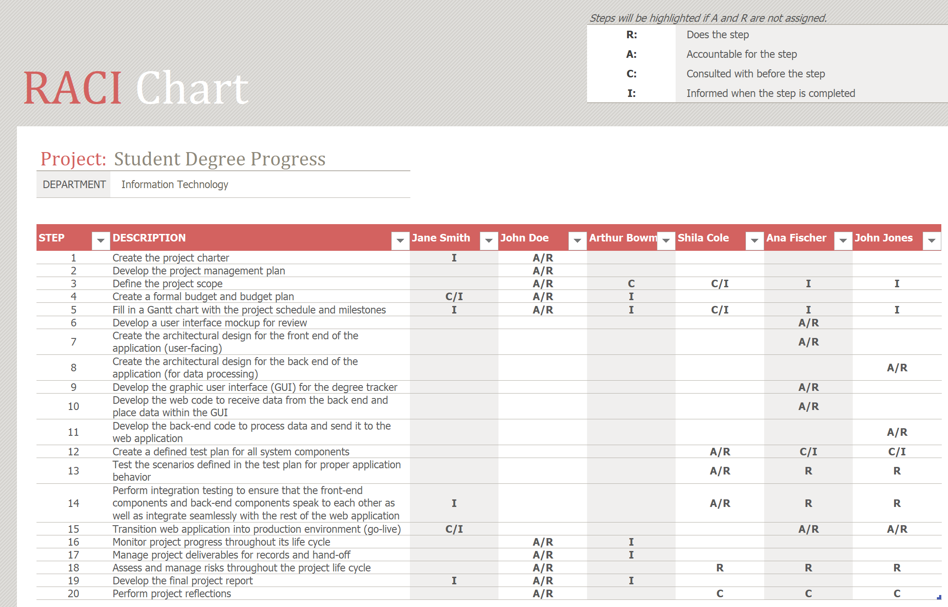

I have selected the Application developer, Ana Fischer’s role. The Application developer’s main responsibilities are to develop a mockup UI, create the layout the users will see, develop the GUI, develop the web code that communicates with the server-side information database, and take the application live for beta testing. The application developer is also an informed when the project scope is defined, and when the Gantt chart is schedule and milestones are decided on. The application developer is consulted/informed when a test plan for system components is ready to be created. The application developer is consulted when the project is being wrapped up for project reflections. The application developer’s tasks are throughout the entire schedule because the project is to make an application. It is important that the scope be defined before any application developing can begin, otherwise the application might not fit into the scope of the project, costing extra money and not following the time schedule. Starting on tasks before the Gantt chart, project schedule, and milestones are completed would result in waisted work and time because the Gantt chart, schedule and milestones tell you what you are supposed to be doing, on what time frame, with whom, and so on.
I have chosen to implement the callout box to provide more detailed information when hovered over. This feature will increase the coding and testing time of the project so the schedule will change. More time needed means more money needed so the budget will increase as well.
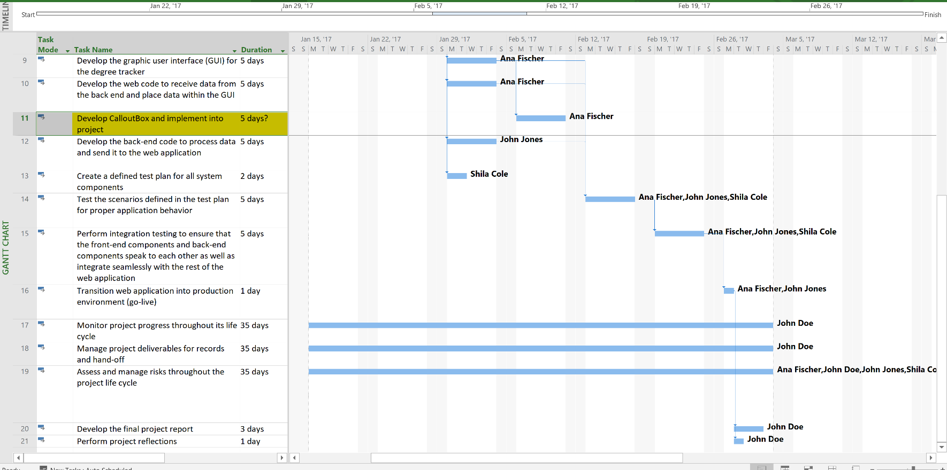
The new task was added after the GUI is developed (ID 9) & web code to receive data (ID 10) is complete. Which in turn moved testing of scenarios (ID 14), integration testing (ID 15), taking the web application live (ID 16), final project report (ID 20), project reflections (ID 21) & the end date of the entire project monitoring (ID 17), (ID 18), (ID 19). Changing the triple constraint of this project allows for the additional task in this project to happen. An additional 10 thousand dollars changes the budget. An extra week covers the schedule. These changes allow the scope of the project to include new features.

Rollout issues is a risk that requires immediate attention. 8000 students will use this application, 40% of those 8000 students are online only students and would need access to this application a lot more than those who study on campus. If this rollout was to be unsuccessful and required major maintenance and was offline for many days, it would affect students’ grades and work in a negative way which the stakeholders, among many others, would not like.
If testing was more thorough (13, 14, 15) to mitigate or avoid this risk the project would have a higher chance of success. If this going-live risk is not taken care of, it would also affect the end of the project (17, 18, 19, 20 ,21).
If this risk is not addressed than cost will increase because you will need to fix these errors to make the application work, which will take your people more time and money to complete. The schedule will be increased to accommodate for the extra time needed to fix these errors. The scope of the project will also change due to this extra unplanned step being added in order to fix these mistakes.
To mitigate this risk, I propose that additional testing be done to ensure that there are no mistakes and no errors that go unfixed. I also propose that there be a mock launch where the application can go live, but not to the students, to the testers. This mock launch will find more bugs that may have been overlooked and can be fixed before the true launch.
This risk mitigation strategy will take a little more time in the testing stage of the project. This extra time will result in extra cost for the project. More assets will need to be allocated to this new task either as a consultant or being responsible for the completion of this task.
My mitigation strategy is the best option for this risk because it will ensure that there is enough time to fix all the bugs before the true launch of the project. Without this mock launch there could be unforeseen bugs that would take up everyone’s time to fix and delay the use of the application to the students.
In conclusion I propose that the risks mentioned here be mitigated using my plan. With a little extra time to fix these issues and add the extra feature, we can ensure that this project be completed and fully functional 1 week later than the original schedule. The scope has changed slightly and the cost is still within budget.
The major points of this memo are that the rollout issues risk needs to be addressed, I propose a mock private launch to expose unseen bugs. The new feature (callout box) needs to be added, I propose an extra week of testing and implementation to ensure these callout boxes function properly. Slight change in scope, and extra week and an extra 10 thousand dollars will mitigate these issues using my proposed plan.
Thank you for your time, I hope you agree with my plan.

