Jared Ramsey
SNHU
2/24/2019
Executive Briefing
The key features included in the XYZ Training Manual of G Suite™ include : Migration tools(to help transfer our stuff from outlook to G Suite™), Communication tools (email, video conference, messenger), Document creation tools (text documents, spread sheets, presentations, etc.), Google Drive™ and Google cloud™ search(basic edition includes 30gb of cloud based storage), Admin tools (manage devices, users, and data securely with 24/7 live support) (G Suite small-business, n.d.)
The manual will contain 2 sections based on the job and knowledge base of the person being trained. Some will need to know everything about the program others will need to know only some features of G Suite™. For example, the CEO will need to know all the features while his secretary will need to know only a limited number of features like how to use the email and calendar features to assist the CEO.
My manual will be available online in a document for easy access and support as well as having training videos broken up into sections available on YouTube™ @ www.youtube.com/fake.url . It will include all the features mentioned earlier and will be organized with the basic information first like communication tools usage, calendar tool usage, document tools usage, and cloud storage and retrieval. The manual will then move on to the intermediate level things like video conferencing, managing devices, managing users, and security and support.

Exemplar
Beginner training
How to contact 24/7 support by phone, email, and online
How to transfer our Outlook™ accounts to our new G Suite™ accounts.
How to use Gmail™
How to use shared integrated Calendars
How to use text documents
How to use spreadsheets
How to use presentation
Collaborate in real time on the same document
How to use Google Drive™
How to use Google Cloud™ Search engine
30GB per person, cross platform access
Intermediate training
How to use Video conference calling
How to use Hangouts Chat™
How to manage devices
How to manage users
How to manage data
How to secure data

Basic Training
The purpose of the training is to make sure all employees are “on the same page” as far as understanding of the new software. Upon completion of the training everyone should be able to log on, use the email system, use the calendar tool, use the text editing software, use the presentation tool, and use the spread sheets tool. Intermediate users should also know how to use the video conferencing tools. The admin level users should know how to use the admin tools such as edit data, edit user info, set security options, etc.
The training will be administered in the form of an instructional video or hands on training in small groups. The basic users should already have basic computer knowledge so watching a video should not be a problem. Hands on training is another more favorable format that supports basic user skills and needs. Given enough time one on one training will be performed in small groups to insure everyone has time and opportunity to understand and test out the new software while an instructor is there to help with any questions that may arise from the testing.
Instructions
Open new software
Start the transfer process from outlook to google
Insure that all files have been transferred properly
Congratulation no more outlook
Intro to Gmail
Compose email
Send, forward, reply, reply-all, etc.
Archives
Calendar tool
Syncing the shared calendar with coworkers
Adding subtracting events
Text editor review
Explain where all the buttons are
Presentation tool
Explain where all the buttons are
Spread sheet tool
Explain where all the buttons are
Gmail example:
Green – Compose
Pink - Inbox and Account options
Orange - Archive and Mail options
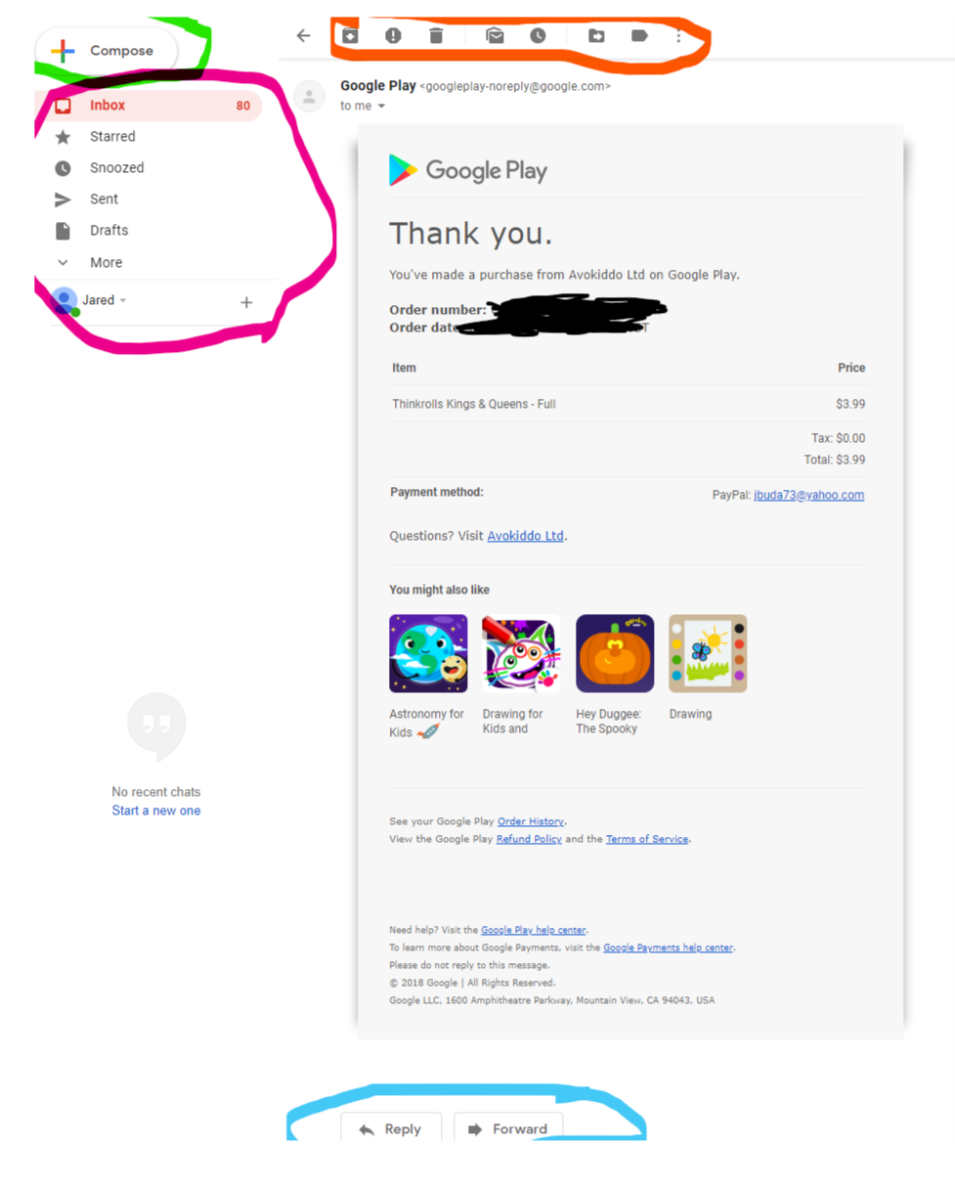
Blue - Reply and Forward buttons
Text editing software example:
Yellow - Program menu options
Green - Clipboard options
Blue - Font options
Pink - Paragraph options ect.
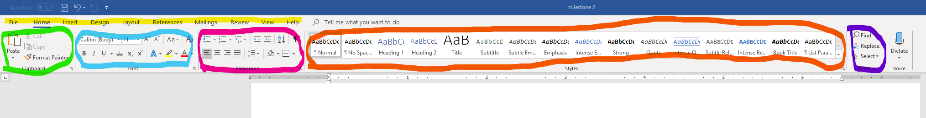

Presentation tool:
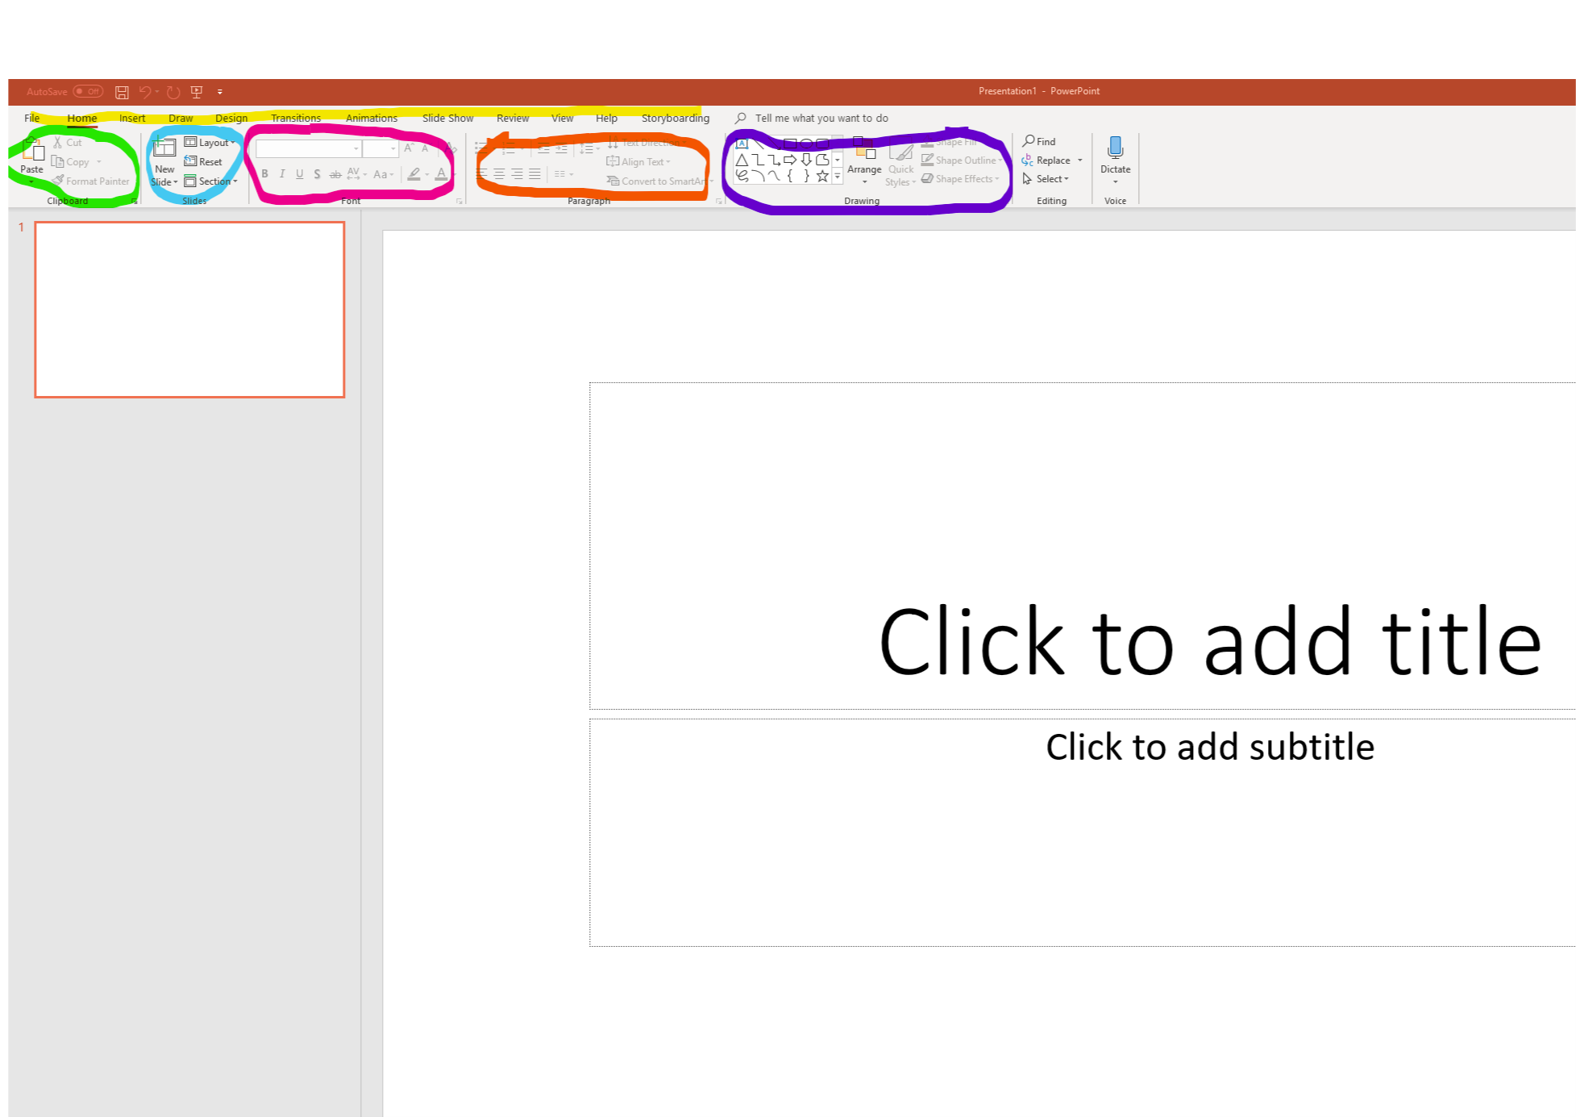
very similar menu and option layout

Spread sheet tool:
Similar menu and option layout
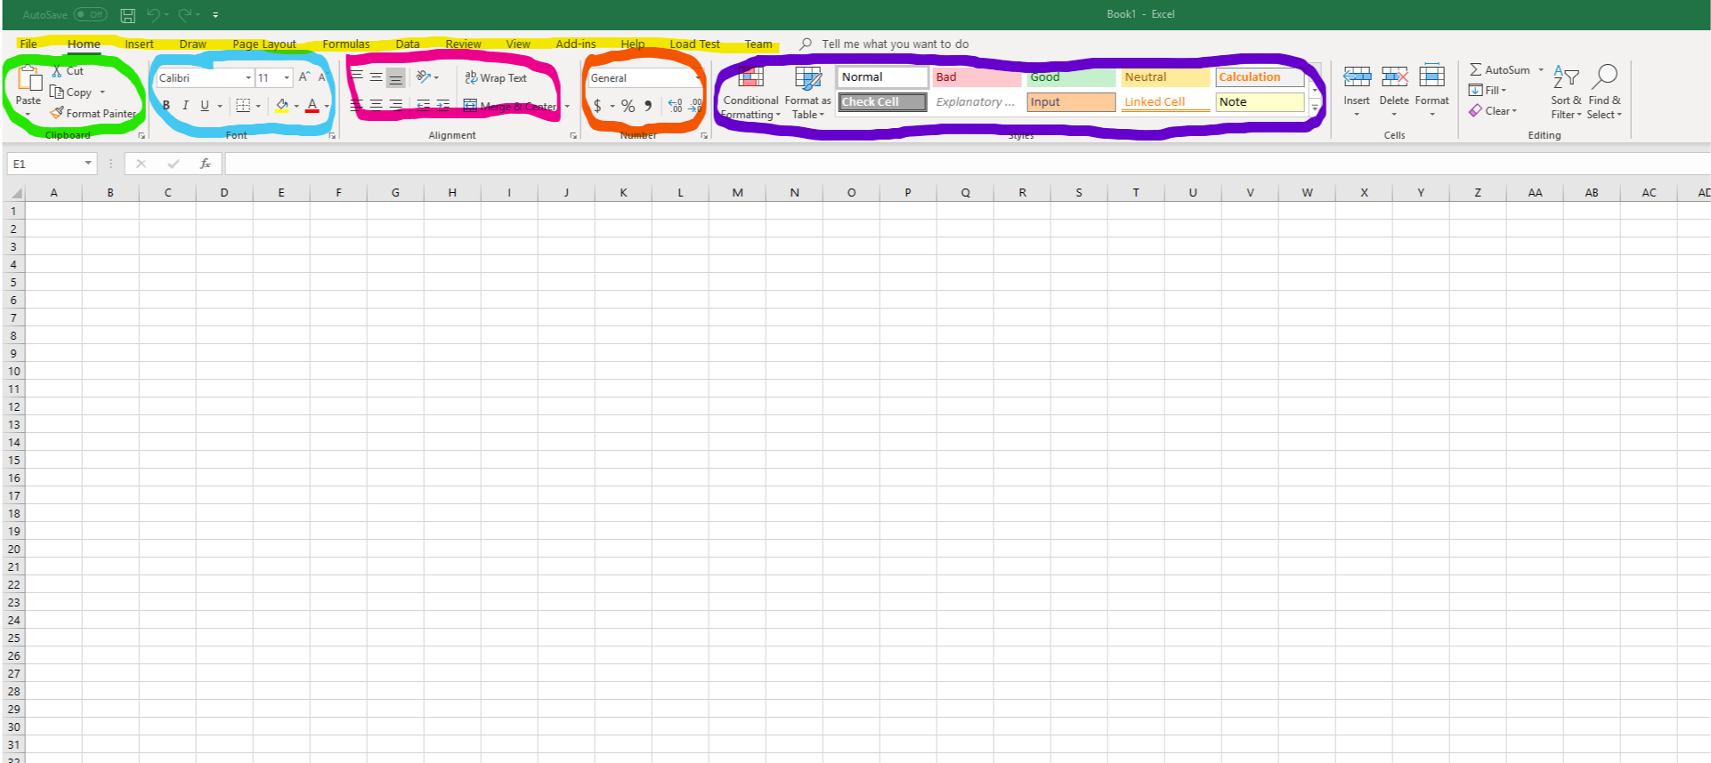

Intermediate Training
The purpose of the training for the intermediate-level users will be to train them in the Basic training plus the more advanced features of the G-Suite such as video conferencing. They will be trained in these tools because they are part of their jobs in addition to the basic training. This training will be for all intermediate level employees to make sure everyone can use the new software.
The format of this training will be a hands-on class where the users can try out the software as we go thought the presentation. That way if any problems arise, they can be addressed for the whole class instead of that one person finding the problem later and not knowing what to do and having to call tech support. For those employees who can’t make the class there will also be several videos on YouTube for them to train or as a refresher for those who need it. Those who don’t make the class will be subject to testing to ensure that they know how to use the tools properly.

Intermediate training
Start meetings:
Schedule in Calendar tool
Start a meeting in a web browser or on mobile
Join a meeting from:
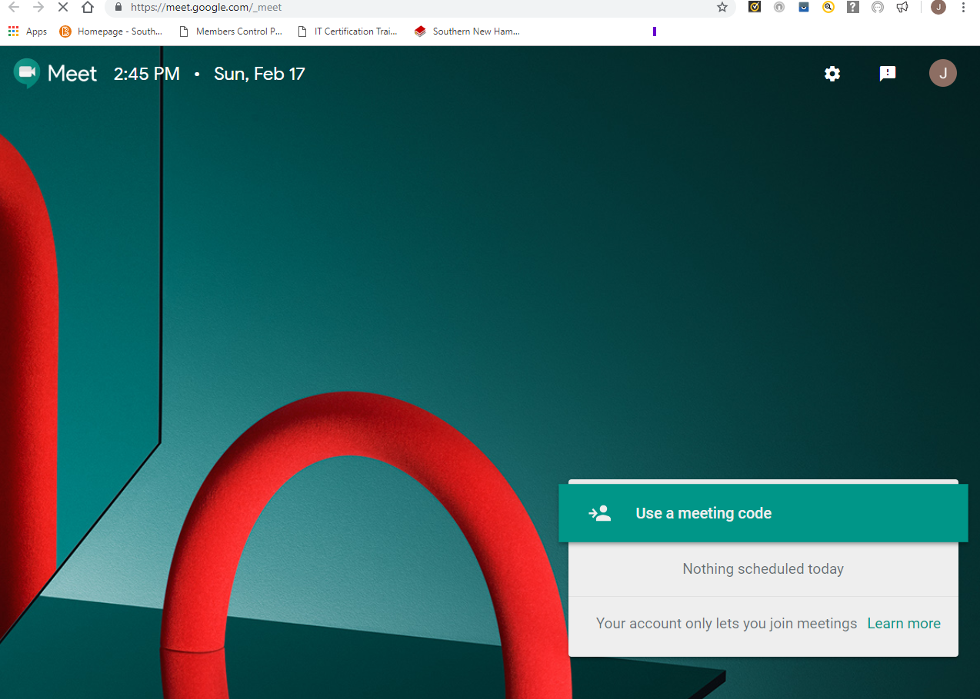
Calendar, Meet, URL link, Meeting code, Dial in from Phone, From a 3rd party system
Collaborate in video meetings:
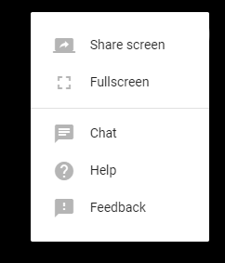
Add and remove guests on the fly, Add more guests to calendar event, Send chat messages, Present your screen, Record a video meeting, Mute guest’s mic (for THAT guy)
Manage device settings:
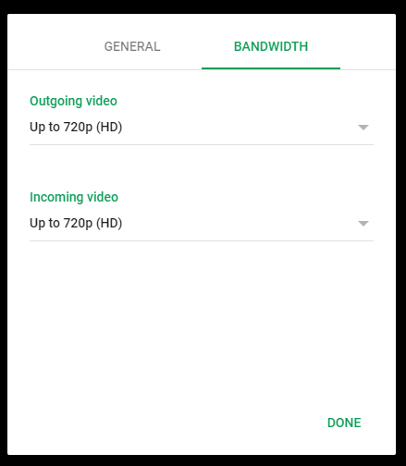
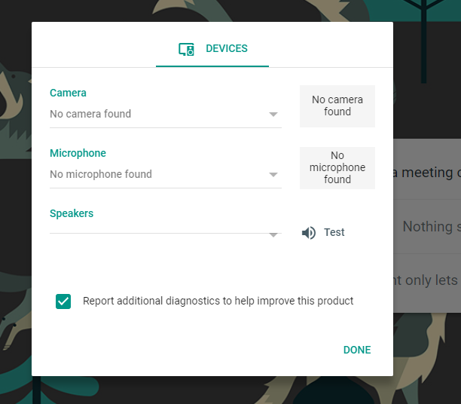
Change camera, speakers, mic, adjust video quality, adjust mobile camera

(GSuite Learning Center, n.d.)

Legal
Legal Notice:
The use of this document in any way other than directed dissolves all liability of XYZ Organization in every way shape and form. This material is copyrighted and belongs to XYZ organization and any use of this material without express written permission from the XYZ organization will be a breach of the Copyright and the violators will be subject to legal action. Copyright 2010 XYZ Organization, Inc. All Rights Reserved. May not be copied, scanned, or duplicated, in whole or in part. (Technical Writing for Success, 3E)

References
(n.d.). In D. Smith-Worthington, & S. Jefferson, Technical Writing for Success, 3E. Cengage Learning Inc.
G Suite small-business. (n.d.). Retrieved from G Suite by Google Cloud: https://gsuite.google.com/solutions/small-business/
GSuite Learning Center. (n.d.). Retrieved from GSuite: https://gsuite.google.com/learning-center/products/meet/get-started/#!/

Images taken from Google™ Gmail™ : https://mail.google.com/mail under my account
Microsoft Word™, Excel™, & PowerPoint™

