Wealth Dynamics in a nutshell
Many people think that there are hundreds of routes to wealth. With Wealth Dynamics, you'll see that there are actually only eight paths to wealth and that one of those paths is the correct one for you.
These paths are highlighted by the successful people who have achieved wealth through following their natural path. This is to say, they found the wealth dynamic match that suited their talents.
Could you imagine Richard Branson as a footballer, or Bill Gates as a fish monger?
No, they discovered the talents they were born with and capitalized on them. They followed a path that they loved, their path of least resistance and they excelled at it. Wouldn't you like to find your path, benefit from your natural strengths and excel?
Let's take a brief look at each of these eight wealth profiles...

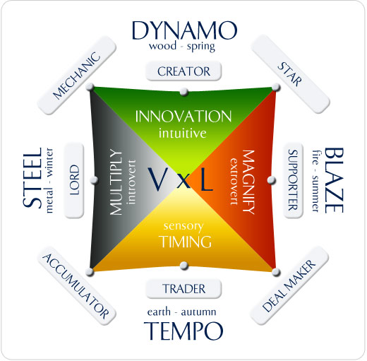

The Creator

Innovation , Product

Creators are big picture thinkers with an awesome ability to get things started, although they tend to be shocking when it comes to finishing things. Their drive and momentum can be exhausting for others around them, and they themselves very rarely know how to use their drive and intuition to maximum effect. It's common for a creator to flit from one project or opportunity to the next...without ever benefiting from the fruit of their efforts. Examples of successful creators include Steve Jobs, JK Rowling and Richard Branson.
The Creators can't help creating! They are good at creating profitable ideas and businesses, but not so good with the day to day running of a business. Successful creators will delegate everything, except the creative process. Example: Walt Disney

The Mechanic

Optimise the process

Using systems and processes, a Mechanic has the ability to control and manage people without necessarily having any charismatic leadership qualities. Mechanics endure and tend to rely on duplication and replication, and love to challenge the status quo. Mechanics may get caught up in the detail, at the expense of the big picture. Successful mechanics include Ray Kroc and Sam Walton
Mechanics are perfectionists who like to finish things, rather than create them. They want to make everything better - fine tune them. Example: Henry Ford.

The Star

Improve the brand

Stars are aware of the strength of their personality, and often use it to their advantage without realizing the negative impact it can have on those around them. As a star increases their ability to shine, they can often get burnt out with extreme demands on their time. Increased success frequently means greater stress, and an inability to capitalize on their stardom in a sustainable way. Examples of Stars who have found their natural path include Oprah Winfrey, Martha Stewart (However, Martha Stewart didn't know she'd found her path and deviated from it...it must have been a painful lesson) and Anthony Robbins
It is easy to spot a star. Obviously, you have film, music and sports stars, but high profile CEOs can also be thought of stars. They rely on the strength of their personality and are aware of the pressure of always having to deliver. Example: Oprah Winfrey

The Supporter

Build team network

Supporters have strong interpersonal skills and are great at building relationships but generally poor at knowing how to use their ability to create sustainable wealth in a way that's fun for them. They have little or no affinity for systems so it is easy for the value they create to be lost. Examples of supporters who have discovered the secrets to their profile are Meg Wittman and Jack Welch.
Supporters are great networkers with loads of energy and enthusiasm. Their greatest wealth can be achieved when they join forces with a Star, Creator, Deal Maker, or Mechanic. Example: Steve Ballmer

The Deal Maker

Get the agreement connect the dots.

Many people have begun to fancy themselves as a trader, possibly as a result of the increased profile of online, retail and options trading. In reality, most people are not designed to be traders, which partially explains why most who try these things, lose their money. Their strength of operating at point blank range is also their weakness as they rarely plan out their big vision. George Soros has achieved great wealth through following his natural path as a trader without deviating.
A deal maker relies on relationships, connections and being able to react intuitively when the best opportunities present themselves. Example: Donald Trump

The Trader

Timing, trend and value

Many people have begun to fancy themselves as a trader, possibly as a result of the increased profile of online, retail and options trading. In reality, most people are not designed to be traders, which partially explains why most who try these things, lose their money. Their strength of operating at point blank range is also their weakness as they rarely plan out their big vision. George Soros has achieved great wealth through following his natural path as a trader without deviating.
A trader is someone who naturally hunts out bargains, naturally loves haggling and gets immense satisfaction from a great deal. They are equally as good at finding high price buyers. Example: George Soros

The Accumulator

Long term thinking
The accumulator is the safest profile, and relies on a system to achieve incremental wealth growth. Many wealth seekers choose this approach but as it is also the slowest, they get itchy feet and move on before they achieve the success they hoped for. Many see accumulators as indecisive and procrastinators, and they often go unnoticed. Warren Buffet is possibly the world's most well known accumulator.
Incremental growth is the key to this wealth dynamics profile. They are patient and disciplined and will stick fast to a successful system. Example: Warren Buffet

The Lord

Refine cashflow

Lords look at the high profile entrepreneurs and stars of this world and wonder why on earth they would ever want to do what they do. Lords are rarely seen, yet rolling in cash, and often in control of natural resources and man made structures. They act slowly and certainly, which frustrates many around them, and inevitably these characteristics may be the source of many of their challenges when it comes to wealth creation. John D Rockefeller and J Paul Getty are two successful and well known Lords (who only became well known after they had achieved the status of being the richest people on earth).
The Lord likes to control everything. You can find a lord where there are fixed assets generating cash. They don't want attention like the stars and like to create wealth quietly. Example: Ingvar Kamprad

These carefully thought out profiles are the result of years of studying the approaches of hundreds of successful wealth creators combined with Chinese philosophy.
Knowing which of these wealth profiles is yours, is like having the keys to the vault of the Bank Of England.
20,000 entrepreneurs have already found their true profile and are discovering, with amazing clarity the direction towards true wealth for them.
Why don't you join them?

