Importance of Credit Rating for SME

Small and Medium Enterprises (SME), for years, have been the ‘common man’ of business fraternity. Though often referred to as the most important part of the economic fabric of the country, hardly anything concrete was done for their growth. However, of late, efforts have been made to bring about a change in the way of working of SMEs through implementation of services like rating of the enterprises, easy loans availability, information technology and a host of schemes of the Government. But, the awareness level is still low.
A major obstacle in the SME development is its inability to access timely and adequate finance. There are several reasons for low SME credit penetration, key among them being insufficient credit information on SMEs, low market credibility of SMEs (despite their intrinsic strengths) and constraints in analysis. This leads to sub-optimal delivery of credit and services to the sector. Availing credit rating from credit rating agencies can play an important role in addressing some of these concerns.
But it has been observed that there are a few characteristics of small entities in India e.g., they are often reluctant to disclose actual sales/revenue or profit. This may be due to the fear of attracting higher tax liability. SMEs also lack effective internal controls or audit. These areas are ignored to save costs. But these practices only create problems for the firm in the long run. Due to weak financial statements, bankers refuse to assist them when they need funds. Therefore, these practices create hurdles in the growth of SMEs and this is where the role of a credit rating agency comes into picture. The rating agency can point out the issues which hinder the growth of SMEs. The rating report can also help SMEs to implement best practices in their day-today operations. The SMEs should be educated to maintain transparency in their activities. The rating can help SMEs to create benchmark for themselves in financial and other parameters.
Basic features of credit rating :
Credit rating is an estimate of the creditworthiness of an enterprise or a country. It is an opinion made by credit evaluators of a borrower’s potential to repay a debt. Every rating grade comes with its probability of default, which in turn assists investors/lenders to take informed investment decision.
Rating is arrived at after considering various financial, non-financial parameters, past credit history and future outlook. There are various types of ratings viz. Issuer Rating, Bank Loan Rating, Issuebased Ratings, Project Rating, etc. based on type of borrower/issuer. Ratings can also be classified based on the type of entity rated, such as Individual Rating, Corporate Rating, Bank/Financial Institutions Rating, SME Rating, MFI Rating, etc.
The advantage of rating symbols is their simplicity which facilitates universal understanding. Rating companies also publish explanations for symbols used as well as the rationale for the ratings assigned by them, to facilitate better understanding.
The rating process is a fairly detailed exercise. It involves, among other things, analysis of financial information, visits to the customer’s office and works, intensive discussion with management, auditors, bankers, etc. It also involves an in-depth study of the industry itself.
Rating does not come out of a pre-determined mathematical formula. Rating agencies do a great amount of number crunching, but the final outcome also takes into account factors like quality of management, corporate strategy, economic outlook and international environment. To ensure consistency and reliability, a number of qualified professionals are involved in the rating process. The rating committee, which assigns the final rating, consists of professionals with impeccable credentials. Rating agencies also ensure that the rating process is insulated from any possible conflict of interest.
Ratings are based on an in-depth study of the industry as also an evaluation of the strengths and weaknesses of the company. The inherent protective factors, marketing strategies, competitive edge, level of technological development, operational efficiency, competence and effectiveness of the management, hedging of risks, cash flow, trends and potential, liquidity, financial flexibility, government policies, past record of debt servicing, and sensitivity to possible changes in business/economic circumstances are looked into.
Credit rating experience gives SMEs an insight into corporate credit analysis and methodologies for understating fundamentals of credit risk, cash flow modelling, enlarging managerial skills and best practices in doing business. Peer group comparisons help creating standardisation in units of SMEs besides identifying risks for hedge and for grooming strategies, which exist, for exploiting opportunities. Rating pinpoints the overall health of the enterprise and explains exactly how the business will fit in relation to competitors and how to deal with it.
Fear of lower rating :
Rating for SMEs as a concept is comparatively new in India. They get themselves rated only when they are pushed by the banks; they go ahead only when there is a fear of loss or hope of gain. There is a general apprehension as to what if the rating goes bad ? There is also a fear among several SMEs that if they get rated low, their value will come down and that may act as a hurdle in raising funds. It is a valid point. But it should be remembered that the fact that an enterprise has opted for rating process from a rating agency.
Subsidy for rating fee :
In order to encourage SMEs to go for credit rating a scheme named ‘Performance and Credit Rating scheme’ was formulated in consultation with Indian Banks’ Association (IBA) and Rating Agencies. NSIC (National Small Industries Corporation Limited) has been appointed as the nodal agency for implementation of this scheme through empanelled agencies.
Basic features of the scheme :
- The SME units are at liberty to select any of the rating agencies empanelled under the rating scheme with NSIC.
- The validity of a rating shall be for a period of one year from the date of issue of the rating letter.
- The rating agencies have different fee structures for their rating of various clients including small-scale units. The rating agencies will devise their fee structure for SSI units under this scheme separately.
- Although, the rating fee of different rating agencies may vary, but for the purpose of subsidising the fee, a ceiling has been prescribed by the Government.
- The small-scale units will have to pay their contribution towards the rating fee along with its application.
- In the event of the request for rating being treated as closed by the rating agency due to non-receipt of the complete information, 50% of the fees received from the SSI unit shall be refunded by the rating agency. However, if the SSI unit backs out from the rating process after the rating agency has carried out its inspection, no amount shall be refunded back.
- The fee to be paid to the rating agencies shall be based on the turnover of the small-scale units which has been categorised into three slabs. The slabs of the turnover and the share of the Ministry of SSI towards the fee charged by the rating agency are indicated in Table 1.
- The rating to be awarded by each of the rating agencies shall be prefixed by the word NSIC. Thus rating awarded by, say, ICRA shall be termed as ‘NSIC-ICRA Performance and Credit Rating’. The list of empanelled rating agencies is given in Table 2.
- NSIC also gives concession in rate of interest for units rated under the Performance and Credit Rating scheme. The concession details are also given in Table 3.

- Reimbursement of performance and rating fee
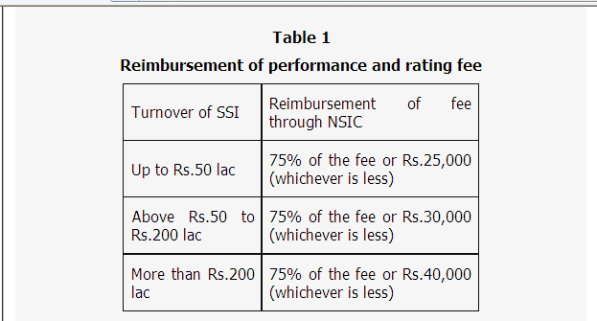

Table 2
List of empanelled agencies by NSIC
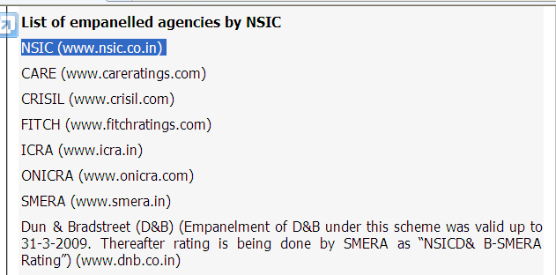

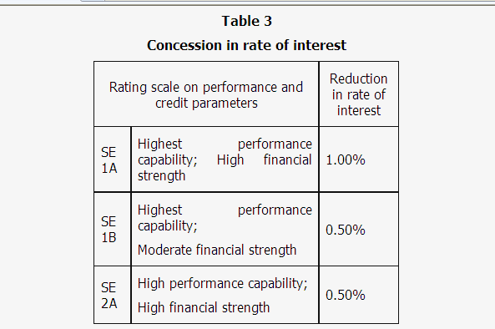

To summarise, credit rating can bring a host of benefits to SMEs and often balance sheets are the starting point for any analysis. CAs can play a better role in educating their clients by giving an advice which is in their long-term interests to make them tomorrow’s Reliance and Infosys.

